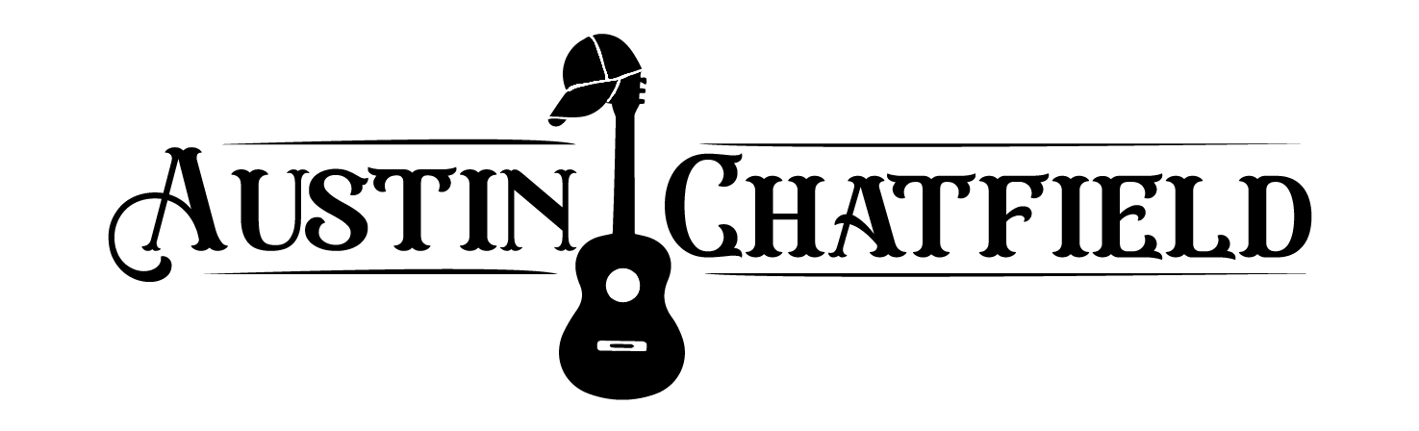

Austin Chatfield is a 21-year-old country singer and songwriter from Frisco, Texas. With over 13 years of music business and performance experience, Austin is currently studying at Belmont University in Nashville, Tennessee in their award-winning songwriting and music business programs.

For more information, music, socials, and contact, please visit the website below and check out other social links. Please also feel free to contact [achatfieldmusic@gmail.com](mailto:achatfieldmusic@gmail.com) .

**Website:** [**https://austinchatfield.com/**](https://austinchatfield.com/)

Tiktok: <https://www.tiktok.com/@austincmusic>

Spotify:<https://open.spotify.com/artist/3E3abjCWIOaiD7tHPltN6w?autoplay=true>

Instagram: <https://www.instagram.com/austinchatfieldmusic/>

Apple Music: <https://music.apple.com/us/artist/austin-chatfield/1458904708>

Performance Video: <https://youtu.be/XOv9twsRwMQ>