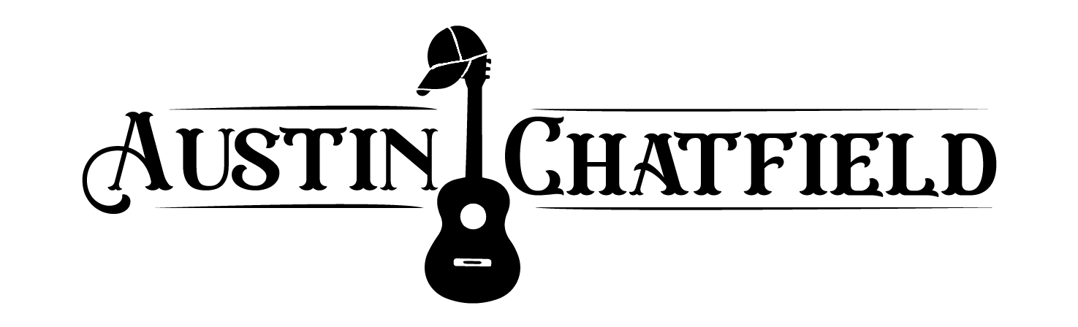

1. Country Girl- *Luke Bryan-* **G**
2. Get Along- *Kenny Chesney-* **G**
3. Should’ve Been a Cowboy- *Toby Kieth-* **G**
4. Destiny- *Austin Chatfield-* **C#**
5. Til’ You Can’t- *Cody Johnson-* **C#**
6. She’s Country- *Jason Aldean-* **C#m**
7. Whiskey Glasses- *Morgan Wallen-* **F#**
8. I Hold On- *Dierks Bentley-* **C**
9. Toes- *ZBB-* **B**
10. You Should Probably Leave- *Chris Stapleton-* **A**
11. Buy Me a Boat- *Chris Janson-***D**
12. Beer Never Broke- *Luke Combs-* **D**
13. Here for a Good Time- *George Strait-* **F#**
14. Ain’t As Easy- *Ernest-* **Eb**
15. Honky Tonk Man- *Dwight Yoakam-* **E**
16. I Ain’t- *Austin Chatfield-* **C**
17. (That’s My Kind of Night- *LB-* **Em (G))**
18. The Truth- *Jason Aldean-* **A**
19. Here and Now- *Kenny Chesney-* **A**
20. Fishin’ in the Dark- *Nitty Gritty-* **D**
21. You- *Chris Young-* **A**
22. Folsom Prison Blues- *Johnny Cash-* **F**
23. In Color- *Jamey Johnson-* **Bb**
24. The Kind of Love We Make- *Luke Combs-* Db
25. Courtesy of the Red White and Blue- *Toby Kieth-* **D**
26. She Won’t Be Lonely Long- *Clay Walker-*  **G**
27. Drunk On a Plane- *Dierks Bentley-* **A**
28. Red Solo Cup- *Toby Kieth-* **A**
29. The Way I Talk- *Morgan Wallen-* **E**
30. Boot Scoot- *Brooks & Dunn-* **Eb**
31. Take it Slow- *Austin Chatfield-* **D**
32. Hawaii- *Old Dominion-*  **D**
33. Chicken Fried- *ZBB-* **Gb**
34. Drinkin Problem- *Midland-* **A**
35. Body Like a Back Road- *Sam Hunt-* **F**
36. Cold Beer & Country Music- *Zach Top-* **D**
37. Save a Horse- *Big & Rich-* **D**
38. Love You Too Late- *Cole Swindell-* **C**
39. God’s Country- *Blake Shelton-* **Eb (Cm)**
40. Gas Money- *Austin Chatfield-* **G**
41. Wanted Dead or Alive- Bon Jovi- **D**
42. Old Fashioned Feeling- *Midland-* **G**
43. Kiss Tomorrow Goodbye- *Luke Bryan-* **Ab**
44. As She’s Walkin’ Away- *ZBB-* **Eb**
45. Dirt on My Boots- *Jon Pardi-* **B**
46. I Was On a Boat- *Old Dominion-* **B**
47. Tennessee Whiskey- *Chris Stapleton-*  **A**
48. Made In America- *Toby Kieth-* **A**
49. Flatliner- *Cole Swindell*
50. Good Directions- *Billy Currington-* **F**
51. Rendezvous- *Austin Chatfield*- **A**
52. Neon Moon- *Brooks & Dunn-* **A**
53. Drink In My Hand- *Eric Church-* **C**
54. Huntin Fishin- *Luke Bryan-* **G**
55. Dancin In The Country- *Tyler Hubbard-* **G**
56. One Margarita- *Luke Bryan***- A**
57. Fake ID- *Big & Rich-* **Dm**

ACOUSTICS

1. Feathered Indians- *Tyler Childers-* **C**
2. Sand in My Boots- *Morgan Wallen-* **Eb**