Meeting Open – 10:05am
- Welcome to Members and Guests
President Rod Sewell welcomed all GULLG Members and Guests. He advised that the purpose of the AGM is to allow members to meet committee members, receive the President’s Report and question GULLG’s accounts and the organisation’s activities.

Attendance:
  - Present: Adam Rowe, Justin Rowe, Bob Kennedy, Ian Fleischer, Glenda Fleischer, Rod Sewell, Evan Davis, Colin Metcalfe, David Redfern, John Cottrell, Jill Tischendorff, Julie Coyle, Evan Fleischer
  - Apologies-: Damien Leonard

Quorum:
The Secretary advised that no business may be conducted at a general meeting unless a quorum is present and that the quorum for a general meeting is the presence of 10% of the members entitled to vote.
A quorum is present.

Confirmation of Minutes of AGM held Sunday 22nd August 2024
President Sewell advised that the unadopted Minutes of the Annual General Meeting held Sunday 22nd August 2024 were circulated following the meeting and also attached to the 2025 AGM Agenda papers and called for their confirmation.
Motion: That the Minutes of the Annual General Meeting held on Sunday 22nd August 2024 be confirmed
Moved: J Tischendorf Second: C Metcalfe
Carried

Business arising from the previous Minutes

- Additional Space at recreation Reserve – Meeting with the reservce committee on Wednesday 17 September 2025, GULLG have permission to utilise the old gun club container for storage. Rod Sewell has the key and confirmed the space is empty

Correspondence
The Secretary advised that due to correspondence now being received largely through email addressed to various of the committee members rather than in postal letter form addressed to the Secretary this would largely focus on the administrative aspects. Secretary confirmed all correspondence has been addressed and when in electronic form, appropriately filed and saved.
Notwithstanding, the majority of correspondence known to have been received relates to the following:
  - grant funding, applications, outcomes and acquittals
  - DECCA on actions of GULLG as Committee of Management
  - LVI on annual membership and insurance
  - UCLN activities

Reports

Presidents Report
A huge thankyou to all of the committee members all the current members and new members for the 2024/25 year and all those who participated on the various activities as listed below.

- Completion of the Pollinator Garden
- Stall at New Years Day attracting new members and provide GULLG information.
- Successful Hand’s on Days/Working bee’s clearing weeds, whipper snipping, mowing grass etc along the Bioink – and a huge thankyou to Glenda & Rosemary for their culinary skills providing lunches.
- Discussions with DEECA and Hepburn Shire Council the potential for GULLG’s involvement in the future of the Glenlyon Wetlands Reserve located between Molesworth and Mostyn Streets, Glenlyon along with community meeting and positive discussions with adjoining landowners.
- 2025 National Tree Planting Day with the cooperation of the Glenlyon Pony Club establishing 3 separate locally indigenous communities (trees, shrubs & grasses) within the grounds of the Glenlyon Recreation Reserve with a view to eventually supersede the aging and deteriorating remnant / habitat trees.

Thank-you to Ian Fleischer and his team ??? for their work during weekdays treating weeds and general cleanup along the Biolink.
Finally, a Huge Thank you tom Both Justin & Adam with their commitment, enthusiasm and allowing their Home to be a venue for General Committee Meetings
Rod Sewell
There were no questions about the President's Report
Motion: That the President's Report be accepted
  - Moved: G Fleischer
  - Second: E Davis
  - Carried

Treasurers Report
In summary, GULLG had a quieter year financially in the last financial year which was reflected in lower than previous spending and revenue. GULLG has obtained charity status with the ACNC, which confirms our tax exempt status and means we no longer need to pay consumer affairs annually.

Income
GULLG’s income totaled $3,081.78 for the 2024-25 financial year and was drawn from the following sources:
- Fundraising (sale of donated spray unit) $819.18
- Hepburn Shire Council Environmental Group Grant $1000.00
- Membership fees $350.20 (Noting that $180 of membership funds were paid in the previous year)
- Term Deposit Interest $786.40 (Up from $538.59 the previous year)
- Donations $21.00
- Equipment Hire $105.00
Income was less than 2023-24 ($5,232.21) due to lower equipment hire and absence of any active fundraising for the year.

Expenditure
Excluding grant expenditure from projects, GULLG’s costs for 2024-25 totaled $2,094.64
Spending largely fell into the following categories:
- Equipment (Trailer registration and maintenance of existing equipment) $551.56
- Operating costs (LVI insurance, Consumer Affairs fee, financial audit, PO Box rental) $888.00
- Plants (Stakes, New Years Day new member giveaway) $194.40
- Administrations (White board, Square reader, first aid kit) $1.75
- Catering (Hands on days, National Tree Day, coffee voucher for weekday volunteer group) $338.93
- Marketing (AGM Speaker) $120.00
This was significantly less that what was spent in 2023-24 ($3,407.47) The main differences being we had higher admin costs from purchasing the whiteboard, square reader and first aid kit, we purchased chemicals with the Reserve and our equipment maintenance costs were higher.
For the 2024-25 financial year GULLG made a profit of $987.14.

2023-24 Budget
Reflecting on the budget endorsed by the GULLG committee early in the 2024-25 financial year, total expenditure was lower than anticipated by $978.36. This was due to the mower service being cheaper than anticipated, using grant funding for purchase of plants, and having no significant equipment purchases for the year.

Income was higher than forecast for the period, with GULLG bringing in $471.78 more than budget. This was due to higher term deposit interest and equipment hire that we don’t factor into the budget.

Grants
In the 2024-25 financial year, GULLG was awarded and oversaw grants to the value of $9,007.00. This included:
- $4,255.00 reimbursed to members as part of the Victorian Gorse Task Community Grant program.
- $1,000.00 from Hepburn Shire Council Environmental Group grant to cover general operating expenses (included above)
- $4,752.00 from the Hepburn Shire Council Biodiversity Grant for Wetland Nature Survey
- There was also $2159.29 of non-expended funds from the previous financial year connected to the HSC Biodiversity Grant for the pollinator garden.
All funds have been expended except for the environmental Group Grant and the Biodiversity Grant which are due to be expended in 2025-26.

Financial Position
GULLG ended the 2024-25 financial year with a combined total of $7,572.85 across both operational accounts (excluding grant funds).
GULLG has significant financial reserves in term deposits to the total of $19,629.87.
As of June 30 2025, GULLG had total funds to the amount of $27,202.72 (excluding committed grants funds). Compared to the 2024-25 financial year this is an increase in overall position of $1,987.14.

Financial Audit
GULLG’s finances were audited by accountant Daryl Santurini on 27 August 2025 as shown below;

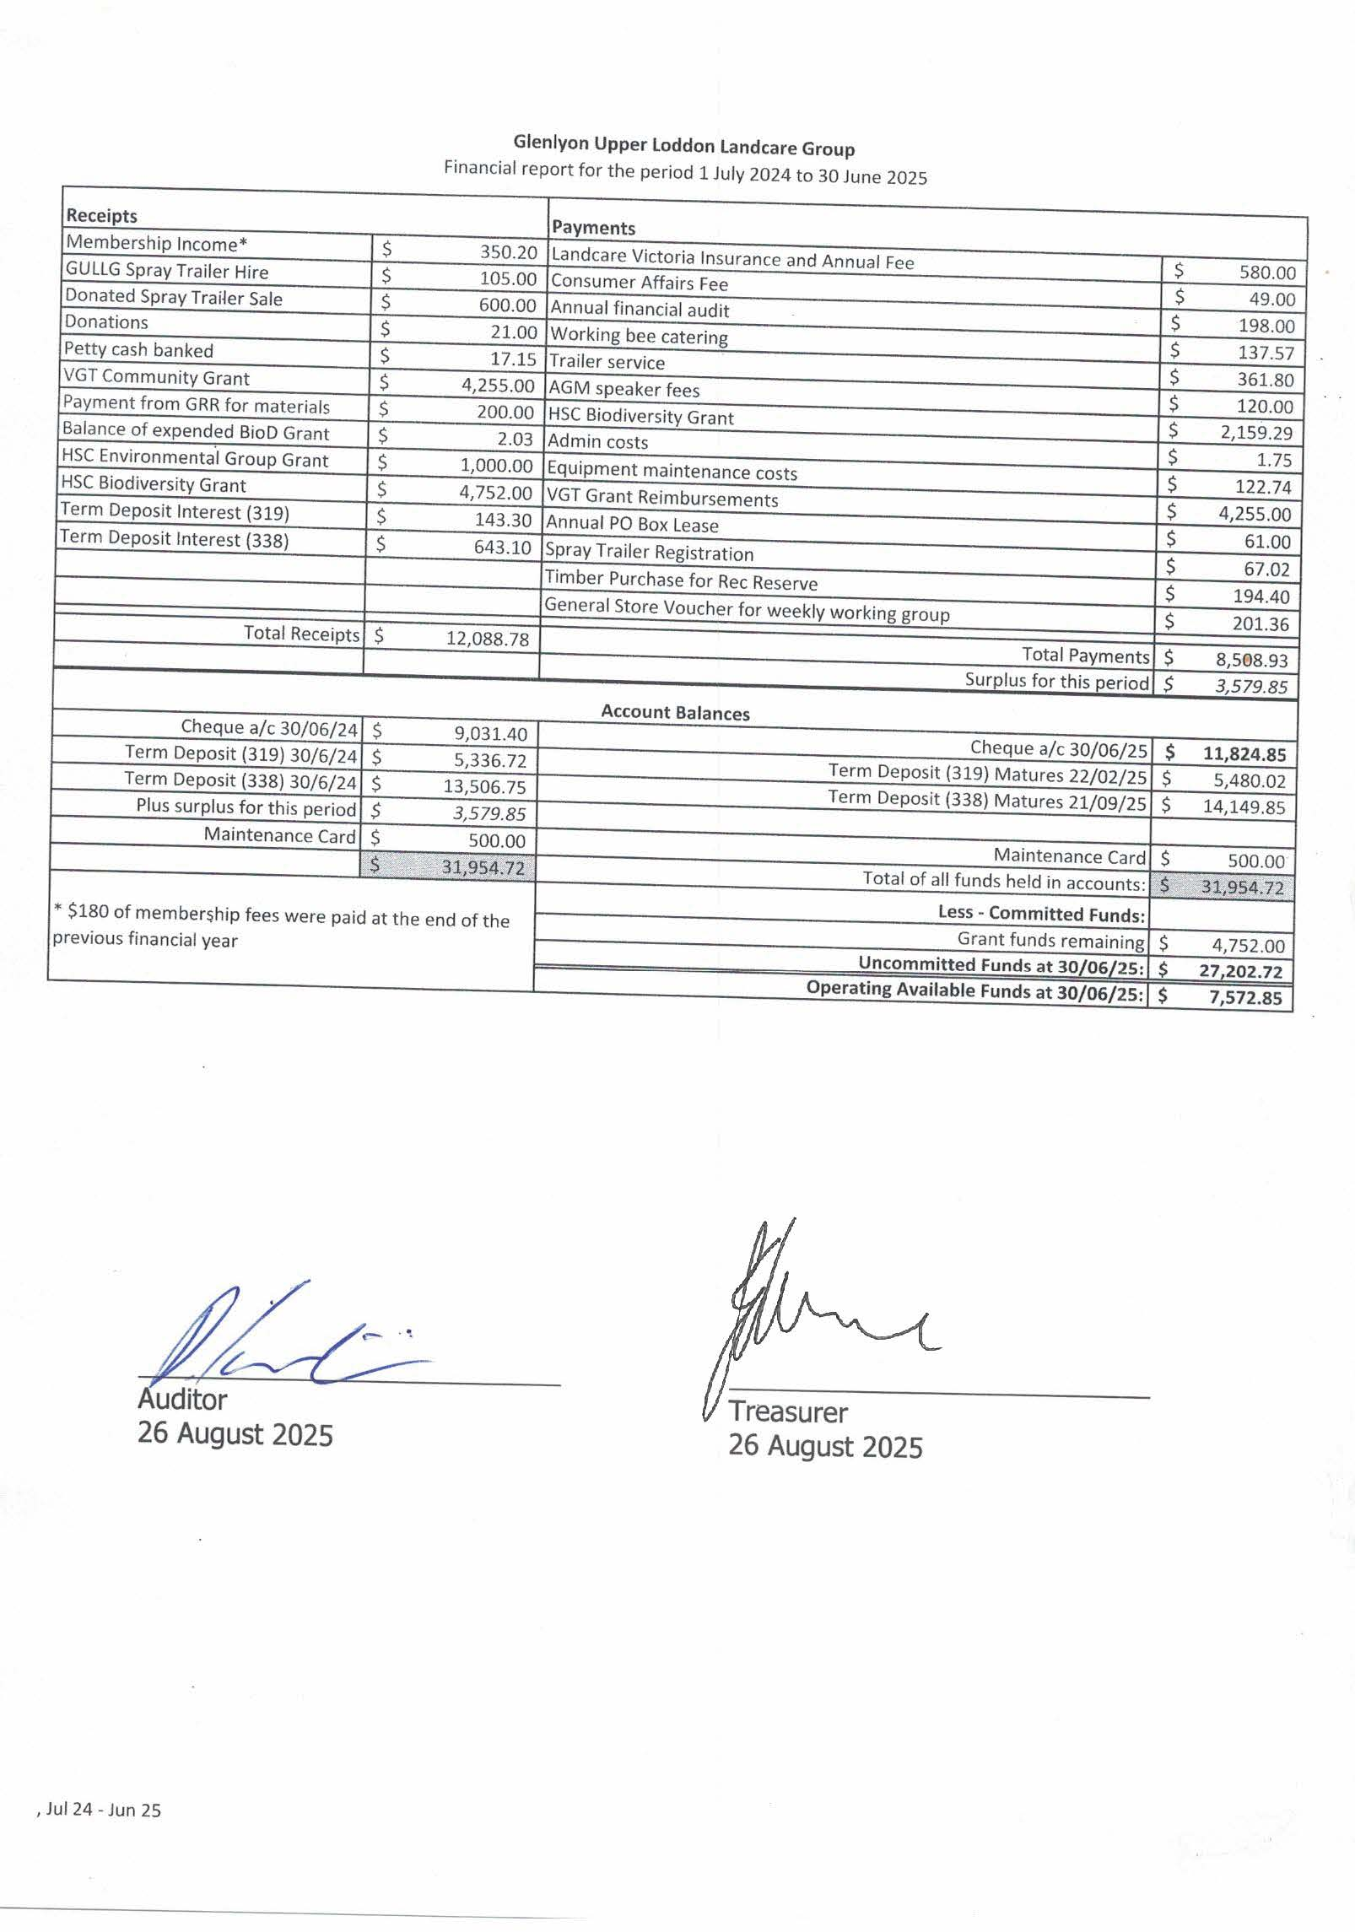

There were no questions about the Treasurers Report
Motion: That the Treasurer's Report be accepted
  - Moved: J Cottrell
  - Second: E Davis
  - Carried

Membership Report
The Secretary advised that the following:

Membership on 30 June 2024. | 66
Membership on 30 June 2025. | 65
2024-25 Membership
- Not renewed (as of 21 September 2025) | 28
- New members | 1
Membership as of 21st September 2025. | 37
Life Members (included) | Bob Kennedy  John Cable

Presentation on History of GULLG
Justin Rowe and Margaret Lockwood presented to the group a short presentation on the history of GULLG. This work was being done to categorise the hard copy historical documents of GULLG as well as maintain records for future.
- Margaret Lockwood noted it’s a partial history as there is nothing complete documentation wise prior to 2009, with the majority being taken from existing and previous members
- Detailed investigation through council, members, existing documentation and Landcare Vic. Founded in 1986, 40th anniversary is in 2026.
- Presidents’ reports are critical as they give a summary of the years work.
- Margaret spoke to the slide presentation which has been distributed to members.
- Establishment of the Biolink and the committee of management to GULLG on or around 2013.
- NOTE – John Cottrell noted that there was documentation showing funding provided to GULLG in 2004 for the establishment of the Bioink

- Jill Tischendorff asked if some of the more controversial or negative issues were going to be noted and Margaret said a lot of that is in the more detailed work.
- John Cottrell asked of there is a section in this to detail the formation of the Biolink and the work to create and upkeep it.
- Adam noted we will circulate presentation and seek additional information from members.

Election of Office Bearers and Committee Members for 2025-2026
President Sewell advised that he would be standing for re-election and accordingly passed the Chair to the Secretary who declared all positions vacant and called for nominations.
The President and Secretary called on Bob Kennedy to oversee the election process
Nominations were called for the position of President – a single nomination was received for Justin Rowe. Mr Rowe accepted the nomination.
As there was no other nomination Mr Justin Rowe was elected unopposed as President.
The president called for nominations for the positions of Vice President, Secretary and Treasurer. The following nominations were received.

Position Vacant | Nomination | Nomination Accepted | Vote Carried
President | Justin Rowe | Y | Y
Vice President | Rod Sewell | Y | Y
Secretary | Julie Coyle | Y | Y
Treasurer | Adam Rowe | Y | Y
Community Members (4x)
 | Colin Metcalf | Y | Y
 | Evan Davis | Y | Y
 | Evan Fleisher | Y | Y
 | VACANT

As there were only single nominations received respectively for the positions of Vice President, Secretary and Treasurer and three of the four community members all positions were declared elected.
The New Committee comprises:

President | Justin Rowe
Vice President | Rod Sewell
Secretary | Julie Coyle
Treasurer | Adam Rowe
Community Members (4x)
 | Colin Metcalf
 | Evan Davis
 | Evan Fleisher
 | VACANT

Bob Kennedy thanked retiring committee members for their contribution over the past year and welcomed the new committee, and with them looked forward to a fulfilling 2025-2026.

Newly elected President Justin Rowe thanks the committee and members and outlined the priorities for the upcoming year.

Membership Fee
President Rowe advised it is the role of the AGM to review the annual membership fee, and that the committee has performed that review and recommends that:
- The annual Glenlyon Upper Loddon Landcare Group Membership Fee remains at $10 per individual for the 2025-2026 financial year, and
- A joining Membership Fee paid in April/May/June also be accepted as the annual fee for the following year.
There were no questions about the recommended membership fee.
Motion: That the annual Glenlyon Upper Loddon Landcare Group Membership Fee remains at
$10 per individual for the 2025-2026 financial year, and that a joining Membership Fee paid in April/May/June of 2026 also be accepted as the annual fee for the following year.
  - Moved: J Cottrell
  - Second: E Davis
  - Carried

Appointment of Auditor
President Rowe advised that the role of the Glenlyon Upper Loddon Landcare Group auditor is reviewed annually and that the committee has performed that review and recommends that:
  - Daryl Santurini Accountant be appointed as Glenlyon Upper Loddon Landcare Group auditor for the financial year 2025-26
There were no questions on the recommended appointment.
Motion: That Daryl Santurini Accountant be appointed as Glenlyon Upper Loddon Landcare Group auditor for the financial year 2025-26
  - Moved: R Sewell
  - Second: J Cottrell
  - Carried

General Business
Bob Kennedy – Noted that with reference to the presentation on the history of GULLG and how GULLG became involved with Reserve Committee Meeting. In an early Reserve Committee meeting it was raised that perhaps GULLG could assist with the weed control and it was passed.

Glenda Fleisher – Does Daylesford Secondary or the Primary Schools have an environmental course that we could tap into? This would perhaps assist with driving some additional membership and exposure, and access to more grants. New Committee Undertook to discuss with the schools and come back.

Next meeting
Motion: The next AGM of GULLG will be held on or around Sunday 20th September 2026
  - Moved: R Sewell
  - Second: J Rowe
  - Carried

Close of Meeting
President Rowe thanked everyone for their attendance and closed the meeting at 11:24am

