QR Code:

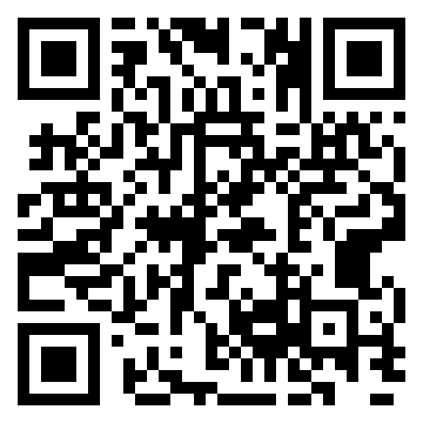

Link to site:
https://Form.jotform.com/243544067668163

