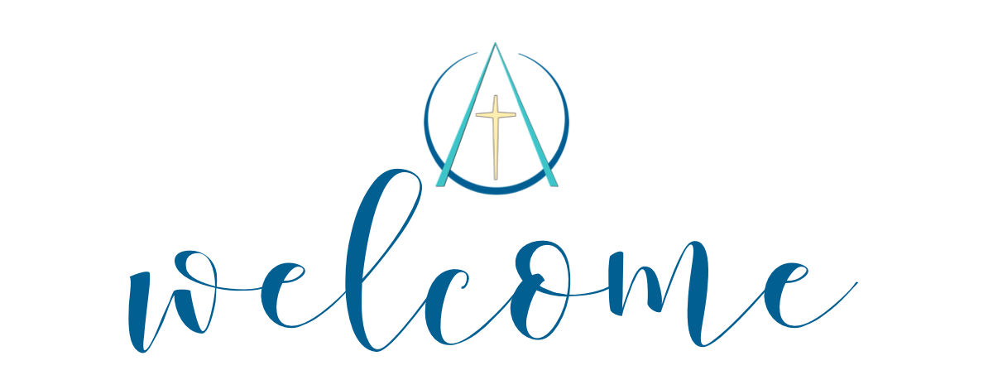

EPISCOPAL CHURCH OF THE ASCENSION
Fifth Sunday After Pentecost, Proper 8, Year A
Holy Eucharist Rite II
10 am
June 28, 2026

405 Talbot Hall Road
Norfolk, Virginia 23505
(757) 423-6715
ORDER OF SERVICE
THE WORD OF GOD

Prelude
Processional Hymn
“God My King, Thy Might Confessing” vs. 1, 3-5 Blue Hymnal 414

Opening Acclamation Book of Common Prayer p. 355
“Glory to God” Blue Hymnal S-280
Collect and Lessons Book of Common Prayer p. 357

The Collect
Almighty God, you have built your Church upon the foundation of the apostles and prophets, Jesus Christ himself being the chief cornerstone: Grant us so to be joined together in unity of spirit by their teaching, that we may be made a holy temple acceptable to you; through Jesus Christ our Lord, who lives and reigns with you and the Holy Spirit, one God, for ever and ever. Amen.

The Old Testament Genesis 22:1-14
God tested Abraham. He said to him, “Abraham!” And he said, “Here I am.” He said, “Take your son, your only son Isaac, whom you love, and go to the land of Moriah, and offer him there as a burnt offering on one of the mountains that I shall show you.” So Abraham rose early in the morning, saddled his donkey, and took two of his young men with him, and his son Isaac; he cut the wood for the burnt offering, and set out and went to the place in the distance that God had shown him. On the third day Abraham looked up and saw the place far away. Then Abraham said to his young men, “Stay here with the donkey; the boy and I will go over there; we will worship, and then we will come back to you.” Abraham took the wood of the burnt offering and laid it on his son Isaac, and he himself carried the fire and the knife. So the two of them walked on together. Isaac said to his father Abraham, “Father!” And he said, “Here I am, my son.” He said, “The fire and the wood are here, but where is the lamb for a burnt offering?” Abraham said, “God himself will provide the lamb for a burnt offering, my son.” So the two of them walked on together.
When they came to the place that God had shown him, Abraham built an altar there and laid the wood in order. He bound his son Isaac, and laid him on the altar, on top of the wood. Then Abraham reached out his hand and took the knife to kill his son. But the angel of the Lord called to him from heaven, and said, “Abraham, Abraham!” And he said, “Here I am.” He said, “Do not lay your hand on the boy or do anything to him; for now I know that you fear God, since you have not withheld your son, your only son, from me.” And Abraham looked up and saw a ram, caught in a thicket by its horns. Abraham went and took the ram and offered it up as a burnt offering instead of his son. So Abraham called that place “The Lord will provide”; as it is said to this day, “On the mount of the Lord it shall be provided.”
The Word of the Lord Thanks be to God

The Psalm Psalm 13
1 How long, O Lord?
will you forget me for ever? *
how long will you hide your face from me?
2 How long shall I have perplexity in my mind,
and grief in my heart, day after day? *
how long shall my enemy triumph over me?
3 Look upon me and answer me, O Lord my God; *
give light to my eyes, lest I sleep in death;
4 Lest my enemy say, "I have prevailed over him," *
and my foes rejoice that I have fallen.
5 But I put my trust in your mercy; *
my heart is joyful because of your saving help.
6 I will sing to the Lord, for he has dealt with me richly; *
I will praise the Name of the Lord Most High.

The New Testament Epistle Romans 6:12-23
Do not let sin exercise dominion in your mortal bodies, to make you obey their passions. No longer present your members to sin as instruments of wickedness, but present yourselves to God as those who have been brought from death to life, and present your members to God as instruments of righteousness. For sin will have no dominion over you, since you are not under law but under grace.
What then? Should we sin because we are not under law but under grace? By no means! Do you not know that if you present yourselves to anyone as obedient slaves, you are slaves of the one whom you obey, either of sin, which leads to death, or of obedience, which leads to righteousness? But thanks be to God that you, having once been slaves of sin, have become obedient from the heart to the form of teaching to which you were entrusted, and that you, having been set free from sin, have become slaves of righteousness. I am speaking in human terms because of your natural limitations. For just as you once presented your members as slaves to impurity and to greater and greater iniquity, so now present your members as slaves to righteousness for sanctification.
When you were slaves of sin, you were free in regard to righteousness. So what advantage did you then get from the things of which you now are ashamed? The end of those things is death. But now that you have been freed from sin and enslaved to God, the advantage you get is sanctification. The end is eternal life. For the wages of sin is death, but the free gift of God is eternal life in Christ Jesus our Lord.
The Word of the Lord Thanks be to God

Sequence Hymn
“Where Cross the Crowded Ways of Life” vs. 1-3 Blue Hymnal 609
The Gospel Matthew 10:40-42
The Holy Gospel of our Lord Jesus Christ according to Matthew.
Glory to you, Lord Christ
Jesus said, “Whoever welcomes you welcomes me, and whoever welcomes me welcomes the one who sent me. Whoever welcomes a prophet in the name of a prophet will receive a prophet's reward; and whoever welcomes a righteous person in the name of a righteous person will receive the reward of the righteous; and whoever gives even a cup of cold water to one of these little ones in the name of a disciple-- truly I tell you, none of these will lose their reward.”
The Gospel of the Lord Praise to you, Lord Christ.

Sermon The Reverend Mimi Lacy
Nicene Creed Book of Common Prayer p. 358
Prayers of the People Form III Book of Common Prayer p. 387

The Ascension Discernment Prayer
(Recited together at the end of the Prayers of the People)

O God of wisdom and guidance,
We ask that you lead our parish in this season of discernment.
Bless our Search Committee with clarity,
Bless our Vestry with faithfulness,
And bless our whole congregation with patience and hope.
May the Holy Spirit guide and instill in the people of Ascension a glorious vision of the future.
And finally, we ask that You prepare the priest You are calling
to join us,
and prepare us to welcome them and serve together in your name.
Through Jesus Christ our Lord. Amen.

Confession and Absolution Book of Common Prayer p. 359
The Peace Book of Common Prayer p. 360

Holy Communion
Offertory
“What Wondrous Love is This” Blue Hymnal 439
Eucharistic Prayer B Book of Common Prayer p. 367
Sanctus Blue Hymnal S-125
The Lord’s Prayer Book of Common Prayer p. 364
Breaking of the Bread Book of Common Prayer p. 364
Communion*
Communion Hymn
“In Your Mercy, Lord, You Called Me” Blue Hymnal 706
Post Eucharistic Prayer Book of Common Prayer p. 365
Recessional Hymn
“Fresh as the Morning” vs. 1-3 Maroon Hymnal 507
Dismissal Book of Common Prayer p. 366
Postlude

*You may come to the rail to receive communion or a blessing. Communion wine may be received from the common cup or by intinction. If you choose intinction, please hold the bread up for the Lay Eucharistic Minister to take it from you who will dip it in the second cup and return it. If coming for a blessing, or if not receiving the communion wine, simply approach the rail and cross your arms over your chest.
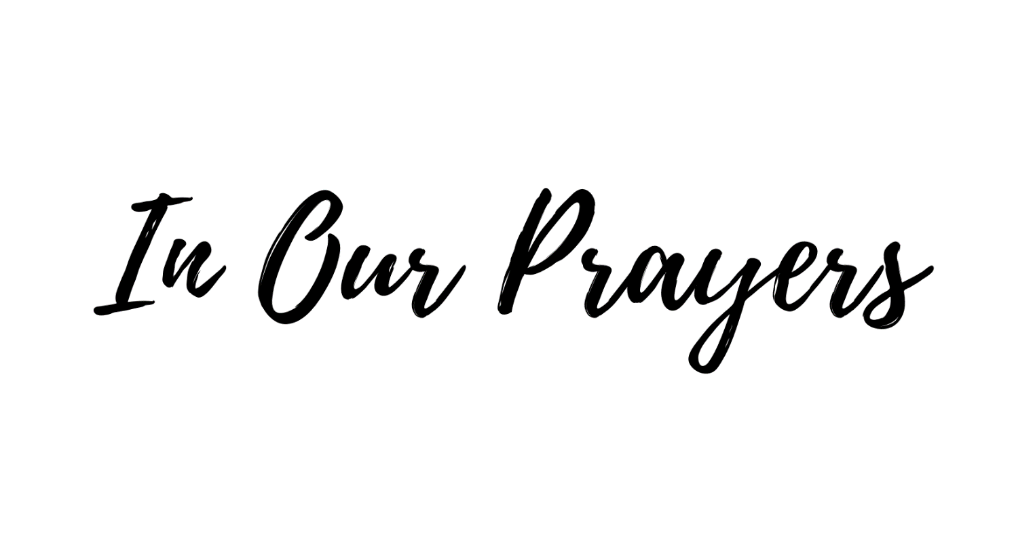
Joe Beck, Susan Beers, Gloria Carter, Billy Clark, Linda Day,
Marilyn Doughty, Elaine Evans, Diane Forrest, William Grygar, Kate Hien, Rebecca Hirschler, Katie Hughes, Sharon Jones, Bryan Knight, Sally Miller,
Phoebe Montagna, Alessandra Myers, Shana Paul, Sydney Rudolph,
Linda Sawyer, Diane Shepheard, Doug Thompson, Courtney Wheeler, and Margaret Wynn.

We pray for Sean our Presiding Bishop, Susan our Bishop, and Mimi, our Guest Priest.

We pray for the people of Ascension, that formed by our Baptismal promises we might embody God’s community of Shalom in the world.

We give thanks for the blessings of this life.

We give thanks for the anniversary of Luke Suber & Kathryn Kramer (7/2).

We give thanks for our Christian formation volunteers.

The Ascension Discernment Prayer
O God of wisdom and guidance,
We ask that you lead our parish in this season of discernment.
Bless our Search Committee with clarity,
Bless our Vestry with faithfulness,
And bless our whole congregation with patience and hope.
May the Holy Spirit guide and instill in the people of Ascension a glorious vision of the future.
And finally, we ask that You prepare the priest You are calling
to join us,
and prepare us to welcome them and serve together in your name.
Through Jesus Christ our Lord. Amen.


We welcome The Reverend Mimi Lacy as our supply celebrant and preacher this morning.

We give thanks to Karla Stead for playing the piano for us this morning. Welcome Karla!

Columbarium Visiting Hours: To help us better accommodate visits and ensure the church office is available to assist as needed, the Columbarium will be open for visitation Monday through Thursday from 9:00 a.m. to 12:00 p.m. If you would like to visit outside of these hours, we kindly ask that you contact the church office in advance so that special arrangements can be made. Thank you for your understanding and cooperation as we continue to care for this sacred space and all who visit their loved ones here.
Breakfast with Jesus -Throughout the summer, adults will gather at 9am for coffee and goodies to discuss the scripture for the day. We will have a nursery from 9-11am all summer. We will not have Godly Play until the fall.

Chanco Chatter
Chanco on the James has been named a 2026 Best of Virginia winner for Sleepover Summer Camp! This honor reflects the vibrant community that makes Chanco such a special place — campers, families, staff, alumni, and supporters whose enthusiasm and dedication continue to shape unforgettable summers along the James River. At Chanco, camp is more than a summer experience. It is a place where young people grow in confidence, build lasting friendships, and encounter joy, faith, and community in meaningful ways. Registration for Summer 2026 is open, and sessions are filling quickly. Don’t miss the opportunity to be part of the camp community that earned this statewide recognition. The countdown to summer memories has begun — reserve your camper’s spot today! To register, visit https://chanco.org/camps/camp-info/

Creation Care
Thanks for participating in our trial recycling program! You can mix all your items together in your collection box. Drop off your items during office hours at DIOSOVA 11832 Rock Landing Drive Suite 100, Newport News (M-F 9-3) or Church of the Ascension 405 Talbot Hall Road, Norfolk (M-Th 9am-12pm). Ascension will also have a small outdoor collection box in their outdoor breezeway beginning April 2026. You can also mail your box to:
Attn: Creation Care Team, 405 Talbot Hall Road, Norfolk, VA 23505.

THE FOLLOWING ITEMS CAN BE RECYCLED
• BEAUTY PRODUCTS AND PACKAGING - Empty Cosmetic, Hair & Skin Care Packaging including Aluminized Tubes, Cosmetic Cases & Sticks, Plastic Packaging Unacceptable Items: Aerosol & Pressurized Cans, Cardboard, Electronic Items, Nail Polish Bottles & Removers, Partially Full & Full Packaging, Perfume Bottles, Wood & Bamboo, Wooden Eyeliner Pencils
• PENS, PENCILS & MARKERS - Pens, Pencils (non-wood), Highlighters, Markers & Caps, Mechanical Pencils, Pen & Pen Caps, Permanent Markers & Caps. Unacceptable Items: Paint Brushes, Wooden Pencils
• BOTTLE CAPS – Metal & Plastic Drink Bottle Caps Unacceptable Items: Bottles, Packaging, Liquids
• WATER FILTERS - Any Brand & Any Size Water Filters Unacceptable Items: Air Filters, Oil Filters
• CONTACT LENSES & PACKAGING - Contact Lenses, Plastic Film, Pods, And Cardboard Packaging Unacceptable Items: Contact Lens Solution, Bottles
• ORAL CARE WASTE & PACKAGING - Floss Containers, Toothbrush & Toothpaste Outer Packaging, Toothbrushes, Toothpaste Tubes & Caps Unacceptable Items: Floss, Other Oral Waste Care Items
• COFFEE BAGS – Empty Coffee Bags Unacceptable Items: Capsules, Coffee Grounds, Discs, Filters, Coffee Electronics, Other Coffee Packaging
• CORKS – Synthetic Beverage Corks Unacceptable Items: Natural Corks, Aluminum Champagne Twists, Bottle Caps, Bottles, Foil, Screw Tops
• STRAWS – Any Size Plastic Straws Unacceptable Items: Paper Straws, Biodegradable Straws
• DISPOSABLE CUPS & LIDS – Paper Coated Cups, Plastic Cups, Plastic Lids Disposable Cups
& Lids that have been rinsed and dried Unacceptable Items: Biodegradable Plastic Cups & Lids, Juice Boxes & Pouches. Other Rigid Plastic Containers
• GLUE STICKS & BOTTLES – Empty Craft Glue Stick Containers & Empty Glue Bottles
Unacceptable Items: Industrial Adhesive Containers

Questions – contact Canon Lynn Farlin at 757-676-6188 or lfarlin@diosova.org

Outreach, Collections, & Opportunities:
Catholic Worker Needs: As the rainy season comes to an end and warmer summer temperatures begin to arrive, there is an increased need for seasonal items to help everyone stay comfortable and prepared. Currently, we are especially in need of t-shirts, Gatorade, and white crew socks with full tops rather than low-cut tennis-style socks. These items would be greatly appreciated and will help meet the needs of those we serve during the summer months. Thank you so much for your kindness and support!


Sunday Seeds

Below are just a few of the ways Ascension is serving our community:
- Each month, members of our church family lovingly prepare 100 sandwiches, which are delivered to Catholic Worker for distribution to those experiencing homelessness.
- Get involved with organizations and community groups that support teens, promote mental health, and work to prevent suicide. Support efforts that advance thoughtful, common-sense legislation and encourage open, respectful conversations about firearm ownership and safety. By working together, we can honor the value of every life and help protect our children, families, friends, and communities from preventable tragedies and unintended consequences.

Please watch for upcoming volunteer opportunities—we welcome your participation and support!

Reminder: The deadline for announcements is Tuesday at 5pm. Announcements received after that time may not make it into the bulletin or the emailed announcements.
Weekly Studies:
Tuesday Centering Prayer meets at 7:45am on Tuesdays on Zoom for one hour. The meeting opens at 7:30 for chatting, then at 7:45 we proceed with the reading of a psalm, 20 minutes of silent prayer/meditation followed by a discussion of the reading. The group is currently reading After the Apple: Women in the Bible - Timeless Stories of Love, Lust, and Longing by Naomi Harris Rosenblatt. We are a diverse group with members joining from three countries and various religious backgrounds. You are invited to join us at any time. To get on the Zoom invite list, please contact Anji Harris (anjiharris54@gmail.com) or Sally Miller (757-489-5293) or samiller903@yahoo.com).

Re-Imagining Church meets on Thursdays at 12pm. The meeting serves as a time of spiritual reflection and planning as we listen for and try to follow God’s call to Ascension. Please join us; your perspective may be how God is informing us of what we should be doing next.

Join Zoom Meeting:
https://us02web.zoom.us/j/88559209322?pwd=BubDI0FA8IXIwwryikkt4Jito7gq0r.1

Meeting ID: 885 5920 9322 Passcode: 346720

Thursday Mid-Morning Seekers’ Bible Study will watch a video, read scripture passages, and discuss the questions together. I recommend joining the meeting early in case you have any issues getting connected. I hope to see everyone on Thursday at 10:00 am! If you are not on the email group or have trouble accessing the Zoom, please contact Susan Meredith at merbec@cox.net or 757-617-1959.

Meeting ID: 832 5615 4914 Passcode: 614216

A Look at the Week Ahead:

Tuesday
7:30 am Centering Prayer – Zoom
10:00 am Food Pantry – Pantry
11:30 am Buildings & Grounds – Rose Hall

Thursday
10:00 am Food Pantry – Pantry
10:00 am Mid-Morning Seekers’ Bible Study – Zoom
12:00 pm Re-Imagining Church – Zoom

Sunday
9:00 am Breakfast with Jesus – Hall for Coffee Then Lounge
(Nursery from 9-11am)
10:00 am Holy Eucharist Rite II – Sanctuary

OUR VISION IS
Honoring the Past
Looking Forward in Hope
Be the Face of Healing
Susan Meredith* | 2024-2026 | merbec@cox.net | 757.617.1959
Anji Harris+ | 2023-2026 | Anjiharris54@gmail.com | 757.831.3474
Pat Duncan | 2023-2026 | Patlduncan2020@gmail.com | 478.777.0904
Karen Newbern^ | 2024-2027 | newby0325@gmail.com | 757.685.6935
Luke Suber | 2024-2027 | lukesuber@yahoo.com | 361.779.7216
Carol Evans | 2024-2027 | cevans1017@gmail.com | 757.335.1774
Robin Kruger | 2025-2028 | Rekruger54@gmail.com | 757.470.9882
Healing is the Core Value
Your Vestry is here to serve you!

*Senior Warden +Junior Warden ^Register

Clergy
Bishop The Right Reverend Susan Haynes
Supply Priest The Reverend Mimi Lacy

Guest Pianist Karla Stead

All music is used with permission under One License A-701614 and CCLI 2009175

