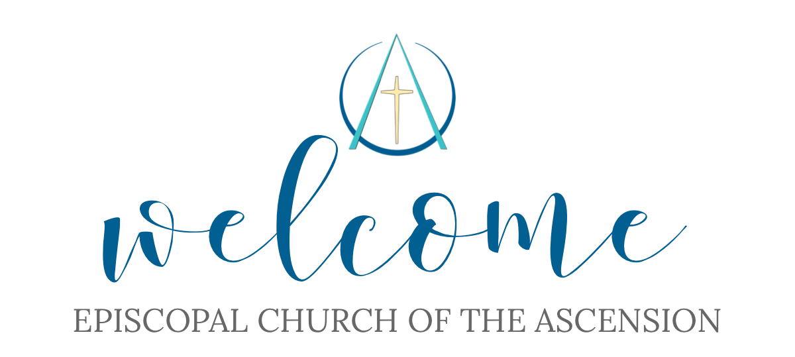

MAUNDY THURSDAY, YEAR A
Worship with Eucharist
F from the
Reserved Sacrament
6:00pm
April 2, 2026

405 Talbot Hall Road
Norfolk, VA 23505
(757) 423-6715

ORDER OF SERVICE
THE WORD OF GOD

Prelude

Processional Hymn “Now Let Us All with One Accord” Blue Hymnal 147

The Opening Acclamation
Bless the Lord who forgives all our sins: His Mercy endures for ever.

THE COLLECT OF THE DAY
The Lord be with you. And also with you.

Let us pray:
Almighty Father, whose dear Son, on the night before he suffered, instituted the Sacrament of his Body and Blood: Mercifully grant that we may receive it thankfully in remembrance of Jesus Christ our Lord, who in these holy mysteries gives us a pledge of eternal life; and who now lives and reigns with you and the Holy Spirit, one God, for ever and ever. Amen.

THE LESSONS
Old Testament Exodus 12:1-4, 11-14a

The Lord said to Moses and Aaron in the land of Egypt: This month shall mark for you the beginning of months; it shall be the first month of the year for you. Tell the whole congregation of Israel that on the tenth of this month they are to take a lamb for each family, a lamb for each household. If a household is too small for a whole lamb, it shall join its closest neighbor in obtaining one; the lamb shall be divided in proportion to the number of people who eat of it.
This is how you shall eat it: your loins girded, your sandals on your feet, and your staff in your hand; and you shall eat it hurriedly. It is the passover of the Lord. For I will pass through the land of Egypt that night, and I will strike down every firstborn in the land of Egypt, both human beings and animals; on all the gods of Egypt I will execute judgments: I am the Lord. The blood shall be a sign for you on the houses where you live: when I see the blood, I will pass over you, and no plague shall destroy you when I strike the land of Egypt.
This day shall be a day of remembrance for you. You shall celebrate it as a festival to the Lord; throughout your generations you shall observe it as a perpetual ordinance.

The Word of the Lord. Thanks be to God.

The Psalm Psalm 116:1, 10-17
1 I love the Lord, because he has heard the voice of my supplication, *
because he has inclined his ear to me whenever I called upon him.
10 How shall I repay the Lord *
for all the good things he has done for me?
11 I will lift up the cup of salvation *
and call upon the Name of the Lord.
12 I will fulfill my vows to the Lord *
in the presence of all his people.
13 Precious in the sight of the Lord *
is the death of his servants.
14 O Lord, I am your servant; *
I am your servant and the child of your handmaid;
you have freed me from my bonds.
15 I will offer you the sacrifice of thanksgiving *
and call upon the Name of the Lord.
16 I will fulfill my vows to the Lord *
in the presence of all his people,
17 In the courts of the Lord’s house, *
in the midst of you, O Jerusalem.

New Testament Epistle 1 Corinthians 11:23-26

I received from the Lord what I also handed on to you, that the Lord Jesus on the night when he was betrayed took a loaf of bread, and when he had given thanks, he broke it and said, “This is my body that is for you. Do this in remembrance of me.” In the same way he took the cup also, after supper, saying, “This cup is the new covenant in my blood. Do this, as often as you drink it, in remembrance of me.” For as often as you eat this bread and drink the cup, you proclaim the Lord’s death until he comes.

The Word of the Lord. Thanks be to God.

Sequence Hymn “What Wondrous Love Is This” Blue Hymnal 439

The Gospel Luke 22:14-30

The Holy Gospel of our Lord Jesus Christ
According to Luke Glory to you, Lord Christ.

When the hour for the Passover meal came, Jesus took his place at the table, and the apostles with him. He said to them, "I have eagerly desired to eat this Passover with you before I suffer; for I tell you, I will not eat it until it is fulfilled in the kingdom of God." Then he took a cup, and after giving thanks he said, "Take this and divide it among yourselves; for I tell you that from now on I will not drink of the fruit of the vine until the kingdom of God comes." Then he took a loaf of bread, and when he had given thanks, he broke it and gave it to them, saying, "This is my body, which is given for you. Do this in remembrance of me." And he did the same with the cup after supper, saying, "This cup that is poured out for you is the new covenant in my blood. But see, the one who betrays me is with me, and his hand is on the table. For the Son of Man is going as it has been determined, but woe to that one by whom he is betrayed!" Then they began to ask one another, which one of them it could be who would do this.
A dispute also arose among them as to which one of them was to be regarded as the greatest. But he said to them, "The kings of the Gentiles lord it over them; and those in authority over them are called benefactors. But not so with you; rather the greatest among you must become like the youngest, and the leader like one who serves. For who is greater, the one who is at the table or the one who serves? Is it not the one at the table? But I am among you as one who serves.

The Gospel of the Lord. Praise to you, Lord Christ.

The Sermon The Reverend Deacon Genevieve Nelson

The Washing of Feet Book of Common Prayer, p. 274
The people are invited to have their feet washed. The following is said afterwards.

The Lord Jesus, after he had supped with his disciples and had washed their feet, said to them, “Do you know what I, your Lord and Master, have done to you? I have given you an example, that you should do as I have done.”

Peace is my last gift to you, my own peace I now leave with you; peace which the world cannot give, I give to you.

I give you a new commandment: Love one another as I have loved you.

Peace is my last gift to you, my own peace I now leave with you; peace which the world cannot give, I give to you.

By this shall the world know that you are my disciples: That you have love for one another.

The Prayers of the People Form II Book of Common Prayer p. 386
(We will recite Ascension’s Discernment Prayer together at the end of the Prayers.)

Ascension’s Discernment Prayer

O God of wisdom and guidance,
We ask that you lead our parish in this season of discernment.
Bless our Search Committee with clarity,
Bless our vestry with faithfulness,
And bless our whole congregation with patience and hope.
May the Holy Spirit guide and instill in the people of Ascension
a glorious vision of the future.
And finally, we ask that You prepare the priest
You are calling to join us,
and prepare us to welcome them and serve together in your name.
Through Jesus Christ our Lord. Amen.

Concluding Collect
Lord Jesus Christ, you said to your apostles, “Peace I give to you; my own peace I leave with you:” Regard not our sins, but the faith of your Church, and give to us the peace and unity of that heavenly City, where with the Father and the Holy Spirit you live and reign, now and forever. Amen.

The Peace Book of Common Prayer, p. 360

The peace of the Lord be always with you. And also with you.

THE HOLY COMMUNION

Offertory Hymn “When I Survey the Wondrous Cross” Blue Hymnal 474

The Lord’s Prayer Book of Common Prayer p. 364
As our Savior Christ has taught us, we now pray:
Our Father, who art in heaven, hallowed be thy Name, thy kingdom come, thy will be done, on earth as it is in heaven. Give us this day our daily bread. And forgive us our trespasses, as we forgive those who trespass against us. And lead us not into temptation, but deliver us from evil. For thine is the kingdom, and power and glory, for ever and ever. Amen.

Distribution of Communion from the Reserved Sacrament
The Deacon says the following Invitation
The Gifts of God for us the People of God
We take them in remembrance that Christ died for us,
and we feed on him in our hearts by faith, with thanksgiving.

Communion Hymn “Now my Tongue, the Mystery Telling” Blue Hymnal 329
(To be sung as a meditation on the Sacrament)

Post Communion Prayer Book of Common Prayer p. 365

Eternal God, heavenly Father, you have graciously accepted us as living members of your Son our Savior Jesus Christ, and you have fed us with spiritual food in the Sacrament of his Body and Blood. Send us now into the world in peace, and grant us strength and courage to love and serve you with gladness and singleness of heart; through Christ our Lord. Amen.

Meditation Hymn “Ah, holy Jesus” Blue Hymnal 158
(In solemn preparation for the desolation of Good Friday.)

Psalm of Sorrow Psalm 22

- My God, my God, why have you forsaken me?*
and are so far from my cry
and from the words of my distress?
- O my God, I cry in the daytime, but you do not answer;*
by night as well, but I find no rest.
- Yet you are the Holy One,*
enthroned upon the praises of Israel.
- Our forefathers put their trust in you;*
they trusted, and you delivered them
- They cried out to you and were delivered;*
they trusted in you and were not put to shame.
- But as for me, I am a worm and no man,*
scorned by all and despised by the people.
- All who see me laugh me to scorn;*
they curl their lips and wag their heads, saying,
- “He trusted in the LORD; let him deliver him;*
let him rescue him, if he delights in him.”
- Yet you are he who took me out of the womb,*
and kept me safe upon my mother’s breast.
- I have been entrusted to you ever since I was born;*
you were my God when I was still in my mother’s womb.
- Be not far from me, for trouble is near,*
and there is none to help.
- Many young bulls encircle me;*
strong bulls of Bashan surround me.
- They open wide their jaws at me,*
like a ravening and a roaring lion.
14 I am poured out like water;
all my bones are out of joint;*
my heart within my breast is melting wax.
15 My mouth is dried out like a pot-sherd;
my tongue sticks to the roof of my mouth;*
and you have laid me in the dust of the grave.
16 Packs of dogs close me in,
and gangs of evildoers circle around me;*
they pierce my hands and my feet;
I can count all my bones.
17 They stare and gloat over me;*
they divide my garments among them;
they cast lots for my clothing.
18 Be not far away, O LORD;*
you are my strength; hasten to help me.
19 Save me from the sword,*
my life from the power of the dog.
20 Save me from the lion’s mouth,*
my wretched body from the horns of wild bulls.
21 I will declare your Name to my brethren;*
in the midst of the congregation I will praise you.
22 Praise the LORD, you that fear him; *
stand in awe of him, O offspring of Israel;
all you of Jacob's line, give glory.
23 For he does not despise nor abhor the poor in their poverty;
neither does he hide his face from them; *
but when they cry to him he hears them.
24 My praise is of him in the great assembly; *
I will perform my vows in the presence of those who worship him.
25 The poor shall eat and be satisfied,
and those who seek the LORD shall praise him: *
"May your heart live for ever!"
26 All the ends of the earth shall remember and turn to the LORD, *
and all the families of the nations shall bow before him.
27 For kingship belongs to the LORD; *
he rules over the nations.
28 To him alone all who sleep in the earth bow down in worship; *
all who go down to the dust fall before him.
29 My soul shall live for him;
my descendants shall serve him; *
they shall be known as the LORD's for ever.
30 They shall come and make known to a people yet unborn *
the saving deeds that he has done.

In silence,
the chancel is stripped of adornment,
the altar is washed,
and the cross is draped in black.

While a brief time will be allowed for continued silent prayers,
the congregation will leave in respectful silence
as the Altar Guild shrouds the crosses in the hallways.
Holy Week Services
Good Friday
Join us for the Solemn Collects at 5:30 pm. The service offers a time of prayer and meditation on the Passion of Christ and our need for God’s blessings. There is no Communion. Katherine Lawrence will officiate and will carry in the cross for the final prayers.

Holy Saturday
The wonderful Altar Guild will decorate the sanctuary for the festival to come on Sunday. We will be welcoming your contributions of Easter Lilies in 6’’ pots to decorate the altar area for Easter. Please plan to deliver them by 10am on Saturday morning.

Easter Sunday
Join us for the great Festival Service of Easter at 10 am. We always decorate a cross with flowers at the beginning of the service. While flowers will be provided, please bring flowers if your garden has already started blooming (no chrysanthemums, please). After our joyous Easter Celebration, please join us for a reception featuring your favorite finger foods that you bring to share.

OUR VISION IS
Honoring the Past
Looking Forward in Hope
Be the Face of Healing
Susan Meredith* | 2024-2026 | merbec@cox.net | 757.617.1959
Anji Harris+ | 2023-2026 | Anjiharris54@gmail.com | 757.831.3474
Pat Duncan | 2023-2026 | Patlduncan2020@gmail.com | 478.777.0904
Karen Newbern^ | 2024-2027 | newby0325@gmail.com | 757.685.6935
Luke Suber | 2024-2027 | lukesuber@yahoo.com | 361.779.7216
Carol Evans | 2024-2027 | cevans1017@gmail.com | 757.335.1774
Robin Kruger | 2025-2028 | Rekruger54@gmail.com | 757.470.9882
Healing is the Core Value
Your Vestry is here to serve you!

*Senior Warden +Junior Warden ^Register

Clergy
Bishop The Right Reverend Susan Haynes
Supply Deacon The Reverend Genevieve Nelson

Guest Pianist Karla Stead

All music is used with permission under One License A-701614 and CCLI 2009175

