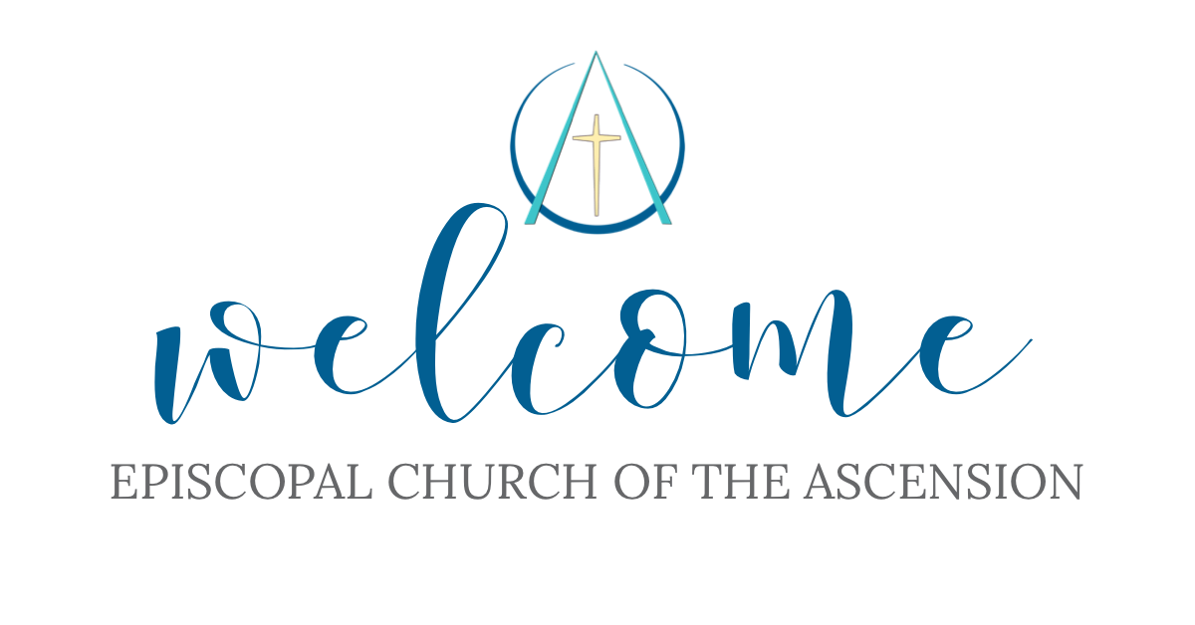

EPISCOPAL CHURCH OF THE ASCENSION
Trinity Sunday, Year A
Morning Prayer
10 am
May 31, 2026

405 Talbot Hall Road
Norfolk, Virginia 23505
(757) 423-6715
ORDER OF SERVICE

Prelude “Spirit of God, Descend upon My Heart” – Fredrick C. Atkinson & Joel
Bloomquist

Processional Hymn
“Holy, holy, holy! Lord God Almighty!” vs. 1, 4 Blue Hymnal 362

Officiant:
Holy, holy, holy is the Lord God Almighty, who was and is and is to come!
Revelation 4:8
The Collect
Let us pray.
Almighty and everlasting God, you have given to us your servants grace, by the confession of a true faith, to acknowledge the glory of the eternal Trinity, and in the power of your divine Majesty to worship the Unity: Keep us steadfast in this faith and worship and bring us at last to see you in your one and eternal glory, O Father; who with the Son and the Holy Spirit live and reign, one God, for ever and ever. Amen.

Confession of Sin Book of Common Prayer p. 79

The Invitatory and Psalter
All stand
Officiant Lord, open our lips.
People And our mouth shall proclaim your praise.
Father, Son and Holy Spirit, one God:
Come let us adore him

Officiant and People
Glory to the Father, and to the Son, and to the Holy Spirit:
as it was in the beginning, is now, and will be for ever. Amen

The Psalm Psalm 8
1 O Lord our Governor, *
how exalted is your Name in all the world.
2 Out of the mouths of infants and children *
your majesty is praised above the heavens.
3 You have set up a stronghold against your adversaries, *
to quell the enemy and the avenger.
4 When I consider your heavens, the work of your fingers, *
the moon and the stars you have set in their courses,
5 What is man that you should be mindful of him? * the son of man that you should seek him out?
6 You have made him but little lower than the angels; *
you adorn him with glory and honor;
7 You give him mastery over the works of your hands; *
you put all things under his feet;
8 All sheep and oxen, *
Even the wild beasts of the field,
9 The birds of the air, the fish of the sea, *
and whatsoever walks in the paths of the sea, *
10 O Lord our Governor, *
how exalted is you Name in all the world!

Officiant and People
Glory to the Father, and to the Son, and to the Holy Spirit:
as it was in the beginning, is now, and will be forever. Amen

Old Testament Genesis 1:1 – 2:4a
In the beginning when God created the heavens and the earth, the earth was a formless void and darkness covered the face of the deep, while a wind from God swept over the face of the waters. Then God said, “Let there be light”; and there was light. And God saw that the light was good; and God separated the light from the darkness. God called the light Day, and the darkness he called Night. And there was evening and there was morning, the first day.

And God said, “Let there be a dome in the midst of the waters, and let it separate the waters from the waters.” So God made the dome and separated the waters that were under the dome from the waters that were above the dome. And it was so. God called the dome Sky. And there was evening and there was morning, the second day.

And God said, “Let the waters under the sky be gathered together into one place, and let the dry land appear.” And it was so. God called the dry land Earth, and the waters that were gathered together he called Seas. And God saw that it was good. Then God said, “Let the earth put forth vegetation: plants yielding seed, and fruit trees of every kind on earth that bear fruit with the seed in it.” And it was so. The earth brought forth vegetation: plants yielding seed of every kind, and trees of every kind bearing fruit with the seed in it. And God saw that it was good. And there was evening and there was morning, the third day.

And God said, “Let there be lights in the dome of the sky to separate the day from the night; and let them be for signs and for seasons and for days and years, and let them be lights in the dome of the sky to give light upon the earth.” And it was so. God made the two great lights—the greater light to rule the day and the lesser light to rule the night—and the stars. God set them in the dome of the sky to give light upon the earth, to rule over the day and over the night, and to separate the light from the darkness. And God saw that it was good. And there was evening and there was morning, the fourth day.

And God said, “Let the waters bring forth swarms of living creatures, and let birds fly above the earth across the dome of the sky.” So God created the great sea monsters and every living creature that moves, of every kind, with which the waters swarm, and every winged bird of every kind. And God saw that it was good. God blessed them, saying, “Be fruitful and multiply and fill the waters in the seas, and let birds multiply on the earth.” And there was evening and there was morning, the fifth day.

And God said, “Let the earth bring forth living creatures of every kind: cattle and creeping things and wild animals of the earth of every kind.” And it was so. God made the wild animals of the earth of every kind, and the cattle of every kind, and everything that creeps upon the ground of every kind. And God saw that it was good.

Then God said, “Let us make humankind in our image, according to our likeness; and let them have dominion over the fish of the sea, and over the birds of the air, and over the cattle, and over all the wild animals of the earth, and over every creeping thing that creeps upon the earth.”

So God created humankind in his image,
in the image of God he created them;
male and female he created them.

God blessed them, and God said to them, “Be fruitful and multiply, and fill the earth and subdue it; and have dominion over the fish of the sea and over the birds of the air and over every living thing that moves upon the earth.” God said, “See, I have given you every plant yielding seed that is upon the face of all the earth, and every tree with seed in its fruit; you shall have them for food. And to every beast of the earth, and to every bird of the air, and to everything that creeps on the earth, everything that has the breath of life, I have given every green plant for food.” And it was so. God saw everything that he had made, and indeed, it was very good. And there was evening and there was morning, the sixth day.
Thus the heavens and the earth were finished, and all their multitude. And on the seventh day God finished the work that he had done, and he rested on the seventh day from all the work that he had done. So God blessed the seventh day and hallowed it, because on it God rested from all the work that he had done in creation.

These are the generations of the heavens and the earth when they were created.

The Word of the Lord. Thanks be to God.

Canticle 16 The Song of Zechariah Book of Common Prayer p. 92
Read in Unison

New Testament 2 Corinthians 13:11--13
Finally, brothers and sisters, farewell. Put things in order, listen to my appeal, agree with one another, live in peace; and the God of love and peace will be with you. Greet one another with a holy kiss. All the saints greet you.

The grace of the Lord Jesus Christ, the love of God, and the communion of the Holy Spirit be with all of you.

The Word of the Lord Thanks be to God.

Canticle 21 You are God Te Deum laudamus Book of Common Prayer p. 95-96
Read in Unison

Sequence Hymn
“Holy God we praise thy Name” vs. 1-4 Blue Hymnal 366

The Gospel Matthew 28:16-20
The Holy Gospel of our Lord Jesus Christ according to Matthew.
Glory to you, Lord Christ.
Now the eleven disciples went to Galilee, to the mountain to which Jesus had directed them. When they saw him, they worshiped him; but some doubted. And Jesus came and said to them, “All authority in heaven and on earth has been given to me. Go therefore and make disciples of all nations, baptizing them in the name of the Father and of the Son and of the Holy Spirit, and teaching them to obey everything that I have commanded you. And remember, I am with you always, to the end of the age.”

The Gospel of the Lord. Praise to you, Lord Christ.

Homily Worship Leader Katherine Lawrence
The Apostles’ Creed Book of Common Prayer p. 96
Officiant and People together, all standing

The Peace

Officiant The peace of the Lord be always with you.
People And also with you.
Then the Officiant and the People may greet one another in the name of the Lord.

Announcements

Praise Hymn “Father, We Praise Thee” Blue Hymnal 1

The Prayers Book of Common Prayer p. 97
The people stand or kneel

Officiant The Lord be with you.
People And also with you.
Officiant Let us pray.

Officiant and People
The Lord’s Prayer

Suffrage B

Prayers of the People

We offer our petitions of need and gratitude and conclude our prayers with The Ascension Discernment Prayer.

O God of wisdom and guidance,
We ask that you lead our parish in this season of discernment.
Bless our Search Committee with clarity,
Bless our Vestry with faithfulness,
And bless our whole congregation with patience and hope.
May the Holy Spirit guide and instill in the people of Ascension
a glorious vision of the future.
And finally, we ask that You prepare the priest You are calling
to join us,
and prepare us to welcome them and serve together in your name.
Through Jesus Christ our Lord. Amen.

A Collect for Sundays Book of Common Prayer p. 98

A Collect for Mission Book of Common Prayer p. 100

The General Thanksgiving Book of Common Prayer p.101 Officiant and People
Concluding Blessings Book of Common Prayer p.102
Officiant Let us bless the Lord.
People Thanks be to God.

Officiant
Glory to God whose power, working in us, can do infinitely more than we can ask or imagine: Glory to him from generation to generation in the Church, and in Christ Jesus for ever and ever. Amen

Recessional Hymn “Holy Father, Great Creator” Blue Hymnal 368

Postlude “God Will Take Care of You” -- Walter S. Martin & Civilla D. Martin

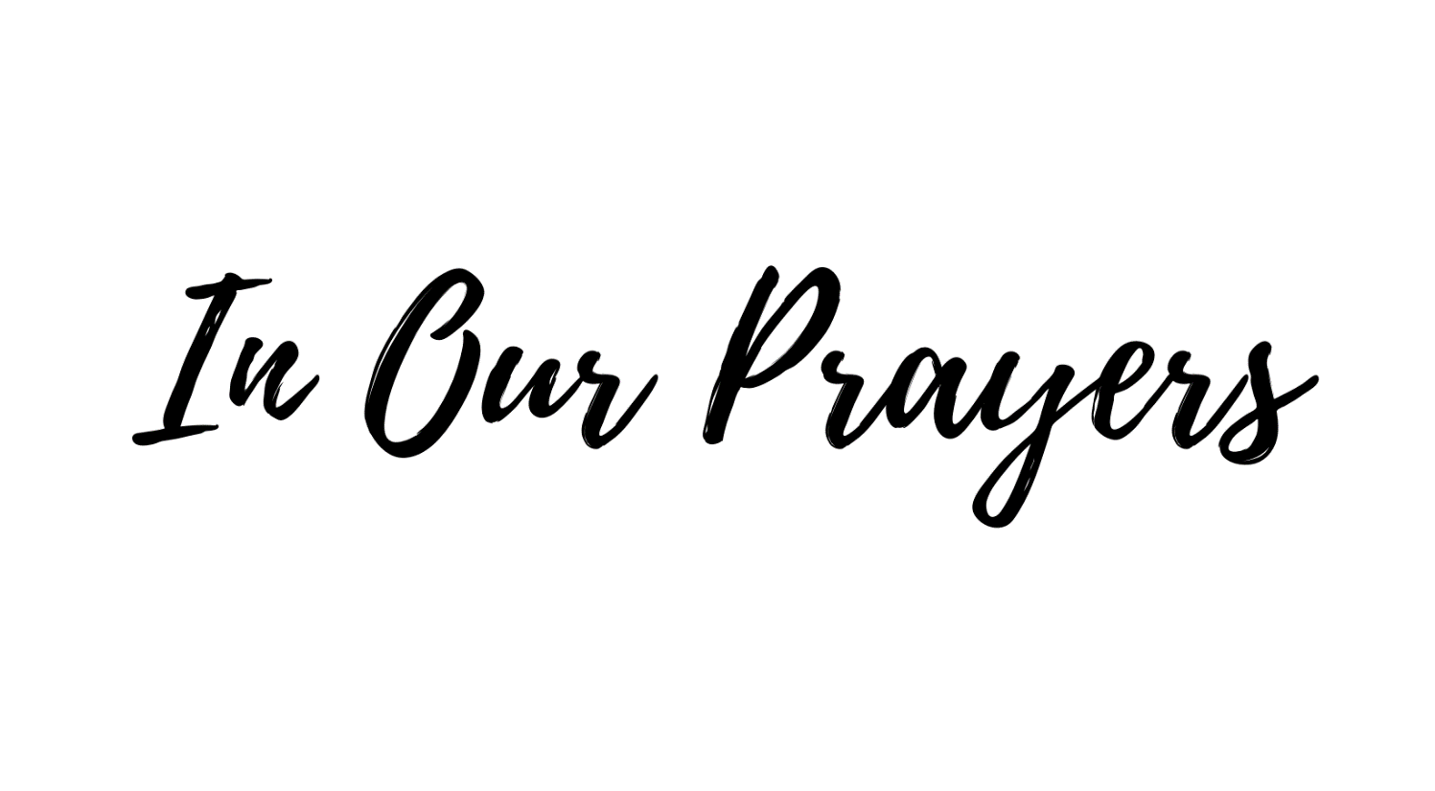
Joe Beck, Susan Beers, Gloria Carter, Billy Clark, Linda Day, Marilyn Doughty,
Elaine Evans, Diane Forrest, William Grygar, Kate Hien, Rebecca Hirschler,
Katie Hughes, Sharon Jones, Bryan Knight, Sally Miller, Phoebe Montagna,
Alessandra Myers, Shana Paul, Sydney Rudolph, Linda Sawyer, Diane Shepheard,
Doug Thompson, Courtney Wheeler, and Margaret Wynn.

We pray for Sean our Presiding Bishop, Susan our Bishop, and Katherine,
our Worship Leader.

We pray for the people of Ascension, that formed by our Baptismal promises
we might embody God’s community of Shalom in the world.

We give thanks for the blessings of this life.

We give thanks for the birthdays of Michael Jones (5/31) and Genevieve Clark (6/2),

We give thanks for the anniversary of Max & Emily Dale (6/6).

We give thanks for our Food Pantry volunteers.

The Ascension Discernment Prayer
O God of wisdom and guidance,
We ask that you lead our parish in this season of discernment.
Bless our Search Committee with clarity,
Bless our Vestry with faithfulness,
And bless our whole congregation with patience and hope.
May the Holy Spirit guide and instill in the people of Ascension
a glorious vision of the future.
And finally, we ask that You prepare the priest You are calling
to join us,
and prepare us to welcome them and serve together in your name.
Through Jesus Christ our Lord. Amen.


Chanco Chatter
Chanco on the James: 2026 Summer Camp Registration Now Open!
Summer is almost here, and Camp Chanco is ready for another unforgettable season on the James. For more than 50 years, Chanco has offered a fun, faith-centered camp experience for youth ages 8–16. From zip lines and high ropes to sailing, archery, arts and crafts, and outdoor adventures, every day is filled with opportunities to try something new. Campers build confidence, form lasting friendships, explore God’s creation, and grow in Christian community — all in a safe and welcoming environment. To register, visit https://chanco.org/camps/camp-info/

Creation Care
Thanks for participating in our trial recycling program! You can mix all your items together in your collection box. Drop off your items during office hours at DIOSOVA 11832 Rock Landing Drive Suite 100, Newport News (M-F 9-3) or Church of the Ascension 405 Talbot Hall Road, Norfolk (M-Th 9am-12pm). Ascension will also have a small outdoor collection box in their outdoor breezeway beginning April 2026. You can also mail your box to:
Attn: Creation Care Team, 405 Talbot Hall Road, Norfolk, VA 23505.

THE FOLLOWING ITEMS CAN BE RECYCLED
• BEAUTY PRODUCTS AND PACKAGING - Empty Cosmetic, Hair & Skin Care Packaging including Aluminized Tubes, Cosmetic Cases & Sticks, Plastic Packaging Unacceptable Items: Aerosol & Pressurized Cans, Cardboard, Electronic Items, Nail Polish Bottles & Removers, Partially Full & Full Packaging, Perfume Bottles, Wood & Bamboo, Wooden Eyeliner Pencils
• PENS, PENCILS & MARKERS - Pens, Pencils (non-wood), Highlighters, Markers & Caps, Mechanical Pencils, Pen & Pen Caps, Permanent Markers & Caps. Unacceptable Items: Paint Brushes, Wooden Pencils
• BOTTLE CAPS – Metal & Plastic Drink Bottle Caps Unacceptable Items: Bottles, Packaging, Liquids
• WATER FILTERS - Any Brand & Any Size Water Filters Unacceptable Items: Air Filters, Oil Filters
• CONTACT LENSES & PACKAGING - Contact Lenses, Plastic Film, Pods, And Cardboard Packaging Unacceptable Items: Contact Lens Solution, Bottles
• ORAL CARE WASTE & PACKAGING - Floss Containers, Toothbrush & Toothpaste Outer Packaging, Toothbrushes, Toothpaste Tubes & Caps Unacceptable Items: Floss, Other Oral Waste Care Items
• COFFEE BAGS – Empty Coffee Bags Unacceptable Items: Capsules, Coffee Grounds, Discs, Filters, Coffee Electronics, Other Coffee Packaging
• CORKS – Synthetic Beverage Corks Unacceptable Items: Natural Corks, Aluminum Champagne Twists, Bottle Caps, Bottles, Foil, Screw Tops
• STRAWS – Any Size Plastic Straws Unacceptable Items: Paper Straws, Biodegradable Straws
• DISPOSABLE CUPS & LIDS – Paper Coated Cups, Plastic Cups, Plastic Lids Disposable Cups
& Lids that have been rinsed and dried Unacceptable Items: Biodegradable Plastic Cups & Lids, Juice Boxes & Pouches. Other Rigid Plastic Containers
• GLUE STICKS & BOTTLES – Empty Craft Glue Stick Containers & Empty Glue Bottles
Unacceptable Items: Industrial Adhesive Containers

Questions – contact Canon Lynn Farlin at 757-676-6188 or lfarlin@diosova.org



Outreach, Collections, & Opportunities:
Catholic Worker Needs: As the rainy season comes to an end and warmer summer temperatures begin to arrive, there is an increased need for seasonal items to help everyone stay comfortable and prepared. Currently, we are especially in need of t-shirts, Gatorade, and white crew socks with full tops rather than low-cut tennis-style socks. These items would be greatly appreciated and will help meet the needs of those we serve during the summer months. Thank you so much for your kindness and support!

Sunday Seeds



Below are just a few of the ways Ascension is serving our community:
- Each month, members of our church family lovingly prepare 100 sandwiches, which are delivered to Catholic Family Worker for distribution to those experiencing homelessness.
- June is National Gun Violence Prevention Month, with various themes to prevent this violence. On Sunday June 7th, there will be a table in the Narthex with information on how we can make a difference. Please consider wearing something orange to signify your solidarity with this effort and to do your part in helping to make a difference in the lives of our children, families, and friends.

Please watch for upcoming volunteer opportunities—we welcome your participation and support!

Reminder: The deadline for announcements is Tuesday at 5pm. Announcements received after that time may not make it into the bulletin or the emailed announcements.
Weekly Studies:
Tuesday Centering Prayer meets at 7:45am on Tuesdays on Zoom for one hour. The meeting opens at 7:30 for chatting, then at 7:45 we proceed with the reading of a psalm, 20 minutes of silent prayer/meditation followed by a discussion of the reading. The group is currently reading After the Apple: Women in the Bible - Timeless Stories of Love, Lust, and Longing by Naomi Harris Rosenblatt. We are a diverse group with members joining from three countries and various religious backgrounds. You are invited to join us at any time. To get on the Zoom invite list, please contact Anji Harris (anjiharris54@gmail.com) or Sally Miller (757-489-5293) or samiller903@yahoo.com).

Re-Imagining Church meets on Thursdays at 12pm. The meeting serves as a time of spiritual reflection and planning as we listen for and try to follow God’s call to Ascension. Please join us; your perspective may be how God is informing us of what we should be doing next.

Join Zoom Meeting:
https://us02web.zoom.us/j/88559209322?pwd=BubDI0FA8IXIwwryikkt4Jito7gq0r.1

Meeting ID: 885 5920 9322 Passcode: 346720

Thursday Mid-Morning Seekers’ Bible Study will watch a video, read scripture passages, and discuss the questions together. I recommend joining the meeting early in case you have any issues getting connected. I hope to see everyone on Thursday at 10:00 am! If you are not on the email group or have trouble accessing the Zoom, please contact Susan Meredith at merbec@cox.net or 757-617-1959.

Meeting ID: 832 5615 4914 Passcode: 614216

A Look at the Week Ahead:

Tuesday
7:30 am Centering Prayer – Zoom
10:00 am Food Pantry – Pantry
11:30 am Buildings & Grounds – Rose Hall

Thursday
10:00 am Food Pantry – Pantry
10:00 am Mid-Morning Seekers’ Bible Study – Zoom
12:00 pm Re-Imagining Church – Zoom

Sunday
9:00 am Breakfast with Jesus – Hall for Coffee Then Lounge
(Nursery from 9-11am)
10:00 am Holy Eucharist Rite II – Sanctuary

OUR VISION IS
Honoring the Past
Looking Forward in Hope
Be the Face of Healing
Susan Meredith* | 2024-2026 | merbec@cox.net | 757.617.1959
Anji Harris+ | 2023-2026 | Anjiharris54@gmail.com | 757.831.3474
Pat Duncan | 2023-2026 | Patlduncan2020@gmail.com | 478.777.0904
Karen Newbern^ | 2024-2027 | newby0325@gmail.com | 757.685.6935
Luke Suber | 2024-2027 | lukesuber@yahoo.com | 361.779.7216
Carol Evans | 2024-2027 | cevans1017@gmail.com | 757.335.1774
Robin Kruger | 2025-2028 | Rekruger54@gmail.com | 757.470.9882
Healing is the Core Value
Your Vestry is here to serve you!

*Senior Warden +Junior Warden ^Register

Clergy
Bishop The Right Reverend Susan Haynes
Worship Leader Katherine Lawrence

Guest Pianist Karla Stead

All music is used with permission under One License A-701614 and CCLI 2009175

