Northern Arizona Academy 2021-2022 School Calendar
August 5: Teachers and Administrative Staff Report, In-Service
August 6, 2021: All staff orientation
August 9: SIS Training
August 11, 2021: 1st Day of School

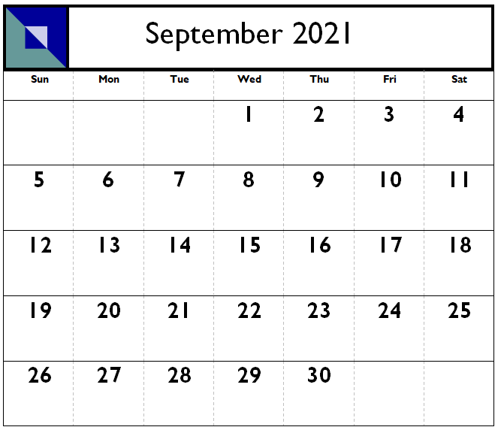  September 3: CPI Training All Staff  September 6: Labor Day-No School (Staff and Students)  September 17: Open Campus | 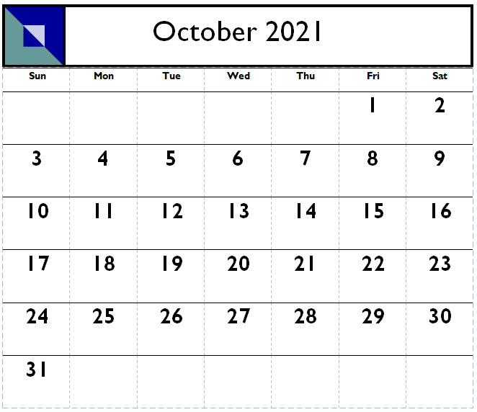  October 6: 40th day  October 25-29: NWEA Testing All students
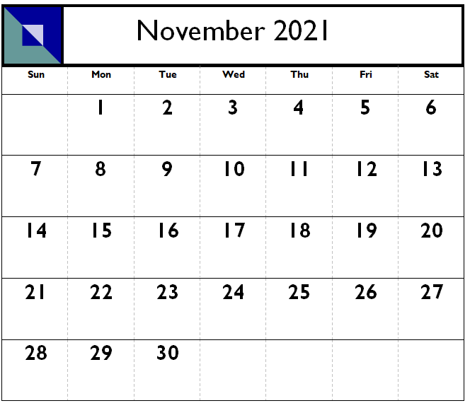  Nov 1 – 5: Finals Week  November 5: Trimester 1 Ends  November 8: Trimester 2 Begins  November 11: Veteran’s Day-No School (Staff and Students)  November 12: No School (No Students, Staff Workday)  November 24-26: Thanksgiving Break-No School (Staff and Students) | 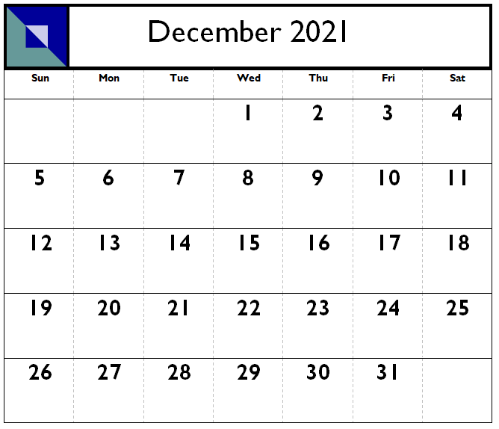  December 17: Open Campus/Holiday Meal  December 20-31: Winter Break -No School (Staff and Students)
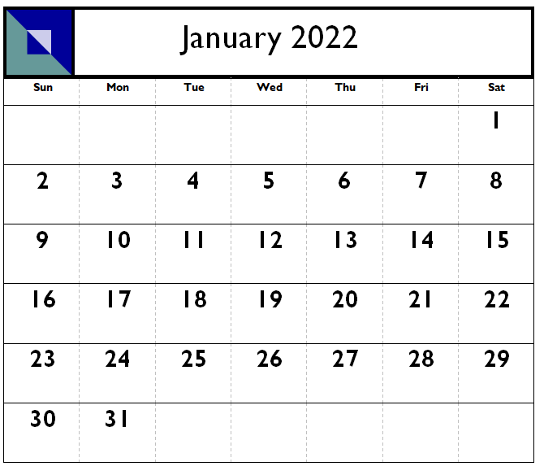  January 3: School Resumes  January 17: Civil Rights Day-No School (Staff and Students)  January 20: 100th day | 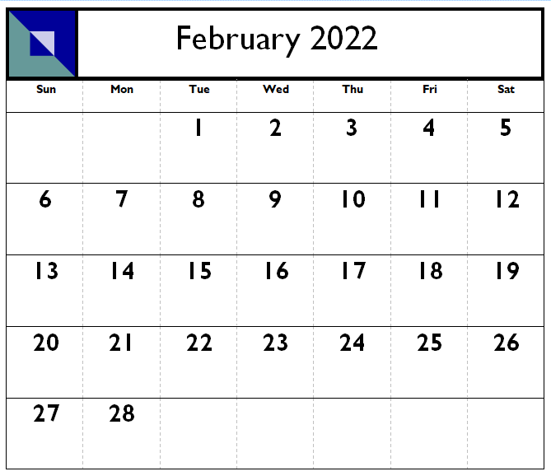  February 14-17: NWEA Testing  February 18: No School (No Students, Staff Workday)  February 21: President’s Day-No School (Staff and Students)  February 22-25: Finals Week  February 25: Trimester 2 Ends / Title 1 Annual Meeting  February 28: Trimester 3 Begins
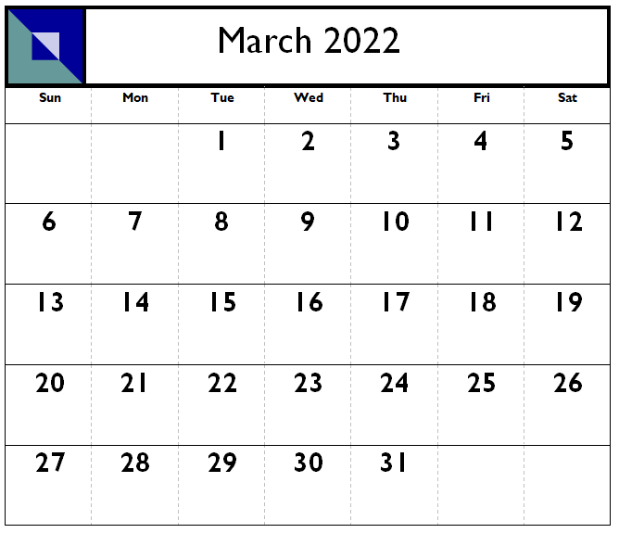  March 14-18: Spring Break | 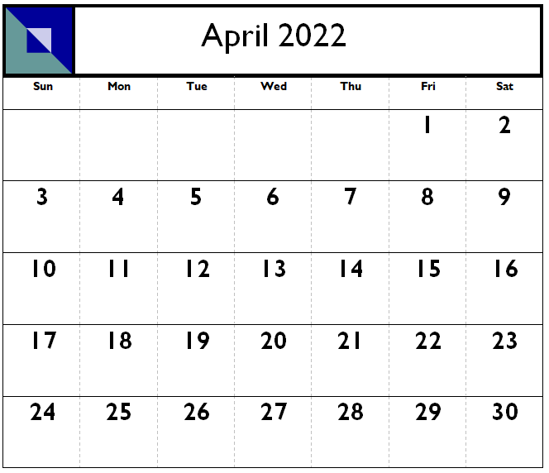  April 2022: AZ Merit Window  April 8: Snow Rebate Day (No Students, Staff Workday)  April 15: Open Campus
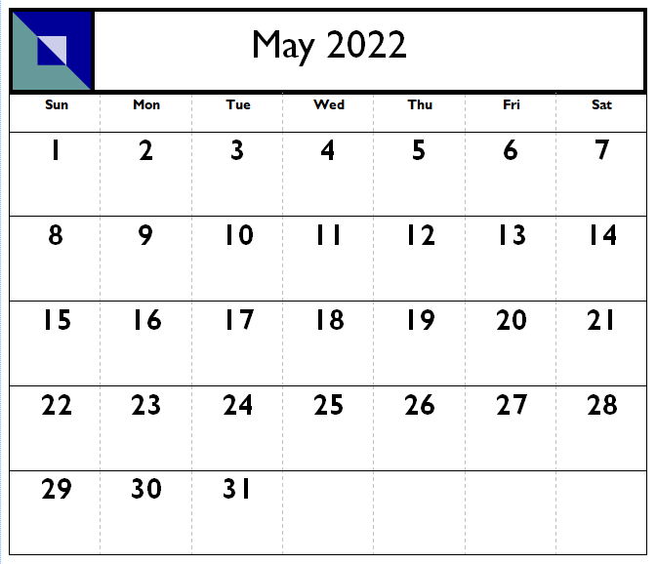  May 9-12: NWEA Testing  May 13: Snow Rebate Day (No Students, Staff Workday)  May 18-25: Finals Week  May 25: Student's Last Day  May 26: Graduation  May 27: Teacher’s Last Day | 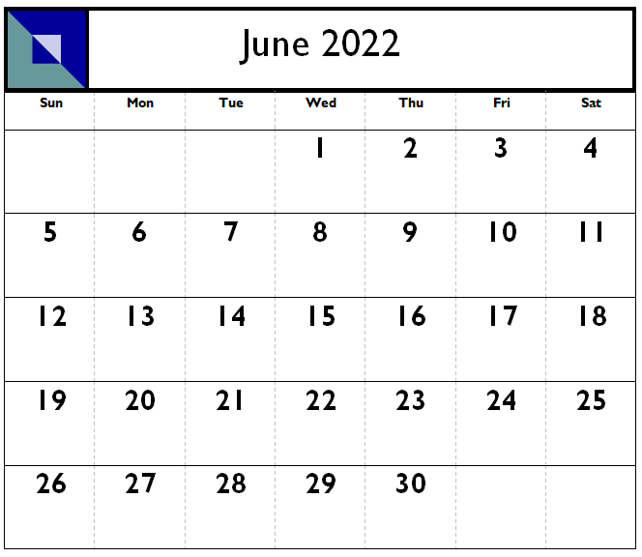  June 1: Admin Support Staff Last Day  Administrative Support Staff Summer Workdays: June 8, 15, 22 and 29

