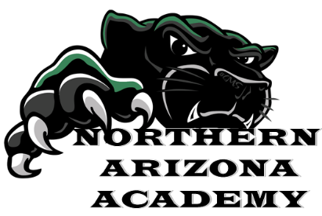
SUMMER SCHOOL 2026
Dates:
- Session 1: June 8th – June 25th
- Session 2: July 6th – July 23th
Days/Times: Monday through Thursday 9am to 1pm.
REMEMBER: Summer school is ALWAYS free for NAA students
If you would like to attend Summer School, please fill out the form below and submit it to Josh.
Name _____________________________________________
Which session would you like to attend?
□ Session 1 □ Session 2 □ Both Sessions □ Remote
What type of classes are you interested in taking?
□ Credit Recovery □ Electives
Name of Class: ______________________________________
Will you need transportation to and from school?
□ Yes, from home to school only □ Yes, from school to home only
□ Both to and from school
Major Cross Streets: ____________________________________________________
Questions? Speak with Lydia at 928-536-4222 or lhumphries@naacharter.org

