CAREER DEVELOPMENT, INC. EXECUTIVE BOARD
BOARD NOTICE AND AGENDA
REGULAR MEETING

Wednesday, December 14, 2022
5:00 p.m.
1300 Centennial Drive, Taylor AZ 85939
PASS Room

Join the meeting on Zoom

Topic: December 2022 Board Meeting
Time: Dec 14, 2022 05:00 PM Arizona

Board Members Present: Julia Shepherd, Vice President; Brandi Barnes; Lorie Jean Haymore. Jason Sellers Board Secretary (Via Zoom)

Board Members Absent: Yevette Tenney

Staff Present: Amy Carlyle, Donna Spires, Recording Secretary Lydia Humphries

1. Call to Order: By Julia Shepherd at 5:02 pm
2. Roll Call: Julia Shepherd (virtual), Brandi Barnes, Lori Jean Haymore, Amy Carlyle,
Donna Spires, Absent Yevette Tenney

3. Welcome and Introductions : No new introductions needed, all welcomed.

4. Pledge of Allegiance led by Lori Jean Haymore
5. Reading of Vision: :led by Julia Shepherd

Northern Arizona Academy may guide students in developing the social and academic skills necessary to achieve their goals and lead successful, fulfilling lives as citizens of the world.

6. Adoption of Agenda
Motion by Jason Sellers to adopt the agenda as written. Second by Lori Jean Haymore. . Final Resolution: Motion passed unanimously with the yea votes Yea: Julia Shepherd, Lorie Jean Haymore, Brandi Barnes and Jason Sellers. Nay: None. Abstain: None

7. Consent Agenda

The Board may approve or disapprove all Consent Agenda items in a single vote. However, any matter on the Consent Agenda may be removed from the Consent Agenda and discussed as a regular agenda item upon the request of any Board member.

A. Payroll Reports
B. Accounts Payable Reports
C. Vacation Liabilities
D. Payroll Action Forms
E. Board Meeting Minutes
F. Monthly Financial Reports

Motion by Brandi Barnes to adopt the consent agenda as written. Seconded by Jason Sellers. Final Resolution: Motion passed unanimously with the yea votes Yea: Julia Shepherd, Lorie Jean Haymore, Brandi Barnes and Jason Sellers. Nay: None. Abstain: None

8. Call to the Public

The public is invited to address the Board on any issue within its jurisdiction, subject to reasonable time, place and manner restrictions. Board members are not permitted to discuss or take legal action on matters raised during Call to the Public unless the matters are properly noticed for discussion and legal action. However, the law permits Board members to do the following at the conclusion of the Call to the Public: (a) Respond to criticism made by those who have addressed the Board; (b) Ask staff to review a matter; or (c) Ask that a matter be put on a future agenda.

Speakers must fill out a card listing name and topic and submit it to the Board Secretary prior to the time Call to the Public is heard. Speakers must make their comments in no more than three (3) minutes. If necessary to accommodate all speakers within the 30- minute overall limit, the Board President may shorten each speaker’s time.

No Public Present

9. Reports and Information Only Items

9.01 Campus Update: The Board will be presented with an update on the campus by Donna Spires. The Board may schedule action for a later meeting based on the documentation provided.

December 15th is the Kittles Field Trip, and ADE Campus Visit. December 16th is Open Campus and Holiday Meal. On January 6th, 2023 a live virtual tour of Auschwitz will take place.

23 students have been invited to Winter intersession to bring up grades. On January 13th, there will be a presentation by the Drug Coalition.

No school on Civil Rights Day.

A teacher put together an angel tree list and presents are being provided to students, and there will be 40 presents provided to students.

9.02 Non-Profit Update: The Board will be presented with an update on Non-Profit matters by Amy Carlyle. The Board may schedule action for a later meeting based on the
documentation provided.

A partnership with George Washington Academy for the National Food Bank has been initiated. Food will be brought to George Washington Academy for those who have signed up to receive food boxes. . This was spearheaded by Nichole Sellers.

The report has not yet been received from the National School Lunch Program audit.

There is a new 8th grade teacher starting on January 2nd, 2023.

An expulsion meeting will be schedule and held at the next board meeting

There were businesses contacted for estimates for paving. After seeing the campus, many of the businesses decided to donate labor and materials so that the cost would be at the grant level, 7500. Amy Carlyle reports that she has received word that the paving will take place around the pavilion. One of the business owners, will be also looking at the driveway. One business is donating $2500.00 worth of labor, and another is donating $1500.00 the asphalt materials.

10. Business: Discussion Topics

Voting shall not occur on discussion topics. The Board may identify items to be placed on future
agendas during the discussion or request a staff member research a matter.

10.1 Capital Improvements: The Board may discuss ideas for ongoing capital improvements to the campus.

Discussion for capital improvements was initially about the kitchen, and potential need
for kitchen supplies for the Summer Food Program.

Shelving was discussed, and creating more spaces for storage was also discussed.
The catwalk was discussed as an area to potentially develop space for storage.

Fencing was also discussed.

10.2 Board Calendar: The Board may discuss upcoming Board events.

This Friday, December 16th is Open Campus and the holiday meal. This starts at noon, and goes until 4pm. Board members were invited to be present.

Board was invited to the Auschwitz live virtual tour, January 6th.

11. Business: Action Items
11.1 Board Award: The Board may discuss nominees and choose recipients of the Board Award.
Julia Shepherd suggested sending an award after paving has happened for the businesses providing the school with supplies and labor at a discounted rate and for their donations for paving.
Motion by Jason Sellers to make Service Contracting and Brimhall Cinders recipients of the Board Award. Seconded by Lori Jean Haymore. Final Resolution: Motion passed unanimously with the yea votes Yea: Julia Shepherd, Lorie Jean Haymore, Brandi Barnes and Jason Sellers. Nay: None. Abstain: None

11.2 Annual Audit Report: The Board may be presented with the final Annual Audit Report prepared by Lorenzo PLC. The Board may approve, approve with modifications, or deny approval of the Annual Audit Report

This audit was presented at the last meeting and nothing has changed since information was presented, and the Board has been given the opportunity to review the information.

Motion by Brandi Barnes to approve the annual audit report. Second by Lori Jean Haymore Final Resolution: Final Resolution: Motion passed unanimously with the yea votes Yea: Julia Shepherd, Lorie Jean Haymore, Brandi Barnes and Jason Sellers. Nay: None. Abstain: None

11.3 Deposit Verification: The Board may verify all deposits recorded by ADI in the deposit log to ensure recorded deposits are accurate for the first quarter of FY23. The Board may approve, approve with modifications or deny approval of the deposit log.

This is a new item. Part of the audit is to have the Board review the deposit log quarterly. Amy Carlyle explained that she verified each deposit, and the supporting documents. All deposits have been verified and reviewed by the Board.

Motion by Jason Sellers to verify all deposit logs are accurate. Second by Lori Jean Haymore. Final Resolution: Final Resolution: Motion passed unanimously with the yea votes Yea: Julia Shepherd, Lorie Jean Haymore, Brandi Barnes and Jason Sellers. Nay: None. Abstain: None

11.4 Comprehensive Needs Assessment Leadership: The Board may provide input on the Comprehensive Needs Assessment by completing the Leadership section of the CNA. The Board may reach a consensus on the ranking in each area and submit it to the Executive Director for inclusion in the CNA. The Board may approve or deny approval of the Leadership section of the CNA.

Amy Carlyle explained the purpose of the Comprehensive Needs Assessment, and how it is connected to grants. At this time, the Board was given a few possible options of how to evaluate the CNA. The options were to fill it out together, or to fill it out separately and to temporarily table this. Amy Carlyle stated however that she can not wait until January for the individual results from the Board. She suggested that these be received from the Board by the end of the year, and that analysis of the completed items can be discussed at the next board meeting.

Julia Shepherd asked if the Board can commit to this, and the Board was receptive to this idea.

Motion by Jason Sellers to table the conversation about the Comprehensive Needs Analysis, to be continued after all board members have completed the survey, by the 31st of December. Second by Brandi Barnes Final Resolution: Final Resolution: Motion passed unanimously with the yea votes Yea: Julia Shepherd, Lorie Jean Haymore, Brandi Barnes and Jason Sellers. Nay: None. Abstain: None

11.5 Proposed Salary Schedule: The Board will review the proposed revision to the Salary Schedule, changes made due to the upcoming increase to minimum wage effective January 1, 2023.

Amy Carlyle provided the Board with the Proposed Salary Schedule. These changes were made due to the upcoming increase to minimum wage effective January 1st. Amy Carlyle explained that she increased every salary by a dollar, to a dollar and five cents. To come to this, she calculated the hourly rate for each position and added a dollar an hour to each salary and hourly wage.

For additional information for the future, Amy Carlyle looked at average salaries for a superintendent and a principal. Then, she looked at the cost of living differential between Maricopa and Navajo. This resulted in an 85% discrepancy. She then calculated a starting wage at 80% of the average wage. This gives 114,000 to an executive director and 76,400 to a principal. This explanation was offered as food for thought, and for future understanding of projected salaries if a new Executive Director or Campus Manager are hired.

Motion by Brandi Barnes to accept the proposed salary schedule. Second by Lori Jean Haymore. Final Resolution: Motion passed unanimously with the yea votes Yea: Julia Shepherd, Lorie Jean Haymore, Brandi Barnes and Jason Sellers. Nay: None. Abstain: None

12. Future Meeting Dates and Items for Future Agendas

The Board may discuss future dates for meetings and direct staff to place matters on future Board meeting agendas.

Julia Shepherd would like to create a selection criterion, or system or matrix for finding people to fill the positions that will take place. Julia Shepherd volunteered to work on creating such guidelines.

Expulsion hearing.

Future pay for executive director and Campus manager.

NSLP Audit.

13. Board Signatures

Board members may be provided items requiring Board signature.

14. Adjournment

Motion by Jason Sellers to adjourn. Second by Lori Jean Haymore Final Final Resolution: Motion passed unanimously with the yea votes Yea: Julia Shepherd, Lorie Jean Haymore, Brandi Barnes and Jason Sellers. Nay: None. Abstain: None

Meeting adjourned at 6:10 pm on December 14th, 2022.

Reviewed, approved and signed by Jason Sellers, Board Secretary on 19th December 2022.
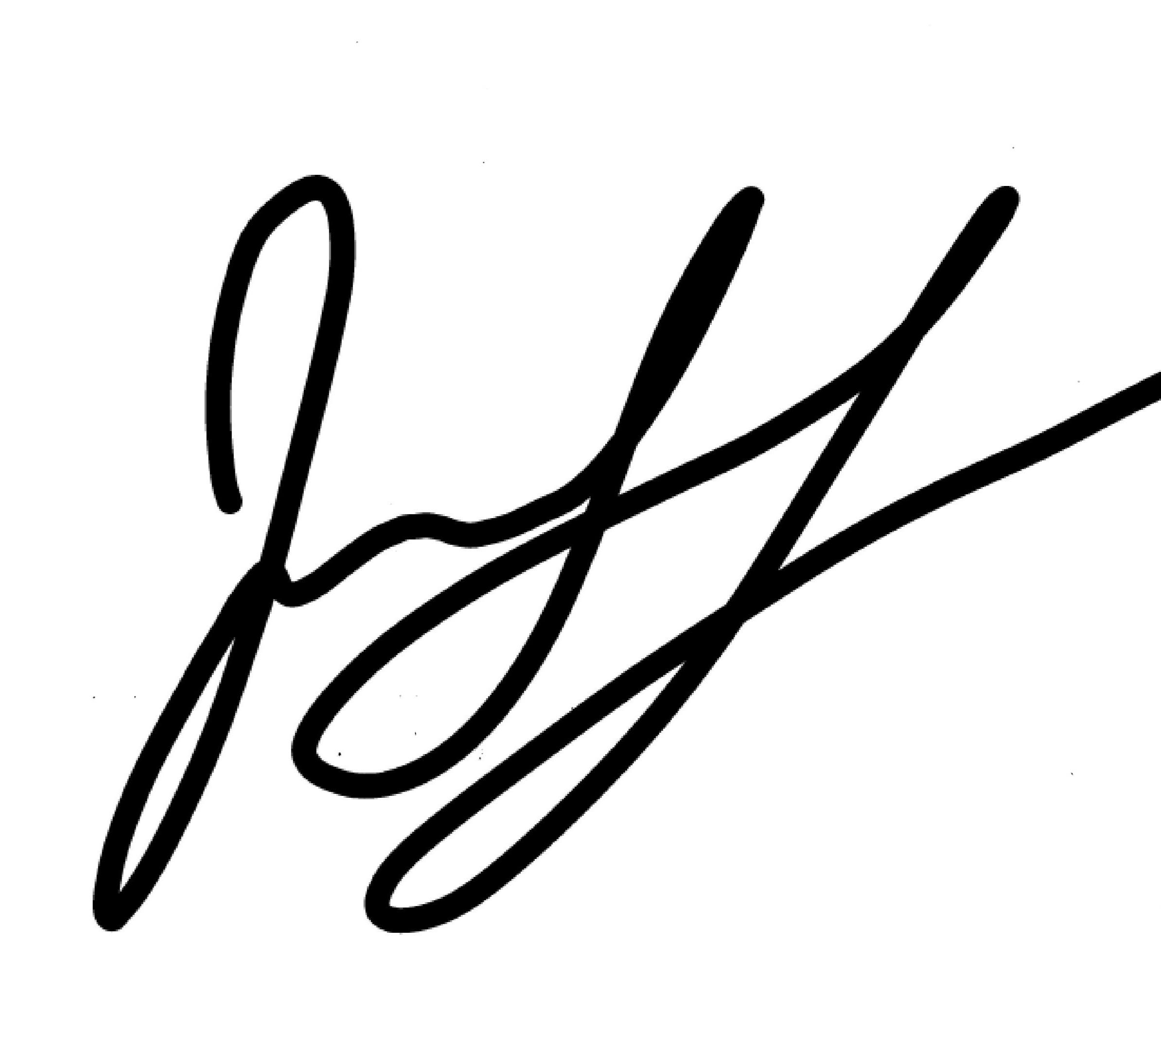

Posted this___________ day of _____________, 2022 by________________________

