CAREER DEVELOPMENT, INC. EXECUTIVE BOARD

BOARD MINUTES

REGULAR MEETING

Wednesday, November 9, 2022

5:00 p.m.

1300 Centennial Drive, Taylor AZ 85939

PASS Room

Meeting on Zoom

Topic: November Board Meeting

Time: Nov 9, 2022 05:00 PM Arizona

**Board Members Present:** Yevet Tenney, President; Julia Shepherd, Vice President; and Lorie Jean Haymore. Jason Sellers Board Secretary (arrived at 5:06 pm)

**Board Members Absent:** Brandi Barnes, Jason Sellers Board Secretary (arrived at 5:06 pm)

**Staff Present:** Amy Carlyle, Donna Spires, Christina Allen, Recording Secretary Lydia Humphries

**1. Call to Order** : Yevet Tenney called a meeting to order at 5:01 pm on November 9th, 2022.

**2. Roll Call :** Lori Jean Haymore, Julia Shepherd, Amy Carlyle, Yevet Tenney. Brandi Barnes absent. Jason Sellers arrived at 5:06 pm

**3. Welcome and Introductions :** No new introductions needed, all welcomed.

**4. Pledge of Allegiance** : lead by Amy Carlyle

**5. Reading of Vision** : Read by Lori Jean Haymore

Northern Arizona Academy may guide students in developing the social and academic skills necessary to achieve their goals and lead successful, fulfilling lives as citizens of the world.

**6. Adoption of Agenda**

Motion by Lori Jean Haymore to adopt the agenda as written. Second byJulia Shepherd. Final Resolution: Motion passed unanimously with the yea votes Yea:Yevet Tenney, Julia Shepherd, Lorie Jean Haymore. Nay: None. Abstain: None

**7. Consent Agenda**

The Board may approve or disapprove all Consent Agenda items in a single vote. However, any matter on the Consent Agenda may be removed from the Consent Agenda and discussed as a regular agenda item upon the request of any Board member.

A. Payroll Reports

B. Accounts Payable Reports

C. Vacation Liabilities

D. Payroll Action Forms

E. Board Meeting Minutes

Motion by Julia Shepherd to adopt the consent agenda as written. Second by Lori Jean Haymore. Final Resolution: Motion passed unanimously with the yea votes Yea:Yevet Tenney, Julia Shepherd, Lorie Jean Haymore. Nay: None. Abstain: None

**8. Call to the Public**

The public is invited to address the Board on any issue within its jurisdiction, subject to reasonable time, place and manner restrictions. Board members are not permitted to discuss or take legal action on matters raised during Call to the Public unless the matters are properly noticed for discussion and legal action. However, the law permits Board members to do the following at the conclusion of the Call to the Public: (a) Respond to criticism made by those who have addressed the Board; (b) Ask staff to review a matter; or (c) Ask that a matter be put on a future agenda.

Speakers must fill out a card listing name and topic and submit it to the Board Secretary prior to the time Call to the Public is heard. Speakers must make their comments in no more than three (3) minutes. If necessary to accommodate all speakers within the 30- minute overall limit, the Board President may shorten each speaker’s time.

No public present.

**9. Reports and Information Only Items**

9.01 Campus Update: The Board will be presented with an update on the campus by Donna Spires. The Board may schedule action for a later meeting based on the documentation provided.

There are currently 59 high school students, 5 students are remote. There are 10 8th grade students. The new Trimester started on Monday the 7th of November. There is a new hire with extensive experience who has been hired and will start Monday the 14th. November 10th is the Trimester 1 awards breakfast.

Donna Spires stated that she has been working with a lot of data about behavior, and credit. There are more referrals, but Donna spires asserts that this is more likely due to the age of new students.

34 students earned 2.5 credits. 10 students earned 2 credits. 2 students earned two credits, 4 students received no credits due to attendance, and are now on intensive attendance contracts. This data initially looks really promising.

Amy Carlyle explained that students must earn 4.5 class credits if they have been enrolled for 80 days, and that this is one of the factors that impacts the school letter grades.

9.02 Non-Profit Update: The Board will be presented with an update on Non-Profit matters by Amy Carlyle. The Board may schedule action for a later meeting based on the documentation provided.

Amy Carlyle started by sharing that the school has been given a letter grade rating of an “A” from the Arizona department of education, which is number 5 out of about 120 alternative schools in Arizona. Amy Carlyle explained the factors that impact this grade.

Amy Carlyle reported to the Board the outcome of the Average Daily Membership audit from 2019, 2020, and 2021. Amy Carlyle shared that the auditors determined that the school incorrectly reported the enrollment data of 24 students, which resulted in its ADM (average daily membership) being overstated by .94. As a result, the school was overfunded by $5,655.85 , which the school must repay to ADE (Arizona Department of Education). Additionally, auditors determined that the school failed to properly maintain some required documentation in student cumulative files.

Amy Carlyle stated that these errors are almost entirely from Independent Study and Learning Lab classes. Amy Carlyle explained that this was a tracking issue of students taking independent classes, or learning lab classes. At this time, stated Amy Carlyle the procedures have been changed so that all students receive a grade for these classes with documentation every trimester. Students who receive NC or a “No Credit” status or an “F” do not complete that course.

The NSLP (National School Lunch Program) Audit has also been completed, however Amy Caryle has not yet received the final outcome. She shared the notes that she had in discussion during the audit. Most mistakes were on the production records, which was due to a change in staff. The production record issue was related to vegetables, which has now been corrected and has not been an issue on previous audits.Labels that are attached to processed meats need to be included. This differs from the nutrition label. Lastly, over the summer food program, there was no non discriminatory clause in advertising. This has also been addressed.

Amy Carlyle explained that the Yearly Audit is broken into two parts.

Legal Compliance portion: No Errors. Everything that was intended to be retained was retained. Everything was met.

Fiscal Compliance portion :The auditor reviews all fiscal activities. The auditor stated that all numbers look really good. There were a few issues. The first issue was in a deposit being counted twice by accountants. This resulted in an overstatement of 20,000 dollars. The second issue was that assets were overstated. The corrective action plan addresses this. It states that twice per year at the January and June Board meetings the Board will review accounts to prevent this issue.

There must be a meeting scheduled within 30 days of the auditor filing the audit. This means the Board will likely have to meet before the next Board meeting to approve the audit review.

Executive Director Applicants: Lydia Humphries withdrew to take on more of a role with Special Education, resume has been provided from Christina Allen.

Parking lot grant: need to obtain 3 quotes from differing providers.

The Rise Grant is the next grant that will be applied for. This can be used to grow the food assistance for equipment and facilities. Amy Carlyle asked the Board to consider what they would like to see the grant fulfill.

10. Business: Discussion Topics

Voting shall not occur on discussion topics. The Board may identify items to be placed on future agendas during the discussion or request a staff member research a matter.

10.1 Capital Improvements: The Board may discuss ideas for ongoing capital improvements to the campus.

Yevet Tenney opened the conversation by reviewing the things that have been previously discussed as capital improvements. The Rise grant was mentioned, shelving for the catwalk was mentioned. No further discussion.

10.2 Board Calendar: The Board may discuss upcoming Board events. Tomorrow, 11/10/22 is the Trimester 1 awards breakfast, Jason Sellers will be in attendance. 11/30/22 The Board will provide something for teachers, as recognition of the “A” ranking. Breakfast was discussed.

11. Business: Action Items

11.1 Board Award: The Board may discuss nominees and choose recipients of the Board Award.

Yevet Tenney opened this conversation by asking for a nomination for the Board Award. Amy Carlyle nominated Melanie Moore, Donna Spires agreed that Melanie has done well and is deserving of the Board Award.

Motion by Julia Shepherd to award the Board Award to Melanie Moore for her service above and beyond to the school. Second by Lori Jean Haymore. Final Resolution: Motion passed unanimously with the yea votes Yea:Yevet Tenney, Jason Sellers, Julia Shepherd, Lorie Jean Haymore. Nay: None. Abstain: None

11.2 Safe Return to Learning Plan: The Board will be presented with the revised Safe Return to Learning Plan required by ADE. The Board may approve, approve with revisions or deny approval of the Safe Return to Learning Plan.

Amy Carlyle provided the Board with the revised, and original plan. The original part of the plan stated that students must be given and required to wear masks. On the revised plan, students are not required to wear masks, but masks are made available. Sanitation requirement has been reduced at this time. Amy Carlyle states that this plan is in effect until September of 2023.

Motion by Julia Shepherd to accept the return to learning plan required by the Arizona Department of Education. Second by Jason Sellers. Final Resolution: Motion passed unanimously with the yea votes Yea:Yevet Tenney, Jason Sellers, Julia Shepherd, Lorie Jean Haymore. Nay: None. Abstain: None

12. Future Meeting Dates and Items for Future Agendas

The Board may discuss future dates for meetings and direct staff to place matters on future Board meeting agendas.

The possibility of a meeting having to take place before the scheduled December meeting is contingent upon the fiscal audit being returned. The Board discussed any days that they would prefer not to meet. Friday was ruled out.

The Holiday meal will be discussed at a future meeting.

13. Board Signatures

Board members may be provided items requiring Board signature.

14. Adjournment

Motion to adjourn the meeting by Julia Shepherd. Second by Jason Sellers . Final Resolution: Motion passed unanimously with the yea votes Yea:Yevet Tenney, Jason Sellers, Julia Shepherd, Lorie Jean Haymore. Nay: None. Abstain: None

Meeting adjourned 5:59 pm on November 9th 2022

**Minutes reviewed and approved by Jason Sellers, Board Secretary on 14 November 2022.**

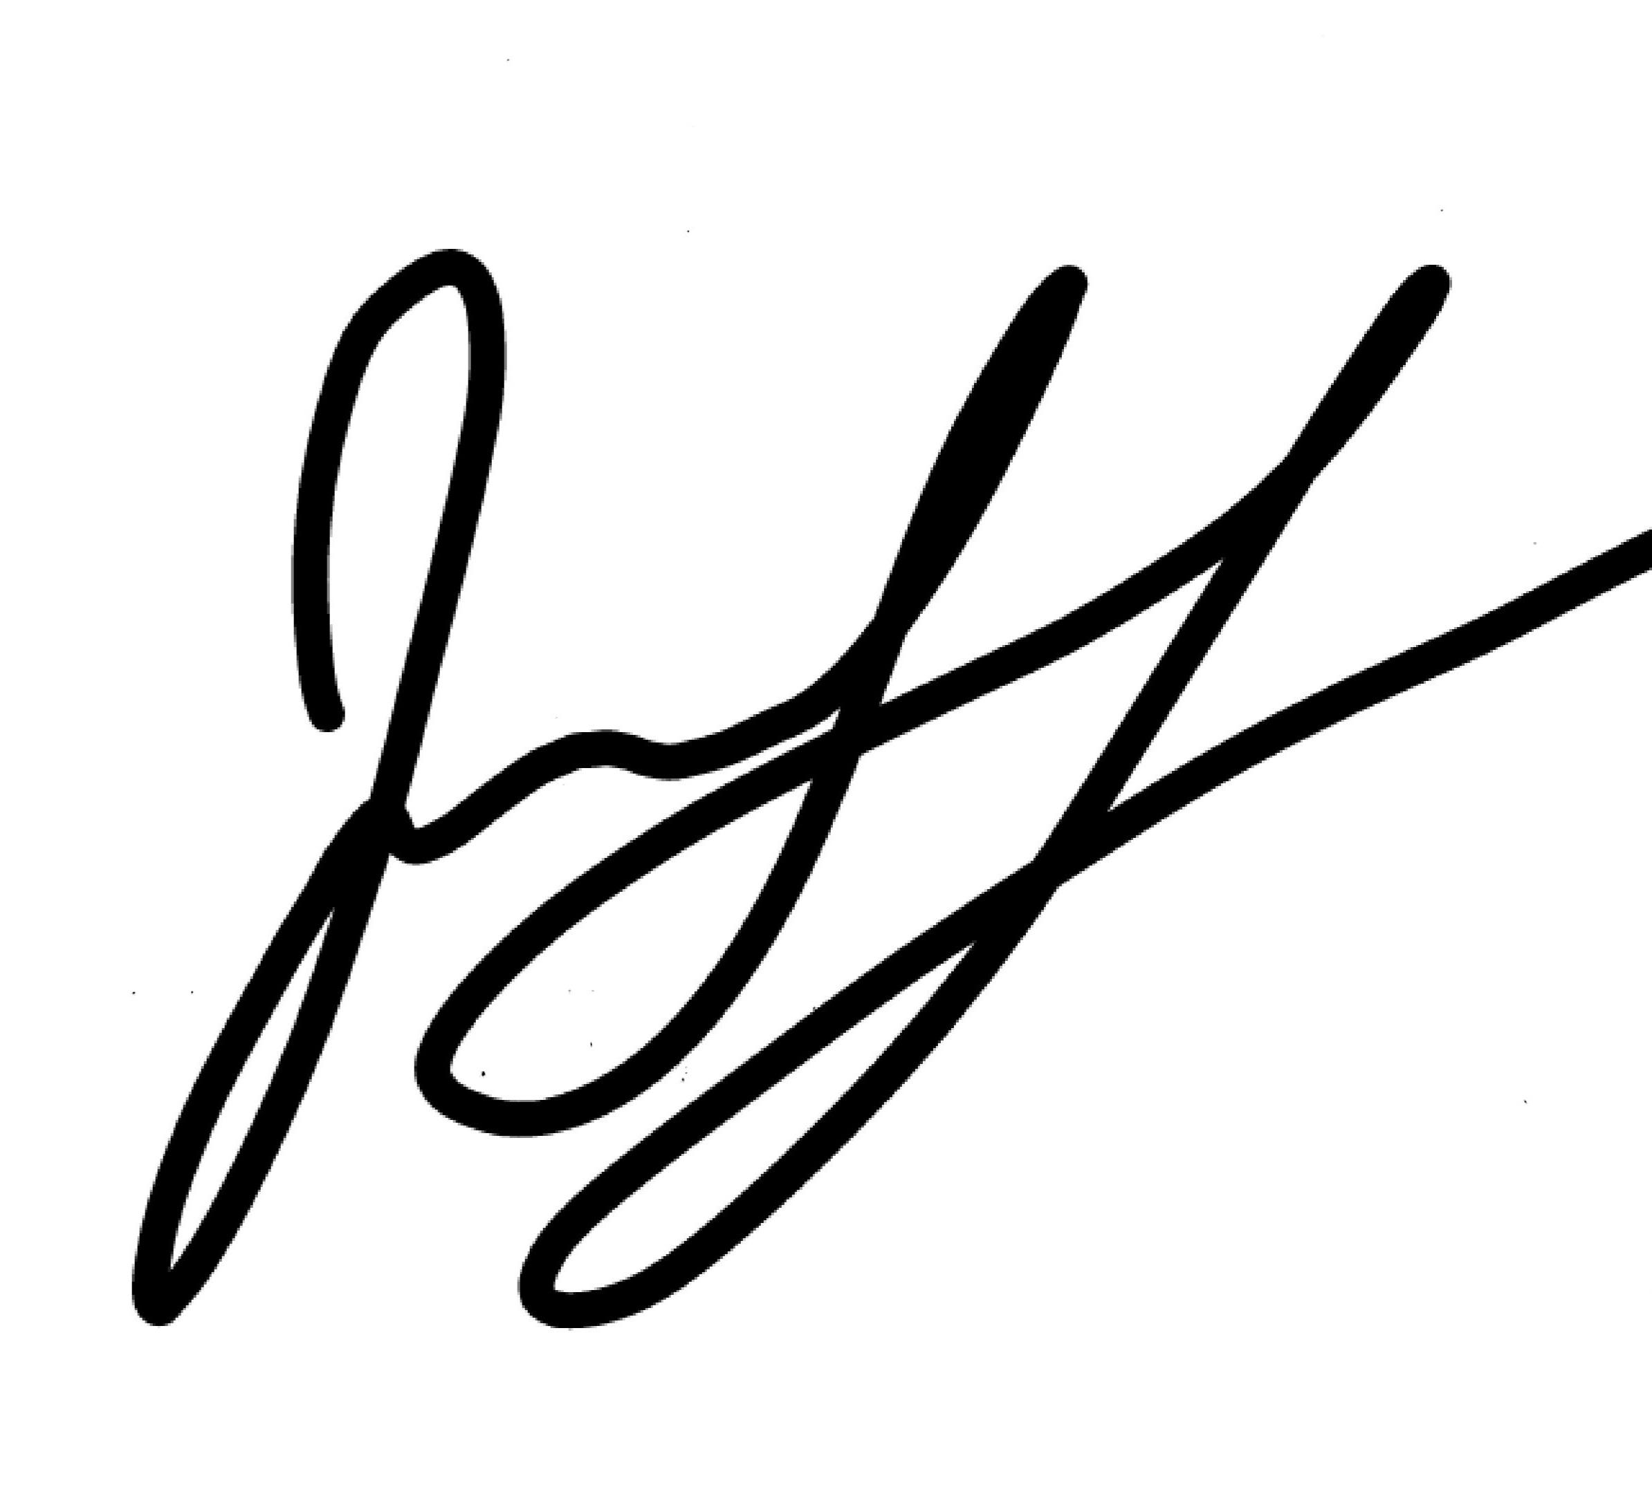

Posted this___________ day of _____________, 2022 by________________________