42 Risk Management Communications & Escalation Policy
1. Purpose
This policy establishes a clear, disciplined framework for how information is communicated and how issues are escalated within 42 Risk Management. It ensures that all internal and external communications are timely, accurate, and aligned with our commitment to proactive, intelligence-led risk management. It also protects clients, staff, and organisational integrity by defining structured escalation pathways.
2. Scope
This policy applies to:
- All 42 Risk Management employees, contractors, and deployed personnel
- All operational environments, including static sites, mobile deployments, events, and client premises
- All communication channels, including verbal, written, digital, and radio communications
3. Communication Principles
3.1 Clarity & Professionalism
All communication must be:
- Clear, concise, and free from jargon
- Fact-based and neutral in tone
- Appropriate to the audience (client, colleague, stakeholder, emergency services)
3.2 Confidentiality
Personnel must:
- Share information strictly on a need-to-know basis
- Protect client data, operational intelligence, and sensitive information
- Use approved communication channels only
3.3 Accuracy & Integrity
- Information must be verified before being shared
- Assumptions must be clearly identified as such
- Personnel must avoid speculation, exaggeration, or unverified claims
3.4 Timeliness
- Critical information must be communicated immediately
- Routine updates must follow established reporting schedules
- Delays or communication failures must be escalated
4. Communication Channels
4.1 Primary Channels
- Radio (where deployed)
- Secure messaging platforms approved by 42 Risk Management
- Email for formal communication
- Phone for urgent or time-sensitive matters
4.2 Prohibited Channels
- Personal messaging apps (unless explicitly authorised)
- Social media
- Unsecured devices or networks
5. Reporting Structure
5.1 Standard Reporting Line
- Frontline Operative / Officer
- Team Leader / Supervisor
- Operations Manager
- Managing Director (42 Risk Management)
5.2 Direct-to-Management Reporting
Personnel may bypass the chain of command if:
- There is an immediate threat to life
- A supervisor is implicated in misconduct
- A critical incident requires senior oversight
6. Escalation Framework
6.1 Escalation Levels
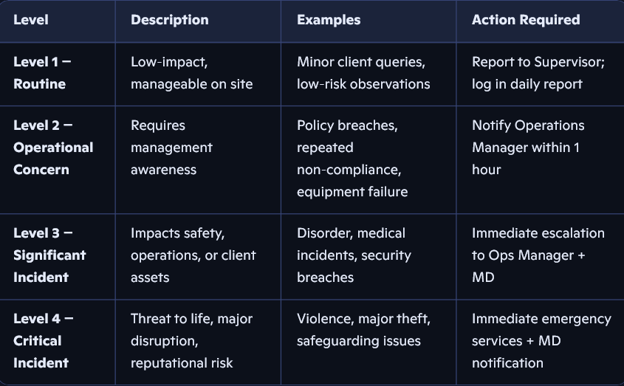
7. Escalation Triggers
Escalation is mandatory when any of the following occur:
7.1 Safety & Security
- Threats to life or serious injury
- Suspicious behaviour or credible intelligence
- Breach of access control or perimeter security
7.2 Operational Integrity
- Failure of critical equipment
- Staff misconduct or impairment
- Repeated procedural non-compliance
7.3 Client Impact
- Complaints or concerns requiring management intervention
- Reputational risk to the client or 42 Risk Management
- Any incident likely to attract media attention
8. Incident Communication Protocol
8.1 Immediate Actions
- Ensure safety of all persons
- Notify emergency services if required
- Inform Supervisor or Operations Manager
8.2 Information to Communicate
Use the AIM Model:
- Action taken
- Incident details (who, what, where, when)
- Mitigation in place
8.3 Documentation
All incidents must be:
- Logged in the incident reporting system
- Documented factually and chronologically
- Submitted within the required timeframe (usually within 1 hour for Levels 3–4)
9. Client Communications
9.1 Who May Communicate with Clients
- Managing Director
- Operations Manager
- Designated Client Liaison
Frontline staff must not provide operational opinions or commitments beyond their authority.
9.2 Client Updates
- Must be accurate, timely, and solution-focused
- Should avoid unnecessary operational detail
- Must align with 42 Risk Management’s professional standards
10. Media & External Communications
Personnel must not:
- Speak to the media
- Post about incidents on social media
- Share images, footage, or operational details
All external communications are handled exclusively by the Managing Director.
11. Breaches of This Policy
Failure to follow this policy may result in:
- Retraining
- Formal warnings
- Removal from deployment
- Contract termination (in serious cases)
12. Review Cycle
This policy is reviewed annually or following:
- A major incident
- Significant organisational change
- Client feedback or regulatory updates

