42 Risk Management Document Control & Record Keeping Policy
1. Purpose
This policy establishes the standards, responsibilities, and procedures for the creation, approval, distribution, storage, retention, and disposal of documents and records within 42 Risk Management. Its purpose is to ensure:
- Consistency and accuracy across all operational documentation
- Compliance with legal, regulatory, and contractual obligations
- Protection of sensitive, confidential, and client-related information
- Clear audit trails and accountability across the organisation
Document control is a core component of our commitment to operational excellence, risk mitigation, and premium service delivery.
2. Scope
This policy applies to:
- All employees, contractors, and representatives of 42 Risk Management
- All documents and records created, received, or maintained in the course of business
- All formats, including digital files, emails, physical documents, photographs, logs, reports, and client-facing materials
It covers operational, administrative, HR, compliance, training, and client-specific documentation.
3. Definitions
Document
A controlled piece of information that is subject to version control, approval, and periodic review (e.g., SOPs, policies, risk assessments, assignment instructions, onboarding packs).
Record
Evidence of activities performed or decisions made. Records are final, non-editable, and retained for a defined period (e.g., incident reports, training logs, attendance sheets, shift notes, audit trails).
Document Owner
The individual responsible for creating, updating, and maintaining a document.
Controlled Document
A document that is formally approved, versioned, and stored in the designated document management system.
4. Responsibilities
Managing Director
- Ensures organisational compliance with this policy
- Approves high-level governance documents
Operations Management
- Maintains operational documentation and ensures version control
- Conducts periodic reviews and ensures staff access to current documents
Document Owners
- Draft, update, and submit documents for approval
- Ensure accuracy, relevance, and alignment with company standards
All Staff
- Use only the latest approved versions of documents
- Report outdated, missing, or incorrect documentation
- Protect records in line with confidentiality and data protection requirements
5. Document Creation & Approval
5.1 Creation
All new documents must follow the 42 Risk Management formatting and branding standards, including:
- Clear title and purpose
- Unique document reference number
- Version number and date
- Author and approver details
5.2 Approval
Documents must be approved by the appropriate authority before use:
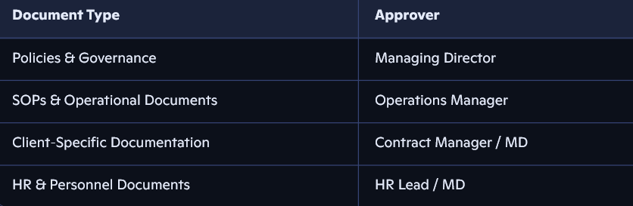
No document becomes active until formally approved.
6. Version Control
To maintain consistency and prevent the use of outdated information:
- All controlled documents must include a version number (e.g., v1.0, v1.1, v2.0)
- Changes must be logged in a revision history table
- Superseded versions must be archived and clearly marked as “obsolete”
- Only the current version may be used operationally
Minor edits (spelling, formatting) may be recorded as incremental versions.
Major changes require a new full version number and re-approval.
7. Document Distribution & Access
- Controlled documents are stored in the central Document Management System (DMS)
- Access is granted based on role and operational need
- Staff must not store local copies of controlled documents unless authorised
- Client-specific documents are shared securely and only with authorised individuals
Printed copies must be minimised and, where used, treated as uncontrolled unless stamped otherwise.
8. Record Keeping
8.1 Creation of Records
Records must be:
- Accurate, factual, and completed in a timely manner
- Signed or digitally authenticated where required
- Stored in the designated system or secure physical location
8.2 Retention
Records must be retained in accordance with legal, regulatory, and contractual requirements. As a baseline:
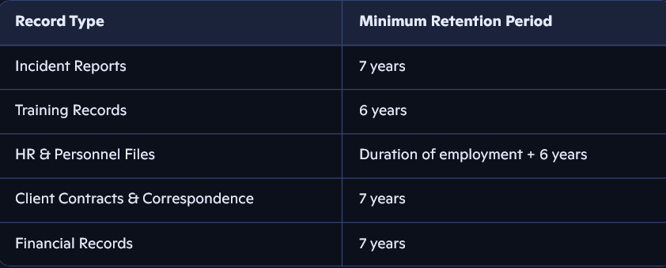
8.3 Disposal
When retention periods expire:
- Digital records must be securely deleted
- Physical records must be shredded or destroyed using approved methods
- Disposal must be logged to maintain audit trails
9. Confidentiality & Data Protection
All documents and records must be handled in accordance with:
- UK GDPR
- Data Protection Act 2018
- Client confidentiality agreements
- Internal data handling procedures
Sensitive information must only be accessed by authorised personnel and stored using encrypted or secure systems.
10. Auditing & Compliance
42 Risk Management will conduct periodic audits to ensure:
- Only current versions of documents are in circulation
- Records are complete, accurate, and properly stored
- Staff are following document control procedures
Non-compliance may result in corrective actions, retraining, or disciplinary measures.
11. Policy Review
This policy will be reviewed annually or sooner if:
- Legislation changes
- Operational requirements evolve
- Client or regulatory bodies require updates
The Managing Director is responsible for ensuring timely review.

