42 Risk Management – Information Security Policy
1. Purpose
This Information Security Policy establishes the principles, responsibilities, and controls that safeguard the confidentiality, integrity, and availability of information handled by 42 Risk Management. It ensures that all data—client, operational, and internal—is protected in line with legal, regulatory, and industry best-practice requirements.
2. Scope
This policy applies to:
- All employees, contractors, and representatives of 42 Risk Management
- All information assets owned, managed, or processed by the company
- All systems, devices, platforms, and communication channels used for business operations
- All third parties who access or process information on behalf of 42 Risk Management
3. Information Security Principles
3.1 Confidentiality
Information is accessible only to authorised individuals with a legitimate business need.
3.2 Integrity
Information is accurate, complete, and protected from unauthorised modification.
3.3 Availability
Information and systems are accessible when required to support operational and client needs.
4. Roles & Responsibilities
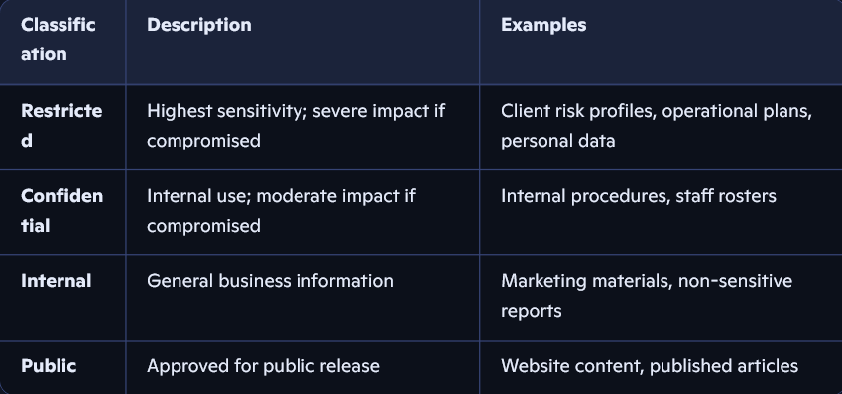
4.1 Senior Leadership
- Set strategic direction for information security
- Ensure adequate resources, training, and oversight
- Approve and review security policies annually
4.2 Information Security Lead
- Maintain and enforce this policy
- Conduct risk assessments and audits
- Manage incident response and reporting
- Oversee access control and data protection measures
4.3 All Personnel
- Follow all security procedures and training
- Report security incidents or suspicious activity immediately
- Protect company devices, accounts, and client information
4.4 Third Parties
- Must comply with this policy and any contractual security requirements
- Are subject to due-diligence checks and ongoing monitoring
5. Data Classification
42 Risk Management classifies information into four categories:
6. Access Control
- Access is granted on a least-privilege and role-based basis
- Multi-factor authentication (MFA) is required for all critical systems
- Access rights are reviewed quarterly and upon role changes
- Shared accounts are prohibited
7. Physical Security
- Devices must be secured when unattended
- Sensitive documents must be stored in locked cabinets or secure digital repositories
- Visitors must be escorted and logged when entering operational areas
- Company devices must not be left in vehicles or unsecured environments
8. Technology & Systems Security
8.1 Device Security
- All devices must use approved security software
- Automatic updates and patching must be enabled
- Encryption is mandatory for laptops, mobile devices, and removable media
8.2 Network Security
- Secure, encrypted connections must be used for remote access
- Public Wi-Fi requires VPN usage
- Firewalls and intrusion detection systems must be maintained
8.3 Email & Communication
- Sensitive information must be encrypted when transmitted
- Staff must be trained to identify phishing and social engineering attempts
- Only approved communication channels may be used for client or operational matters
9. Data Protection & Privacy
- Personal data is processed in accordance with UK GDPR and the Data Protection Act 2018
- Data minimisation principles apply to all collection and storage
- Retention schedules must be followed, and data securely disposed of when no longer required
10. Incident Reporting & Response
- All incidents must be reported immediately to the Information Security Lead
- Incidents will be logged, investigated, and resolved following the Incident Response Procedure
- Clients will be notified where required by law or contract
- Lessons learned will be incorporated into future controls
11. Training & Awareness
- All personnel must complete security induction training
- Annual refresher training is mandatory
- Additional training is provided for high-risk roles (e.g., operations, client management)
12. Third-Party Management
- Third parties must undergo security due diligence before engagement
- Contracts must include confidentiality and data protection clauses
- Access to systems or data is monitored and revoked when no longer required
13. Policy Compliance
- Compliance is mandatory for all personnel
- Violations may result in disciplinary action, contract termination, or legal consequences
- Regular audits will be conducted to ensure adherence
14. Policy Review
This policy is reviewed annually or following significant organisational, legal, or technological changes.

