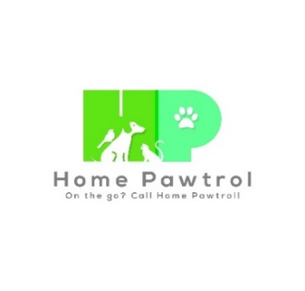
Email:laura@homepawtrol.com
Phone: (813) 505-6004
www.homepawtrol.com

Pet Guardian Information

Name: Date:
Address:
City: State: Zip:
email:
Home phone: Cell phone:
Work phone: Primary contact:

Emergency Contacts
Name: Phone:
Name: Phone:
Please list - any individuals who will have access to your home during the time we are caring for your pets (maid, relatives, friends):

Security System
Do you have an alarm system?
Location of control panel:
Instructions to set and turn off alarm:
Gate code (if applicable):

Vacation Contact Information
Vacation location name & address:

Phone numbers where we can reach you:

Pet Information

Pet Information:
Name: Type: DOB:
Breed: Color: Sex: Age: Weigh:
Health Issues:
Medications: Please list name, dosage, and times:

Has your pet ever exhibited the following behaviors?
☐Aggression towards people ☐Aggression towards other animals ☐Biting ☐Attacked unprovoked
Please explain:

Pet's favorite activities and/or toys:

Date of vaccines: Rabies: Bordetella: Distemper:

Pet Information:
Name: Type: DOB:
Breed: Color: Sex: Age: Weigh:
Health Issues:
Medications: Please list name, dosage, and times:

Has your pet ever exhibited the following behaviors?
☐Aggression towards people ☐Aggression towards other animals ☐Biting ☐Attacked unprovoked
Please explain:

Pet's favorite activities and/or toys:

Date of vaccines: Rabies: Bordetella: Distemper:

Pet Information:
Name: Type: DOB:
Breed: Color: Sex: Age: Weigh:
Health Issues:
Medications: Please list name, dosage, and times:

Has your pet ever exhibited the following behaviors?
☐Aggression towards people ☐Aggression towards other animals ☐Biting ☐Attacked unprovoked
Please explain:

Pet's favorite activities and/or toys:

Date of vaccines: Rabies: Bordetella: Distemper:

Pet Care Schedule Agreement

Dates of Service:
Start / End Dates:

Pet Care Daily Visit Schedule – Please specify date, number, length and time of visits
(e.g., 8/1/19 – 2x 15 min @ 8am and 5pm | 1x 30 min @ 12pm)

Key Handling policy: I agree to provide two keys to my residence for use by Home Pawtrol during periods when their service is in effect. Keys will be coded and will not have guardian’s name or address on the key tag. Keys will be retained by Home Pawtrol until pet sitting services are no longer needed.

I have engaged Home Pawtrol, LLC to provide the above Pet (s) and Home care in my household. I agree to the key handling policy. I agree to make payment in full prior to the start date. I agree to the terms and conditions outlined in the Service Agreement Terms and Conditions.

Pet Guardian Full Name:
Pet Guardian Signature: Date:

