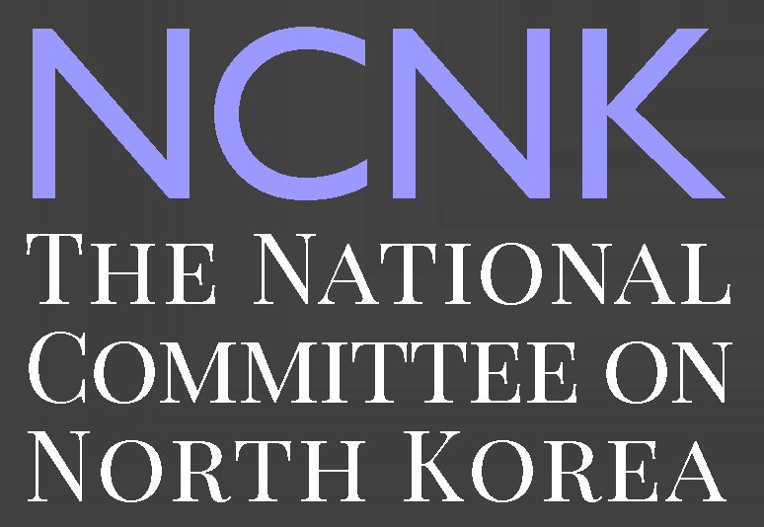

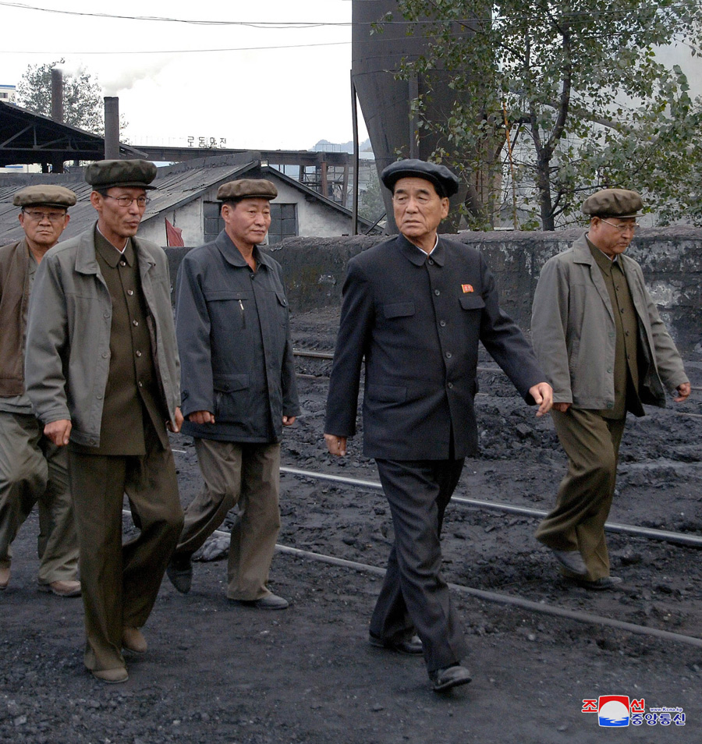

**SPECIAL REPORT**

North Korea’s Shackled Economy, 2018

**WILLIAM B. BROWN**

March 2018

**ABOUT THE AUTHOR**

William Brown is an adjunct professor at Georgetown University School of Foreign Service where he teaches courses on the Chinese, Japanese, and Korean economies, and he continues to do contracting work for the federal government from which he is retired. His most recent service was as Senior Advisor to the National Intelligence Manager for East Asia in the Office of the Director of National Intelligence. Prior to that his career as an economist and East Asia specialist has included extensive work in CIA, Commerce Department and the National Intelligence Council where he served as Senior Research Fellow for East Asia and as Deputy National Intelligence Officer for Economics. Brown was a founding member of the National Committee on North Korea, and currently serves as a non-resident fellow at the Korea Economic Institute of America. He received an MA in Economics and Chinese studies, and most coursework for the PhD, from Washington University in St. Louis and his BA in International Studies from Rhodes College in Memphis. Brown was raised in Kwangju, Korea by Presbyterian missionary parents who themselves were born and raised in China and Korea, respectively. He and his wife live in Herndon, Virginia and have four grown children.

**NCNK**

The National Committee on North Korea (NCNK) is a non-governmental organization of persons with significant and diverse expertise related to the Democratic People’s Republic of Korea. NCNK and its members support principled engagement with North Korea as a means to promote peace and security on the Korean Peninsula and to improve the lives of the people of North Korea. NCNK also works to provide policymakers, the academic and think tank community, and the general public with substantive and balanced information about developments in North Korea. NCNK was founded by Mercy Corps, a global aid and development organization, in 2004.

# CONTACT

**Honorary Co-Chairs**: Amb. Tony P. Hall and Amb. Thomas C. Hubbard

**Steering Committee**: Charles Armstrong, Brad Babson, Robert Carlin, Katharine Moon, Susan Shirk, Scott Snyder, Robert E. Springs, and Philip Yun

**Executive Director**: Keith Luse

The National Committee on North Korea

1111 19th St. NW, Suite 650

Washington, DC 20036

[www.ncnk.org](http://www.ncnk.org)

[info@ncnk.org](mailto:info@ncnk.org)

Image result for twitter @NCNKorea

Copyright © 2018 by the National Committee on North Korea. All rights reserved.

Cover Image: Premier of the State Council, Pak Pong Ju, visits the Pukchang power plant, North Korea’s most important industrial facility, 23 October 2017. Photo via KCNA.

**Executive Summary[1]**

The North Korean economy remains weak and vulnerable, but its structure is changing as it confronts major internally- and externally-generated pressures. Ironically, as UN sanctions have tightened in recent years, the economy has become more decentralized and productive, as weakening state controls have allowed the spread of market activities, providing incentives for individuals and families to work in their own self-interest. Central planning is weakening as money replaces the once ubiquitous ration coupon, and self-reliance on both a national and localized level is increasing as foreign trade and foreign aid dwindle. However, the state-run economy has not withered away, and Pyongyang dictates perhaps half of all economic transactions, a far larger share than does the central government in any other country. The state and its enterprises and the huge farmers’ collectives still own most capital and property, and through their extensive regulations and police powers extract large rents from individuals and families.

The people of North Korea are very poor. The country’s GDP per capita – estimated at anywhere between $700 and $2,000 – places North Korea near the bottom of world rankings, and even these figures give an exaggerated notion of living standards. A large share of GDP is spent by the government for itself and its military, and relatively little goes to people’s consumption. People continue to suffer from shortages of food, fuel, electricity, running water, and other necessities, although there is little evidence of an ongoing famine as experienced in the 1990s. Malnutrition and food insecurity remain widespread, especially outside of Pyongyang, although UN nutrition surveys have shown a gradual decline in malnutrition rates since 2000.[2] Unusually for a command economy system, few state resources appear to be devoted to investment. The country runs a persistent and large merchandise trade deficit, financed by small amounts of foreign aid, net service sector earnings, illicit activities, and remittances from tens of thousands of overseas workers and compatriots.

Never the “hermit kingdom” suggested by outsiders, or the self-reliant economy as promoted by the ruling Kim family, North Korea is now being forced into a shell as its nuclear activities create barriers for economic interaction with the rest of the world. The various UN sanctions resolutions adopted in the past two years prohibit nearly all of the country’s exports and other income-earning activities, and have also banned or restricted many categories of North Korean imports, including fuel. With the adoption of these sanctions, even China – mostly a steadfast partner for sixty-five years – is sharply cutting its purchases from North Korea, and other countries have essentially stopped trade. But sanctions have been just part of the problem. North Korea’s lack of membership in the world’s market trading system, the WTO, has meant that major trading nations automatically place high tariffs on North Korean exports, making them uncompetitive internationally. Pyongyang’s decades-long sovereign debt default, meanwhile, adds to its inability to access foreign credit or direct investment.

Ironically, these economic and political troubles provide a narrow pathway for reforms that could unshackle the economy, creating growth even greater than its stellar neighbors, South Korea, China, and Japan, at equivalent periods in their development. As with those countries, major policy corrections must be made internally, but overseas aid agencies and the UN, given their own poor record of success, also should reconsider their programs and condition future work on market and productivity enhancing reforms. These could begin with:

* Transferring ownership of property from the state to the private sector wherever possible, liquidating real assets to generate funds for public investment while allowing private interests to use this property more productively. This is the China model.

* Unifying the bifurcated monetary system, possibly under a U.S. dollar or RMB currency board. The current system, with domestic and foreign currencies used side-by-side for domestic transactions, entails great vulnerability should the North Korean won begin to slip in value.
* Unifying the wage system by bringing state salaries in line with market wages, and paying workers directly with real money, rather than ration coupons that stifle productivity and prevent financial savings.
* Allowing private farming and the private ownership and transfer of farm assets, allowing the agricultural sector to become more productive and thereby increasing the size of the urban workforce.

An end to international sanctions, which would presumably require the dismantlement of North Korea’s nuclear program, would be necessary for the country’s reintegration into the international economy, but would by itself be insufficient to revitalize the country’s economy. To fully unshackle the potential of the North Korean economy, the U.S. and others could couple the prospect of sanctions relief with an offer to sponsor North Korea into a WTO accession process, as it did with China seventeen years ago. WTO accession would be a win for all sides, given it would require most of the above reforms and would open the world’s markets to what would no doubt become highly competitive North Korean industries.

**North Korea’s Macroeconomic Confusion**

North Korea publishes little economic data, hence many measures of aggregate production and consumption are little better than guesswork on the part of outsiders. The country’s only officially released macroeconomic data is that given to the UN Statistics Division responsible for systematic national income accounting (GDP) of all UN members, but the GDP figures Pyongyang provides are extremely small – only $16.8 billion in 2016, or just $665 per capita – and appear unreliable.[3] While up from $575 in 2006, the per capita figure would place North Korea below what most would consider to be subsistence income, especially after consideration of the high share of GDP that undoubtedly goes to the government, leaving little (probably less than a dollar a day) for consumption. This data indicates that agriculture and fishing constitute 22 percent of GDP; mining and energy production 18 percent; manufacturing 21 percent; construction 9 percent; and services 31 percent. The UN data also shows $1 billion in goods and service exports in 2016, and $1.9 billion in imports – considerably less than the merchandise trade estimates of $3 billion in exports and $3.9 billion in imports that KOTRA, a South Korean agency, calculates based on mirror trade data.[4] Finally, North Korea’s data also show the total population as 25.3 million in 2016, growing at a slow 0.5 percent per year, and an age dependency ratio – the proportion of the population supported by those of working age (15-65 years) – of a modest 44%.[5]

Two foreign agencies, South Korea’s Bank of Korea and the CIA, attempt to fill in the gaps by making annual proxy estimates of GDP using, presumably, extensive intelligence collection on North Korea. The Bank of Korea estimates that North Korean GDP grew by four percent in 2016, rising to about $32 billion, or about $1,500 per capita, as electric power, coal, metals, and manufacturing each are thought to have rebounded from declines the year before. Agriculture improved slightly, and services, both government and private, are figured to have declined.[6] This was the fastest estimated growth since 1999, although most if not all the improvement is likely to have evaporated in 2017 due to plunging exports and a weak harvest. The Bank of Korea’s estimate of North Korean GDP, which uses South Korean prices and value-added weights to calculate the value of North Korean economic activities, would put it at about one-fortieth of South Korean production, or one-twentieth South Korea’s GDP per capita. The CIA, in its *World Factbook*, makes a parallel effort to gauge North Korea’s economy, coming up with GDP in a wide range of $30-$50 billion and with a slight decline in 2015, its latest estimate.[7] It says its methodology is rough and its goal seems to be to fill in a gap in its worldwide GDP presentation. It ranks North Korean per-capita income as 215th out of 230, in league with South Sudan and The Gambia.[8]

Regardless of the roughness of these numbers, each paint a broadly accurate picture of a partly industrialized country with a large though outdated capital stock, a literate and well-trained workforce, extensive but poorly used natural resources, modest and dilapidated infrastructure except in its capital city, and a socialist control system that in theory and in law denies private ownership of the means of production, including virtually all capital stock and land.[9] The Korean Workers’ Party, through its planning commission and price control bureau, has tried since the 1950s to implement a centrally planned or “command” economy, in which most normal economic decisions are made by central authorities and markets – even money – play minor roles. Nominal prices, wages, and interest are supposed to be fixed according to social desirability, not private demand. Economic growth is desired, so production is geared to investment goods, not goods for consumption or for export.

The system never worked well, and key parts broke down amidst a massive famine in the 1990s. The result in 2018 is a hybrid system with unregulated and often unruly markets, and with market prices and profit-driven allocations competing with the state’s fixed prices and planned allocations. It is thus a land of many prices for the same good, service, or hour worked. Trade with the rest of the world is severely constrained by the need to protect this fixed price system. (Otherwise, for example, with domestic prices of coal cheap and external prices expensive, all the coal would be exported with none left for electricity production. If domestic prices were increased, coal-intensive heavy industry would be bankrupted.) Even before the adoption of UN sanctions, the result of this system was extremely poor efficiency in the use of labor and capital and thus a poverty-stricken population. But while malnutrition remains widespread, pockets of relative wealth are emerging as market activity takes hold in some areas and among some population groups.

The resiliency of this bifurcated economic system – one money and profit driven, the other commanded by the central state through rations and coercion – is often seen as remarkable given the torturous path the economy has undergone. North Korea has consistently defied predictions of collapse or systemic reform, which were especially prevalent during the 1990s after the Soviet Union and its Eastern Bloc satellites collapsed, as China shifted from plan to market, and as North Korea itself underwent famine and the death of its founder, Kim Il Sung. One explanation for this resiliency may be that foreign aid, which has historically been quite high relative to North Korean GDP, has provided the central state with just enough resources needed to prevail in its epochal fight with private markets, but never enough to buy back the economy and fully reinstate the command system.[10]

As shown in the sections below, the country, and its economy, is not without strengths, often overlooked in the morass of poor policy decisions that have nearly extinguished the productivity of the hard-working and long-suffering people. These offer hope for the people should economic reforms ever be given a chance.

**Infrastructure—Opportunities in Rust**

North Korea’s physical infrastructure is in poor shape after three decades of neglect as the government has focused its limited resources on nuclear, missile, and other military programs, and on building a modern city in Pyongyang. This neglect extends through the rail and road systems, electric power supply, water and sewer systems, heating systems, public health infrastructure, and many other areas. Communication systems are a bit better off but only because modern technology has advanced so rapidly, in terms of both performance and in lower costs, that even in North Korea communication has improved dramatically. Investment by an Egyptian company, Orascom, brought a 3G cellular network to the country, though data services remain limited and mobile phone users cannot connect to the internet. (North Koreans are restricted to a domestic intranet, though foreigners in North Korea are able to access the internet through the country’s 3G service.) Costs associated with rebuilding the country’s infrastructure to a level adequate to promote economic modernization are likely in the hundreds of billions of dollars, and are often assumed to require massive South Korean or foreign assistance.[11]

The necessity of foreign aid can be debated, however, as infrastructure redevelopment may be the quickest avenue to increased productivity and growth in the economy and may easily be self-supporting. Like China in about 1980, the real property that underlies all infrastructure is owned by the state and is used very inefficiently. Privatization of even a small portion of these assets could provide enormous funds needed to build both public and private infrastructure. Extraordinary real returns are likely given the footprints of former structures are already there (for example in rail transportation and power distribution), and immediate productivity boosts could be expected in all lines of work. Foreign investment would help, and a forward-looking, post-sanctions North Korean government easily could elicit competitive bids from the huge construction and engineering companies of South Korea, Japan, and China eager for such work, with North Koreans providing the labor. But even absent significant foreign investment, North Korea might be able to do most of the work itself, and build private companies up in the process if it allowed a banking or private capital system to channel domestic savings into productive investment.

The footprint – that is, the existing framework for infrastructure development – is already there, making potential development relatively easy and fast. An ancient civilization with well-developed villages and towns, northern Korea received a large amount of Japanese investment during the colonial occupation (1910-45), including a modern rail system, ports on both its east and west coasts, hydro-electricity, and telephone and telegraph services. This infrastructure avoided damage during World War II but was devastated during the Korean War and then rebuilt in its aftermath. Between 1953 and the mid-1980s, Pyongyang, with substantial assistance from the Soviet Union, Eastern Europe, and later China, added significant thermal electric power, a limited express road system, and petroleum-related energy infrastructure. These have been very poorly maintained, however. Transportation routes are hindered by a mountainous interior that divides the country east and west, with reliance on an aging and nearly decrepit electrified and coal-powered steam rail system. Extraordinary delays are met even in travel between Pyongyang and Wonsan, only 90 miles apart across the middle of the peninsula. Travel between Pyongyang and the country’s second largest city, Chongjin in the northeast corner, can takes days by train. In contrast, north to south travel on the west coast (less so on the east) can be accomplished relatively quickly by road or rail.

Ports, and the rail system that links them to the interior, were originally developed to service trade with Japan and remain adequate for the small amount of international trade currently undertaken by North Korea. The major Yellow Sea port is Nampo, downriver from Pyongyang and accessible through a large “lock gate” system to deal with tides. Others include Haeju, bottled up by the Northern Limit Line (the *de facto* inter-Korean maritime border); and Sinuiju, also limited to minor coastal trade, on the Yalu river. Generally, the west coast is encumbered by the extreme tidal variations of the Yellow Sea and by extensive marshes. East coast ports are much deeper and include Wonsan, Sinpo, Chongjin, and Rajin, which all enjoy reasonable access to the country’s mineral and metal resources, but lack easy access to the important Pyongyang and west coast industrial areas.

Various schemes have been floated to take advantage of the country’s geography, sitting as it is near or even between rich economies in South Korea and Japan, and the vast potential of China and Russia. Nothing but disappointments have come of these, however. As part of its “Sunshine Policy” of engagement with the North, South Korea rebuilt a rail line into the DMZ, with the idea of connecting it to the trunk line extending through Pyongyang and on into China, but after a brief period of limited service in 2007 and 2008, it has awaited passengers for more than a decade. A similar east coast rail line also has come to naught. China recently built a modern highway bridge across the Yalu River near Sinuiju in hopes of replacing a well-worn 1940s-era railroad and vehicle bridge linking Sinuiju and Dandong, but North Korea has failed to build the connecting road to what is otherwise an apparently completed project. Russia and South Korea have periodically discussed building rail links and an energy pipeline connecting South Korea with Russia’s Far East via North Korea, but the project remains on ice. Russia has, however, enjoyed modest success in rebuilding the short rail line between its border and the North Korean port of Rajin, primarily to use the port as a transshipment point for Russian coal exports. UN sanctions include an exception that allows Russian coal to be transshipped out of Rajin, and Russia has reportedly used this route to ship 3.2 million tons of coal to China from August 2016 through August 2017.[12]

Electric power, a relative strength of the North Korean economy in its early decades, is currently one of its weakest links, and perhaps the most visible indicator of the centrally planned system’s gradual collapse. Under that system, electricity is allocated by the central plan and is nearly free, as is the coal, equipment, and labor needed to provide it. In the absence of a pricing mechanism, scarce electricity is allocated on the basis of political priorities. This proved workable enough when central planning dominated the North Korean economy, even if the lack of price signals led to the inefficient use of energy. In the mixed system, however, power plants are at a loss to purchase needed inputs and then give away the power. Installed capacity has stayed even at about 7,000 MW, with constantly degrading equipment, for three decades, evenly split between hydropower and coal fired thermal plants, and an antiquated high-voltage grid connects most parts of the country.

Two power plants dominate North Korea’s electricity production: Supung hydro plant on the Yalu, which began operations in 1943 as the largest in Asia, with seven 100-MW turbine generators split between China and Korea; and the even more important Pukchang coal-fired plant, with sixteen 100-MW generators, furnished by the Soviet Union in the 1960s. Responsible for about a third of the country’s power output, Pukchang sits next to underground anthracite coal mines worked at least in part by political prisoners, or might what be called slave labor. A handful of petroleum-fired power plants, dozens of smaller coal-fired plants, and hundreds of small hydro plants fill out the system. One petroleum-fired plant at Rajin in the northeast is being retrofitted to burn coal, although even that will not purge the entire system of the need for oil, since the difficult of burning anthracite means that coal plants need some fuel oil to start.

Anthracite coal resources in North Korea are plentiful, but the collapse of the centrally planned management system has left coal mines flooded for lack of power to run their pumps—some of the largest mines are under sea level—even as power plants lack coal to supply the electricity to the pumps, a chicken and egg problem only possible in a command economy. In recent years a large expansion of coal exports to China may have hurt the power industry as well, although UN sanctions now may be forcing the coal back into domestic use.[13]

Since at least the early 1980s, the North Korean energy industry has planned for nuclear power to play a large role but, subordinated to the nuclear weapons program, huge funds have been expended and no capacity has been created. A large setback occurred in 2002, when revelations of Pyongyang’s covert pursuit of uranium enrichment capabilities led to the breakdown of the Agreed Framework with the U.S., North Korean withdrawal from the Nonproliferation Treaty, and the abandonment of two 1,000 MW light water reactors (LWR) that were being built and funded by the U.S.-managed KEDO consortium. These reactors would have expanded the country’s total usable capacity by about a third to a half.. The KEDO plants thus joined at least two other nuclear projects Pyongyang had initiated on its own and had abandoned at the outset of the Agreed Framework. In 2012, Kim Jong-un announced yet another new (but only pilot scale) 25-30 MWe experimental LWR project to great fanfare, where preliminary testing appears to have recently begun after several years of apparently stalled construction.[14]

With little new capacity coming on line in decades, deteriorating distribution equipment across the board, and inefficient allocations and use of electricity, the North Korean economy is plagued by shortages of power. Industrial equipment, lights, trains, even elevators are often shut down due to power outages. However, as market activities expand elsewhere in the economy, off-grid energy systems are becoming increasingly common, as households and enterprises turn to markets to buy solar panels imported from China, diesel generators, and imported fuel. Output from the devices is then sold at very high prices to people desperate for power, generating stiff profits. Some wealthy households have also reportedly bribed officials to siphon off electricity from politically-prioritized institutions, such as military bases or local Party headquarters.[15]

Pressures may be building for a similar solution to the national grid. The *Daily NK* reports that apartment units in Pyongyang are being required to purchase electric meters and that power will be sold by the actual amount used, not by the number of appliances, as is the current rule.[16] If so, it would be relatively easy for Pyongyang to gradually raise the price and allocate more funds to the power plants to buy coal and improve or repair equipment. A big casualty of market pricing, however, would be heavy industry which uses cheap power very inefficiently. As has occurred in China and the former Soviet Union, huge sunk investments in outdated equipment—equipment optimized for cheap energy and expensive capital—would instantly be made worthless by market priced energy and cheaper (or at least available) capital.

**Mining and Manufacturing—Look to Comparative Advantages for Growth**

Under North Korea’s Juche or self-reliance philosophy, the country tries to produce a little of everything that it needs, and to encourage autarkic practices at the local scale. The result is an impressive array of factories and farms that do a little bit of everything, but nothing very efficiently. Inevitably, the quality of goods is suspect and the quantity is insufficient – casualties of a broken planned system, a chaotic market that overlays it, and the huge obstacles to foreign trade imposed by both domestic imperatives and (more recently) by a world seeking to sanction North Korea for its nuclear weapons program. However, if these barriers were replaced with solid incentive structures and access to global markets, the mining and manufacturing industries could drive rapid economic growth.

While impressive in some aspects, the ultimate result of this system is hungry people: a country that can’t export enough products to afford to import enough food even to keep them alive. The output of a few large zinc mines – of which North Korea has many – probably could have been traded in world markets for enough grain to stave off the famine that killed hundreds of thousands of citizens in the 1990s. Or, in today’s world, zinc exports could be used to service the country’s debt and restore its creditworthiness. Those mines are nearly shut, due to lack of electricity, fuel, equipment and (most importantly) entrepreneurial, profit-driven management that could compensate for the breakdown in the plan mechanism.

A rational division of labor would likely focus on building up several key industries while shutting down others. A look at the structure of the country’s trade with China is instructive though not complete, given the irrational nature of prices in North Korea. Comparative advantages can likely be found in many high-valued mineral and metals products, including zinc, lead, iron, anthracite coal, gold, and rare earths. North Korea’s work force is well-skilled and literate, which is conducive to construction, many types of manufacturing, and textile production – providing the basis for both a solid export base and for the reconstruction of domestic infrastructure. Some large chemical or iron and steel plants, such as the Kim Chaek Iron and Steel Complex in Chongjin – North Korea’s largest industrial establishment with tens of thousands of skilled workers[17] – might be rebuilt from the ground up, and then could likely compete effectively with equivalent Japanese, South Korean, and Chinese industries, given North Korea’s excellent resource base and highly competitive skilled labor. Comparative disadvantages are likely found in hundreds of smaller factories that waste energy and labor inputs; production of relatively scarce minerals such as aluminum and copper; certain electronics and consumer goods; and most importantly, the low-productivity agriculture which engages one-third of the work force.

In developing its service sector, North Korea likely would have a large comparative advantage in tourism, an area that Kim is currently trying against all odds to develop. Relatively rich populations in China, Japan, and South Korea would likely flood to North Korea given the right political and security conditions, given the country’s location, scenery, and historic context. Facilities easily could be self-supporting and would generate hard currency. However, North Korea would first have to make significant changes in policies that address the needs of tourists, assuring potential visitors that the country is safe to visit and convincing the U.S., South Korea, and Japan to remove travel-related sanctions. In other services areas such as education and healthcare, North Korean providers would likely be at large comparative disadvantages and require imported material and expertise.

**Agriculture – Comparatively Disadvantaged, But Necessary in Transition**

As was the case in Deng Xiaoping’s China, agriculture may hold the key to economic reform given the potential for unleashing productivity gains among North Korea’s many farmers. [18] Unfortunately, it is also the sector most frustrated by the country’s dogged adherence to collectivist policies. Perhaps not coincidentally, agriculture has experienced much foreign intervention, including many billion dollars of food aid over the past two decades, amid efforts by UN and foreign aid agencies to improve farming practices, which continues.[19] Even as UN sanctions mounted in the summer of 2017, the World Food Program issued new calls for food aid due to what it thought might be the worst drought since the famine.[20]

Two major crops, rice and corn, provide the bulk of the nation’s food supply, although potatoes have risen in importance in recent years, grown in marginal fields and on hillsides. Rice is grown in irrigated paddies, especially in the large southwestern plain, between Pyongyang and the DMZ. Corn is grown in the colder and drier regions of the north and east. Both are susceptible to the country’s highly variable climate, with droughts and floods often impacting production across different regions in any given year. Pyongyang, and foreign aid agencies, often cite bad weather and the rugged geography as cause for shortfalls and hunger, but agricultural self-sufficiency has long been a poorly-conceived national goal. Southern Korea always was the national granary, and North Korea is rich in many other resources, easily traded for food.

North Korea’s labor productivity in agriculture is even weaker than its other industries, having declined from its heyday in the 1960s and 1970s when, copying Soviet practices, farms were mechanized and utilized great amounts of chemical fertilizer to overcome poor soil conditions. After reaching this peak, however, agricultural mechanization gradually decreased due to shortages of equipment and diesel fuel, and the heavy use of chemical fertilizers led to badly depleted soils. After subsidized fuel imports and fertilizer production bottomed out in the early 1990s, farmers were left with degraded and unproductive land, tilled by hand or oxen and often fertilized with night soil -- leading to famine and associated public health challenges.[21]

The famine opened an era of foreign food aid that brought in millions of tons of grain from all over the world, including large amounts from the country’s putative enemies in South Korea, Japan, and the United States. Importantly, the famine ended the universal food rationing system, since the state was unable to acquire enough grain to meet urban rations, and it let citizens forage on their own, especially in rural areas. This led to grain markets that now provide the bulk of the nation’s food, even in cities.

The emergence of these markets, along with some modest changes in agricultural practices and policy, has led to increased agricultural output since food production bottomed out two decades ago. Prices for rice and corn are somewhat regulated but generally rise and fall with supply and demand conditions, and no major famine has been observed since markets took on the job of distribution, despite declining imports and a near cessation of foreign food aid. However, the agricultural sector remains highly inefficient. The North Korean data provided to the UN shows agriculture provides 22 percent of GDP, and that the rural population accounts for about a third of the total.[22] CIA estimates are similar, with agriculture put at 25 percent of GDP and the agricultural workforce at 37 percent of the total. This implies output per worker of only around $1,000 per year; South Korea’s aged farmers each produce 15 to 20 times more output.[23]

The largest problem is that North Korea’s farms continue to be organized along strict collectivist lines – most are large cooperative farms encompassing dozens of villages and thousands of farmers, where the most productive land is used to grow grain in fulfillment of state-imposed quotas. (There is also a smaller number of state-run farms which produce more specialized products.) Private ownership of land, and most residences, is not allowed. Work teams of about ten families are the core production units and are allowed some rights to produce after annual quotas are fulfilled – this production can be sold externally at prices higher than the rationed rate but below full market value. Since the famine, individuals have been allowed to farm peripheral land, including on hill sides, with the output privately consumed or sold in markets. More recently, farmers have been allowed to cultivate and sell fruits, vegetables, and other non-grain crops grown in privately-built greenhouses. Naturally, more attention is given to this private farming, a misuse of labor since the better-quality collectively owned land is underworked.[24]

Market prices for food in North Korea have fluctuated, both seasonally and in conjunction with overall production and monetary policy. From the famine to 2012, the price of rice and corn increased exponentially, requiring several episodes of massive currency devaluations that shook the faith in the North Korea won. Kim Jong Un, to his credit, has gotten inflation under control, and grain prices have flattened since he came to power in 2012 and are now stable. However, this has come at the cost of allowing U.S. dollars and Chinese RMB to saturate the economy, the long-term consequences of which remain to be seen. The relative price of corn, considered by North Koreans to be an inferior substitute to rice, has also fallen from its long-term average and is far below the famine era, suggesting less deprivation in food supplies.

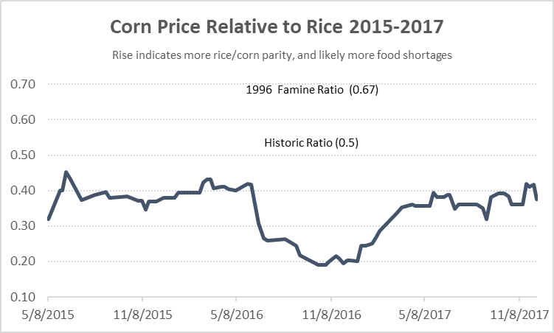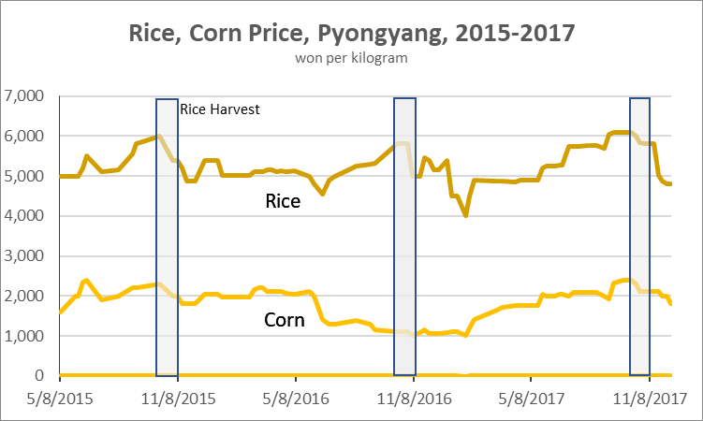

*Source: Daily NK*

**Foreign Trade: The Sanctions Crush Begins**

The “Hermit Kingdom” has been a misleading moniker for North Korea for better than half a century but, if the latest UN Security Council sanctions are enforced, it may soon be all too accurate. North Korea’s foreign trade was once far more varied than its current reliance almost entirely on trade with China would suggest. When UN sanctions were first adopted in 2006, just after its first nuclear test, Pyongyang’s foreign trade was small but relatively diversified, with China holding about 38 percent of trade; South Korea 30 percent; Japan and Russia about 5 percent each and the rest of the world 22 percent.[25] And before that, the Soviet Bloc, Western Europe and Japan were large partners, as well.[26] (The US is alone among major countries in never having traded significantly with North Korea.) Debt defaults, the collapse of the Eastern Bloc’s fixed price trading agreements, and angry episodes with Japan and South Korea progressively cut into Pyongyang’s trade from the 1980s through the early 2000s.

*Source: Global Trade Atlas*

Beginning around 2010, however, North Korean trade with China began to rise dramatically, more than compensating for North Korea’s trade losses elsewhere and making Beijing the only consequential trade partner for Pyongyang, accounting for 91 percent of North Korea’s exports and imports in 2016 as tallied by mirror data.[27] Rising trade with China has had a significant impact on North Korea’s evolving markets, with Chinese-made consumer goods and electronics in high demand by North Koreans with newfound cash to spend. But with the adoption of increasingly comprehensive (rather than simply arms, luxury goods, and WMD-focused) UN sanctions in 2016 and 2017, and an apparent newfound willingness in Beijing to enforce these sanctions, it appears that North Korea’s trade with China may soon begin to plummet. Though China’s long-term willingness to enforce sanctions remains to be seen, its trade with North Korea declined rapidly in the fourth quarter of 2017, down 42 percent from the same period a year earlier.

The latest UN sanctions have hit North Korea’s major exports – anthracite coal, non-ferrous and ferrous metals, fish products, and textiles – especially hard. China’s exports to North Korea have been relatively less impacted, causing a big and likely temporary increase in China’s trade surplus – now running about $200 million a month – which likely is draining North Korea’s hard currency reserves and reducing its ability to import needed products. Restrictions or bans on the export of refined petroleum, industrial equipment, and metals to North Korea will, if enforced, have a ripple effect throughout the North Korean economy, and as North Korea’s currency reserves dry up the country will likely face difficulties funding the imports of other products, as well. North Korea will likely try to increase sales of non-sanctioned goods such as fruits and vegetables, which are already on the upswing, but it is doubtful that these can compensate for the loss of its big earners.

*Source: Global Trade Atlas, February 2018*

**North Korea: Total Trade, Major Trade Partners, Latest Month, 2017**

|  |  |  |
| --- | --- | --- |
|  | **Million dollars** | **Percent change from same**  **month a year earlier** |
| China (Dec) | 308.5 | -51 |
| India (Nov) | 3.6 | -55 |
| Philippines (Nov) | 2.8 | Not meaningful |
| Sri Lanka (Dec) | 2.1 | +10 |
| Russia (Nov) | 1.3 | -78 |
| Hong Kong (Nov) | 1.1 | +98 |
| Ghana (Nov) | 1.0 | Not meaningful |
| EU (Dec) | 1.0 | -6.5 |
| Switzerland (Nov) | 0.6 | Not meaningful |
| Brazil (Sep) | 0.3 | -42 |

*Source: Global Trade Atlas, February 2018*

**Monetary Impact of Sanctions – Key to “Maximum” Pressure – Not Yet Evident**

Curiously, the tripling in North Korea’s merchandise trade deficit with China to $1.68 billion in 2017 has not hurt the value of the North Korean won in informal North Korean marketplaces, where it appears to be traded freely for U.S. dollars and RMB.[28] (The official North Korean exchange rate, at around 100 to the dollar, is grossly out of proportion with the informal rate of 8,000 to the dollar, but this rate has become increasingly irrelevant and now exists mostly to create a two-tiered pricing system for foreign visitors.) North Korea probably runs a surplus on the rest of its current account – net services income, remittances from overseas Korean workers and relatives, unreported sales of arms or other illicit goods, and some aid from UN agencies and others. Since the country is effectively bankrupt, new borrowings or inward investments are virtually impossible, so net capital account income is zero and the current account must be self-financing except for use of reserves. It is difficult to see, however, how the non-goods component of the current account could be rising to cover this rising goods deficit, especially since new sanctions target overseas workers and their remittances as well. Spending of foreign exchange reserves could pay for some of the imbalance, but these are not likely large enough to go on for long, and much of these funds presumably are controlled by Kim Jong Un himself, so he would feel like he is spending his own money.

Large questions thus arise as to how long the regime can maintain this monetary stability, especially an exchange rate that is nearly fixed to the dollar, and what will happen if its citizens suddenly lose confidence – as they have on several occasions in the past, most recently and most disruptively in 2009 – when the won was forced to devalue by orders of magnitude and inflation soared. Money, either won or dollars, was much less important than it is now, and in today’s money-driven North Korea, panic easily could erupt, at least among the monied elites and the merchants. Short of that, one can expect declines in imports with consequential impacts on prices and availability of consumer and investment goods.

Understanding these dangers, Pyongyang’s monetary authorities no doubt are keeping a close eye on the informal exchange rate and may even be intervening (spending reserve dollars and RMB) to keep won fixed at the 8,000 per dollar rate. The informal exchange rate for the won has been remarkably stable since 2013, following a period of hyperinflation in the aftermath of the 2009 currency revaluation. Monetary interventions aiming to stabilize the exchange rate can be painless if the public accepts the power of the state to enforce the rate, but a significant price movement in favor of the dollar – for instance caused by a missile or nuclear test and calls for new sanctions – could lead to panic selling of won, subsequent hyperinflation, and turmoil for the growing class of money lenders. Meanwhile, monetary authorities, seeking to defend the value of won, are not likely providing much credit for state enterprises and government agencies, forcing the state to try to raise funds wherever it can and crimping the already extremely low state wages.

So far though, there has not been much market reaction to the visible trouble in the trade sector. The biggest exception is the doubling in the market prices of gasoline, diesel, and kerosene fuels last summer; prices declined somewhat after rumors that China would cut crude oil supplies dissipated, but have remained much higher than international prices. Fuel prices will likely stay high and may climb higher now that sanctions on imports of refined products have set in. Also evident are new campaigns to raise government income by charging tolls and, possibly, raising the price of electricity.[29] With strong sanctions only a few months old, it may be a nervous time for North Korea’s growing class of money lenders and foreign exchange traders, and certainly for anyone in charge of Kim Jong Un’s money reserves.

*Source: Daily NK, data through February 21, 2018*

**Sanctions May Provide Leverage for Lasting Reform**

A South Korean legislator, presumably using information from his government’s intelligence services, said in February that North Korea has about $3 billion in cash reserves that it is quickly running down. He said the reserve would last until October, thus assuming about a $250 million per month net outflow, consistent with Chinese trade data, and suggested panic will set in before then.[30] Whether or not this is accurate, it illustrates what has become a three-way race of sorts between Pyongyang’s ability to withstand a large net outflow on its current account; its continuing nuclear program; and foreign tolerances for maintaining the stiff sanctions, especially by China and South Korea. Regardless of these strategic considerations, these sanctions ironically are creating a potential pathway for overseas aid organizations, and the UN, to press the case for radical reforms in North Korea – reforms that could save the country from the debilitating crush of its classic long-term poverty trap, where there is no savings surplus available to invest and all production is needed just to sustain the lives of the people and the activities of the government.

Pyongyang, at this point, may be more interested in systemic reform than it has previously been, given its need for hard currency and the dangers it must understand are coming from the increasingly dollarized economy. Drawing on the examples of post-war Japan, Park Chung-hee’s South Korea, and Deng’s China, such reforms could include:

* Transferring ownership of property from the state to the private sector. Pyongyang, in effect, owns the country. By liquidating real assets, the state can generate funds needed to build infrastructure and fulfill its social obligations, while allowing private interests to raise productivity of the country’s not-small quantity of industrial and real assets.

* Unifying the monetary system, possibly under a U.S. dollar or RMB currency board system (as did Hong Kong in 1982 in a successful step toward integrating with China). The recent dollarization of the economy has achieved monetary stability, a considerable achievement of the Kim Jong Un government and the starting point for market development. But the two-currency system, with won and hard currencies used side-by-side, creates great vulnerability should the won begin to slip in value. The chance of financial panic in these circumstances is very high.
* Unifying the wage system by bringing state salaries in line with market wages, and by paying workers directly with real money, not in ration coupons that stifle productivity, prevent financial savings, and are rife for abuse. A ration-based economy can’t take advantage of the multiplying impacts of money circulation—where activities in one area breed further activities in another. (The payment of wages is required by the International Labor Organization; North Korea is about the only UN country that does not subscribe to ILO rules.)
* Allowing private farming and private ownership and transfer of farm assets. As has occurred in China over the past three decades, the one-third of the North Korean population engaged in farming could double or triple their productivity, creating surplus income and a workforce capable of generating lucrative export-driven growth. (Beginning in 1978, and lasting for two decades, Chinese provinces near North Korea experienced 8 percent per year productivity growth in agriculture following such reforms.)[31]

A start to this process could begin with the US offering to sponsor North Korea into a WTO accession process, as it did with China seventeen years ago, and an end to sanctions, in return for an end to Pyongyang’s nuclear development program. WTO accession would be a win for all sides, given it would require most of the above reforms and would open the world’s markets to what would no doubt become highly competitive North Korean industries. More importantly to the Kim family, it might prevent hyperinflation and people in the streets.

1. This paper reflects the views only of its author. It is intended to inform NCNK membership and the broader public about economic issues in North Korea, and does not necessarily represent the viewpoints of NCNK or its members, of which, no doubt, there are many.
2. “Situation Analysis of Women and Children in the Democratic People’s Republic of Korea – 2017,” UNICEF, 2016, <https://www.unicef.org/dprk/Situation_Analysis_of_Children_and_Women_in_DPR_Korea_UNICEF_2017.pdf>
3. “National Accounts Main Aggregates Database,” United Nations Statistics Division, <https://unstats.un.org/unsd/snaama/dnllist.asp> (last updated December 2017). This includes a mixture of a small amount of reported official North Korean data and widespread, very rough, estimates made by UNSD.
4. A variety of data on North Korea’s foreign trade, based on mirror statistics, is available at North Korea in the World, [www.northkoreaintheworld.org](http://www.northkoreaintheworld.org).
5. World Bank, “Age Dependency Ration (% of Working Age Population),” DPRK, 2016. <https://data.worldbank.org/indicator/SP.POP.DPND?end=2016&locations=KP&start=1960&view=chart>
6. Kang Chang Ku, “Gross Domestic Product Estimates for North Korea in 2017,” The Bank of Korea, July 22, 2017, available at <http://www.nkeconwatch.com/nk-uploads/GDP_of_North_Korea_in_2016_f.pdf>.
7. “Korea, North,” CIA World Factbook, <https://www.cia.gov/library/publications/resources/the-world-factbook/geos/kn.html>, last updated March 14, 2018.
8. “Country Comparison:: GDP – Per Capita (PPP),” CIA World Factbook, <https://www.cia.gov/library/publications/the-world-factbook/rankorder/2004rank.html#kn>, 2017 Estimate.
9. An excellent simplified explanation of this system can be found in Yang Mun-su, *North Korea’s Planned Economy and Marketization* (Ministry of Unification Institute for Unification Education, 2015). Another useful guide to the North Korean economy can be found in Kim Byung-yeon, *Unveiling the North Korean Economy: Collapse and Transition* (Cambridge University Press, 2017). A shorter look at the phenomena of marketization and monetization is Bryan Harris, “North Korea Begins Journey from Feudalism to Crony Capitalism,” *Financial Times*, June 21, 2017, <https://www.ft.com/content/db738fb8-3ed2-11e7-82b6-896b95f30f58>
10.
11. Shin Chang-min, “Korean Reunification: Costs, Gains and Taxes,” *Unification and Law*, Vol. 3 (November 2010), <http://www.koreafocus.or.kr/design2/layout/content_print.asp?group_id=103354>
12. “Midterm report of the Panel of Experts established pursuant to resolution 1874 (2009),” UN Security Council, S/2017/742, p. 33.
13. It is an interesting economic policy question as to which is a better use of coal for North Korea, as an export item or as domestic fuel. Hard currency is desperately needed to import many products, including petroleum, but electricity also is in short supply, constrained by coal supplies. A system that allowed electricity to be sold a market prices could resolve the question – my guess is that it is better used domestically rather than exported, a result ironically dictated by the UN sanctions. The power might then generate export earnings far in excess of the coal itself.
14. Tim Lister, “North Korean Nuclear Reactors Show New Signs of Activity,” *CNN*, March 15, 2018, https://www.cnn.com/2018/03/15/asia/north-korea-nuclear-reactors-activity/index.html
15. Andrei Lankov, “How North Korea’s Electricity Supply Became One of the World’s Worst,” *NK News*, May 31, 2017, <https://www.nknews.org/2017/05/how-north-koreas-electricity-supply-became-one-of-the-worlds-worst/>
16. Kim Sung Il, “Toll Booths and Electric Meters Latest Government Tax Schemes,” *Daily NK*, November 2, 2017, <http://english.dailynk.com/english/read.php?cataId=nk01500&num=14800>
17. “Kim Chaek Iron and Steel Complex: Down but Not Out,” *38 North*, June 20, 2016, <https://www.38north.org/2016/06/kimchaek062016/>
18. Output per farmer rose about 8 percent per year in Jiangsu province in China for the twenty years following Deng Xiao Ping’s reform of the collectives system, allowing surplus food supplies and a surplus of workers who then moved to towns to develop secondary and export oriented industries. Jiangsu in 1978 was probably similar to North Korea today. Growth of that magnitude would create an investable surplus in North Korea with salutary impacts across the economy.
19. Mark E. Manyin and Mary Beth Nikitin, “Foreign Assistance to North Korea,” *Congressional Research Service*, April 26, 2012,<http://pdf.usaid.gov/pdf_docs/pcaac459.pdf>.
20. Martin Seitz, “North Korea’s Impending Perfect Storm,” *The Diplomat*, August 25, 2017, <https://thediplomat.com/2017/08/north-koreas-impending-perfect-storm/>
21. For an excellent study of North Korean agriculture up until the famine, see Andrea Matles Savada, *North Korea: A Country Study* (Library of Congress, 1993), <http://countrystudies.us/north-korea/49.htm>.
22. “Democratic People’s Republic of Korea,” United Nations Statistical Division, <http://data.un.org/en/iso/kp.html>
23. GDP is estimated at about $40 billion so one fourth is $10 billion. The work force is estimated at about 15 million, so 37% would be 6 million, implying about $1,300 per farmer per year, although the error range is likely very large. On South Korean farm productivity (2010 data) see Ma Sang-jin, “How to Encourage Young Generation to Engage in Farming: Korea’s Case,” Korea Rural Economic Institute, November 5, 2014, <http://ap.fftc.agnet.org/ap_db.php?id=324>; see also Mamta Bakar, “Why South Korean Farmers are 40 Times More Productive Than Chinese Farmers,” *Business Insider*, August 7, 2012, <http://www.businessinsider.com/chinese-farmer-productivity-2012-8>.
24. Colin Carter, Jing Chen, and Baojin Chu, “Agricultural Productivity Growth in China: Farm Level Versus National Measurement,” University of California – Davis, Department of Agricultural and Resource Economics, Working Paper No. 99-001, January 1999, <http://ageconsearch.umn.edu/bitstream/11954/1/wp99-001.pdf>
25. John Kruzel, “Does North Korea Account for 90% of North Korean Trade, as Rex Tillerson Said?” *Politifact*, May 1, 2017, <http://www.politifact.com/truth-o-meter/statements/2017/may/01/rex-tillerson/does-china-account-90-north-korean-trade-rex-tille/>; Insung Kim and Karin Lee, “Macroeconomic Statistics and the DPRK,” NCNK Issue Brief, December 21, 2009, <https://www.ncnk.org/sites/default/files/NCNK_Issue_Brief_Statistics_December_2009.pdf>
26. *North Korea: A Country Study,* op. cit.
27. Global Trade Atlas, November 2017 data
28. Exchange rate data is available at Daily NK, “Market Trends,” <http://english.dailynk.com/english/market.php>
29. Kim, “Toll Booths and Electric Meters Latest Government Tax Schemes,” op. cit.
30. “N. Korea’s Hard Currency Reserves Expected to Dry Up by October: Lawmaker,” *Yonhap News*, February 21, 2018, <http://english.yonhapnews.co.kr/national/2018/02/21/0301000000AEN20180221003000315.html>
31. While the North Korean agricultural workforce is much smaller relative to overall population than China’s agricultural workforce was at the start of reform, North Korean students, soldiers, and laborers are routinely sent to the fields during periods of peak agricultural labor demand – a more efficient agricultural system would alleviate the need for this disruptive pattern of labor.