North Korea and its Money

For GW Conference, 27 September 2019
William B. Brown
I don’t know how many of you noticed last month when Asia Press, out of Tokyo, in its usual biweekly report on prices in North Korea, suddenly upped the value of the US dollar to 9,400 NK won, after years of having it sit tight right about 8,400 won--a roughly ten percent devaluation of the won and about an 8 percent drop against the already weak RMB. I usually watch this rate through the excellent NK Daily site, but there the rate remained at about its old rate, no real change. I called around a bit to find out which was right and people, including Daily NK said the won had suddenly fallen for a short time and they were all looking into it, but without satisfactory answers. To me, this was big news, if accurate. A sudden ten percent jerk downward from a pegged rate would, it would seem, cause panic among anyone holding won. Thinking that the government had lost control or had finally exhausted dollar reserves to support won, they would sell in mass, creating a self-sustaining downward spin that would send the dollar rate up to 10,000, 20,000 or more. Inflation would soar and people would be in the streets. It has happened before, when money was much less important in North Korea, and it had big repercussions, even then. I’m still not sure what happened but such a panic did not erupt and both Asia Press and Daily NK now report the won is back to about its five-year, amazingly stable, rate of a little over 8,000 won to the dollar. I’ve been calling the won a pegged currency but now am much less sure what to think.

Why does all this matter? We should look a little at history and theory. Its not all that complicated, and it tells nicely the dismal story of North Korea’s economy and where it sits now, perhaps with a faint glimpse of the future. But it also shows the need for different kinds and more precise attention to information coming out of North Korea and a bit of what I would say is laziness on the part of North Korea watchers of all stripes. North Korea is changing, becoming more normal, and as in all normal countries, money, and all the prices that go with it, matters and not just for economics.
The topic of this panel is change in North Korea and I would say the biggest change I have seen since I first started looking at it, in the mid-1970s, is the use of money. In Kim Il Song’s old centrally planned, or, using a better label, “command economy”, money in a classical definition – medium of exchange, a universal pricing mechanism, and, most importantly, a “store of value” – did not exist. The state had taken ownership of the means of production, that is capital of all kinds, and all land and other resources, and in a fixed price system, dictated, or commanded, the allocation of labor and all production. Distribution was by ration, not money. Ration cards may look a bit like money but like airline miles they should never be confused with such because they lack a “store of value”. Your ration ticket may have allowed you to some food for ten days but after that it was worthless, and it was non-transferable. No one could stockpile assets they could use to become capitalists. Karl Marx liked this system because it freed workers from some of the cutthroat competition of the industrial revolution but Lenin and the Soviets, and Mao and Kim after him, loved it because it was an ideal way to control people. People, without any money in their pockets were, and are, at the mercy of the party cadre who doles out the rations.
It’s a long well-worn story by now but rationed or command economies make exceedingly inefficient use of scarce resources and all have failed—famines are the usual result--including North Korea. As they fail, money seeps in to replace the ration ticket, the ticket producers are corrupted, and the state loses control over the economy and even its own workers. Meanwhile the private assets allowed by money are used much more efficiently and the economy grows, but not in a way the socialist state can tolerate. Competition through markets, not command through rations, becomes the driver.
In Russia and Eastern Europe this change occurred rapidly, in China slowly and methodically, but in North Korea it has moved in fits and starts with the ration system never, even now, completely gone. Unlike the communist giants, the North Korean government has always found ways to obtain just enough foreign aid to keep the ration system alive—either through extortion or beggary—but not enough to completely restore the command system. The way I picture it, Kim Il Song’s ration economy dissolved with the famine to a “bad money” economy under Kim Jong Il’s leadership, with people forced to used highly inflation prone North Korean won instead of rations, and then to the remarkably liberal, partially dollarized economy of Kim Jong Un. I’m not sure he had any choice but the young leader did an amazing job of getting inflation under control by pegging the won to the dollar and getting citizens to freely accept US dollars, RMB, and NK won at stable rates, now for five years or longer. The three currencies now circulate freely in everyone’s wallets, as freely as say in a currency board economy like Hong Kong. And this freedom to own wealth has sparked a huge increase in private-led productivity which we see on the streets of Pyongyang and in some other cities.
But there are two problems. Two very big problems.
Kim Jong Un’s state allows the liberal use of money but it still insists on state ownership of most of the means of production, including most importantly, land, and agriculture, with a third of the population, is still collectivized. Moreover, North Korean state workers, maybe a third of the population, are still paid ration, not money, wages. This creates a system with at least two prices for everything. A ration price and a market price with the differences up to 100 times. Two prices for the same thing spells incredible inefficiency, arbitrage, and corruption. In fact, as a result, I would say North Korea makes the least productive use of its not small stock of capital, including human capital, of any country in the world. A schoolteacher, probably a college graduate, in the state system earns 3,500 won per month plus ever withering rations; her high school sister in a semi-autonomous textile factory may earn 300,000 won a month, without rations. Still only a dollar or two a day but enough to have a cell phone and an occasional cup of coffee. But without legal property rights, and worries her dollars might be confiscated, she is unlikely to invest her earnings and thus spend all she earns, leading to what visitors see as conspicuous consumption amid incredible poverty.
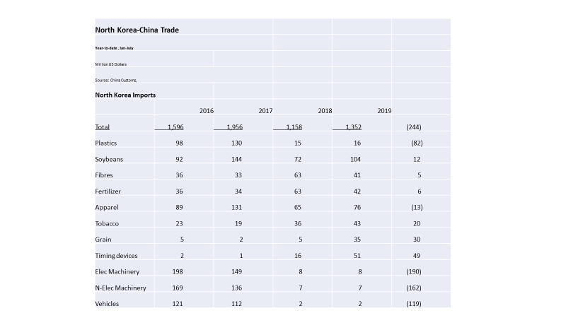
The second big problem is what we all hear about, the trade sanctions. It is false to think of North Korea as a “hermit” kingdom. Since 1945 it has always depended a great deal on trade. And most of its industry has been built with aid from abroad. Important commodities, such as all of its petroleum fuels and plastics and some of its food is imported. But since China jumped on board the UN sanctions in 2017, after the big nuclear test, North Korean exports have fallen about 80 percent and imports by about 40 percent. A tiny uptick this year—exports and imports of watch parts—gets the news but the real story is no one in the world will trade normally with Pyongyang except through expensive, illicit methods. So, through August of this year the country imported virtually no industrial equipment or vehicles, no mechanical parts, no metals, no chips. Necessary consumption goods imports, such as cereals and fertilizers, have continued, but almost nothing in the way of investment products was

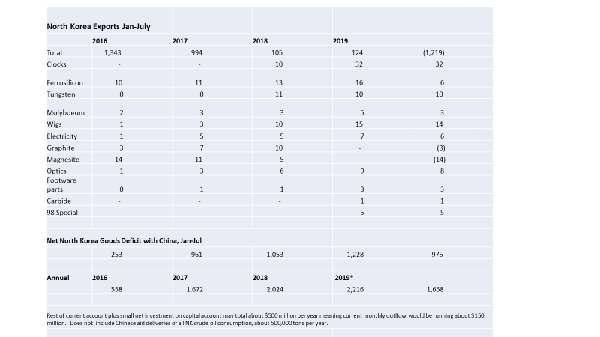

purchased for future growth. Meanwhile Kim, instead of talking about prosperity, is talking about self-reliance which, to any North Korean, must mean belt tightening.
This brings us back to the exchange rate and how Kim has been able to keep it stable. And more importantly; whether he will he be able to keep the country’s finance, money and budgets, under control.
As best as I can estimate, based largely on Chinese customs data, North Korea’s goods trade deficit with the world has increased to about $2 billion a year, from less than $1 billion a year prior to the Chinese sanction actions in 2017. Or about $150 million a month outflow. Certainly, there is reason to believe there is also substantial unrecorded goods trade, both imports and exports, a likely services and remittances surplus, and perhaps a small amount of foreign investment inflows—Chinese Koreans buying cheap Korean apartments. This income may have offset the persistent goods trade deficit up through 2017 but it is difficult to see that in the face of sanctions on all kinds of services and overseas labor that this income could have risen to offset the increased goods deficit. Moreover, people making exchange rate decisions inside North Korea would probably have no better insight than we do and certainly would know of the near Chinese embargo on North Korean sales. So, given a likely dollar or RMB outflow, why don’t they sell their won and buy the ever-present dollars and RMB? It’s a tricky question but my hypothesis is that, as with any other country bent on maintaining a fixed exchange rate, North Korea would match the dollar outflow with a reduction in internal won credit, keeping the won equally scarce against the dollar and thus the rate of exchange constant. So, people don’t have the won to buy the dollars. As people have become used to the stable rate, they don’t speculate against it, so the regime doesn’t have to spend much foreign exchange. But any movement invites speculation and a potential run on central bank reserves, hence the importance of the peg and any movement against it.
I said this money stability was a major accomplishment of the Kim government, and it has added greatly to the increase in productive market activity, but there are heavy economic repercussions to restricting won credit, in effect an extremely tight monetary policy that would not allow lending to enterprises or even funding any increases in the large government budget and the military. It keeps inflation low, and the exchange rate stable, but there is little or no room for state supplied investment, or for pay increases needed to keep state workers from fleeing to the private sector. And this is what we see, anecdotally. A country with virtually no industrial investment of the type normally provided by a socialist state. Dilapidated train service and terrible electric power and utilities services. Major health care concerns. The private sector may be growing, although it also may now be feeling the impact of reduced credit—as evidenced by declining apartment prices in Pyongyang—but the state sector is eroding much faster. We also see the state trying to raise funds by leavening fees on everything and peeling off the employment obligations of state factories, allowing once socialist activities to become private. According to some, state factories can now pay market wages if they can earn enough from their increasingly market driven sales. This can go on for a long time, as it has in China, but inevitably it means a shift in resources and power to the private side of North Korea, a development we should all applaud. Efficiency would gain, people would prosper, and the authority of the state would weaken as real money fills people’s pockets and as pockets of private wealth, and power, crop up to compete against the party.
Can the Kim regime survive such a dynamic? Maybe. He seems pretty clever. The Chinese like to say once you jump on the capitalist tiger you can’t get off, lest you be eaten. I’d say for Kim it is too late. The tiger is lose and he better jump on and start feeding it, privatizing the state, before he is eaten himself.

