https://www.facinghistory.org/resource-library/video/origins-lynching-culture-united-states
An amazing 10min video with experts, images, and patterns of lynching! However, it does spend 2 min on the worry about African American males’ lusting for white women’s purity.

http://loc.gov/rr/print/list/085_disc.html
Here are dozens and dozens of signs re Jim Crow. If you print these all off, it will give kids a feel for how pervasive and ubiquitous Jim Crow really was! And, they’re all LOC docs! And, it goes well with:
http://americanradioworks.publicradio.org/features/remembering/laws.html

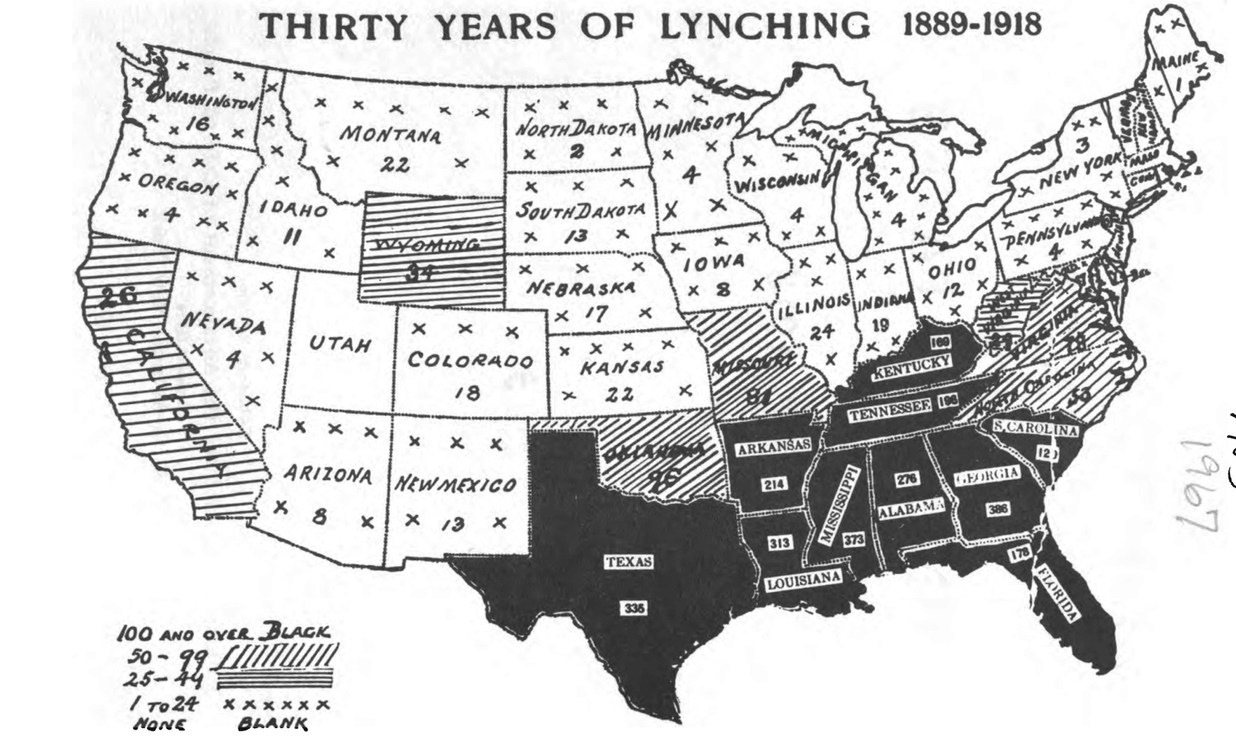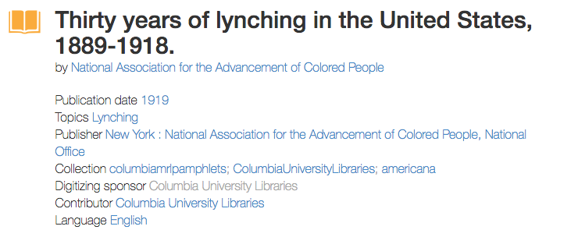 Book’s bibliographic information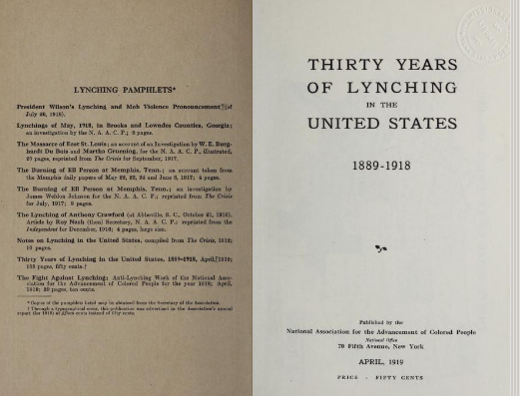 Cover page of book

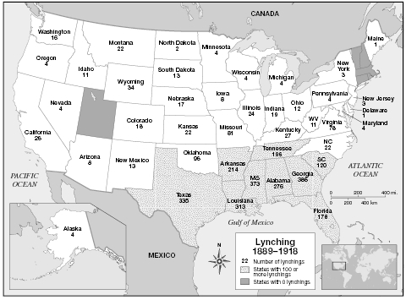
Encyclopedia of African-American Culture and History, 2006

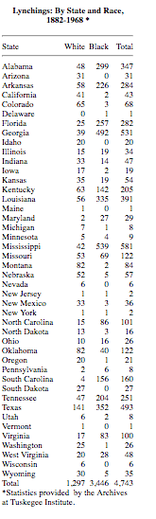 Look at the states with 100+ victims…where are they located?
http://law2.umkc.edu/faculty/projects/ftrials/shipp/lynchingsstate.html

https://www.eji.org/ Equal Justice Initiative documents/names victims of lynching! EJI “identifies victims of lynching between the end of Reconstruction in 1877 and 1950. It's a list that could go on for pages and, yet, still to this day remains incomplete.” You can find the actual report here:
https://lynchinginamerica.eji.org/report/ it is startling! But, probably not something you’ll use with the students.

