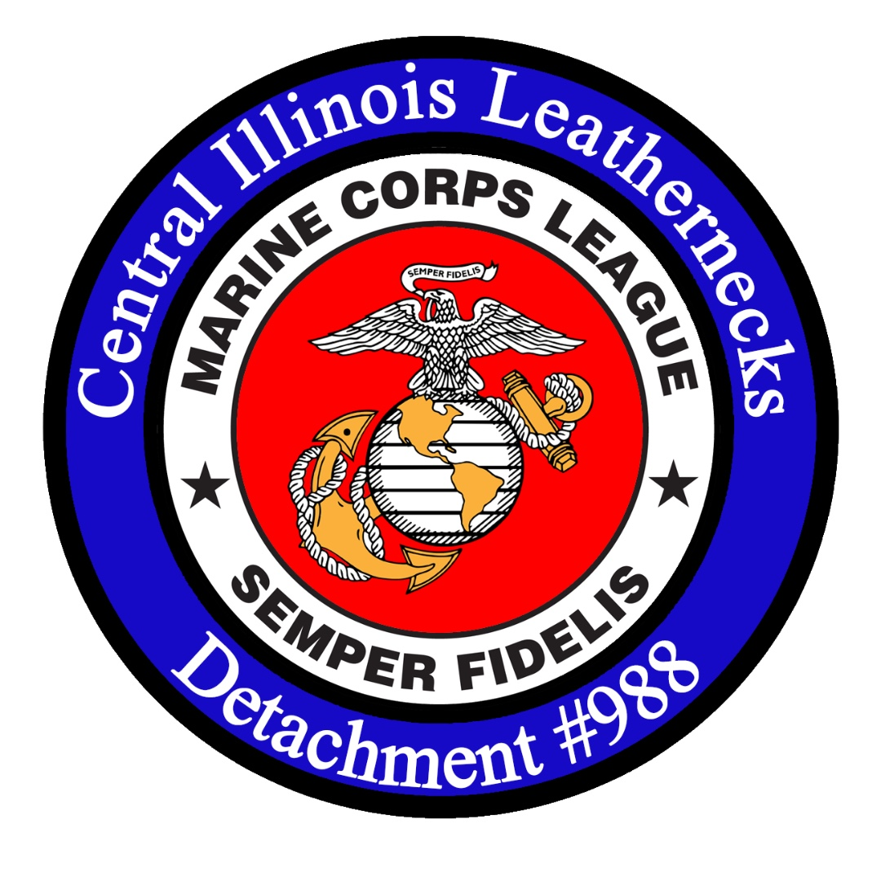
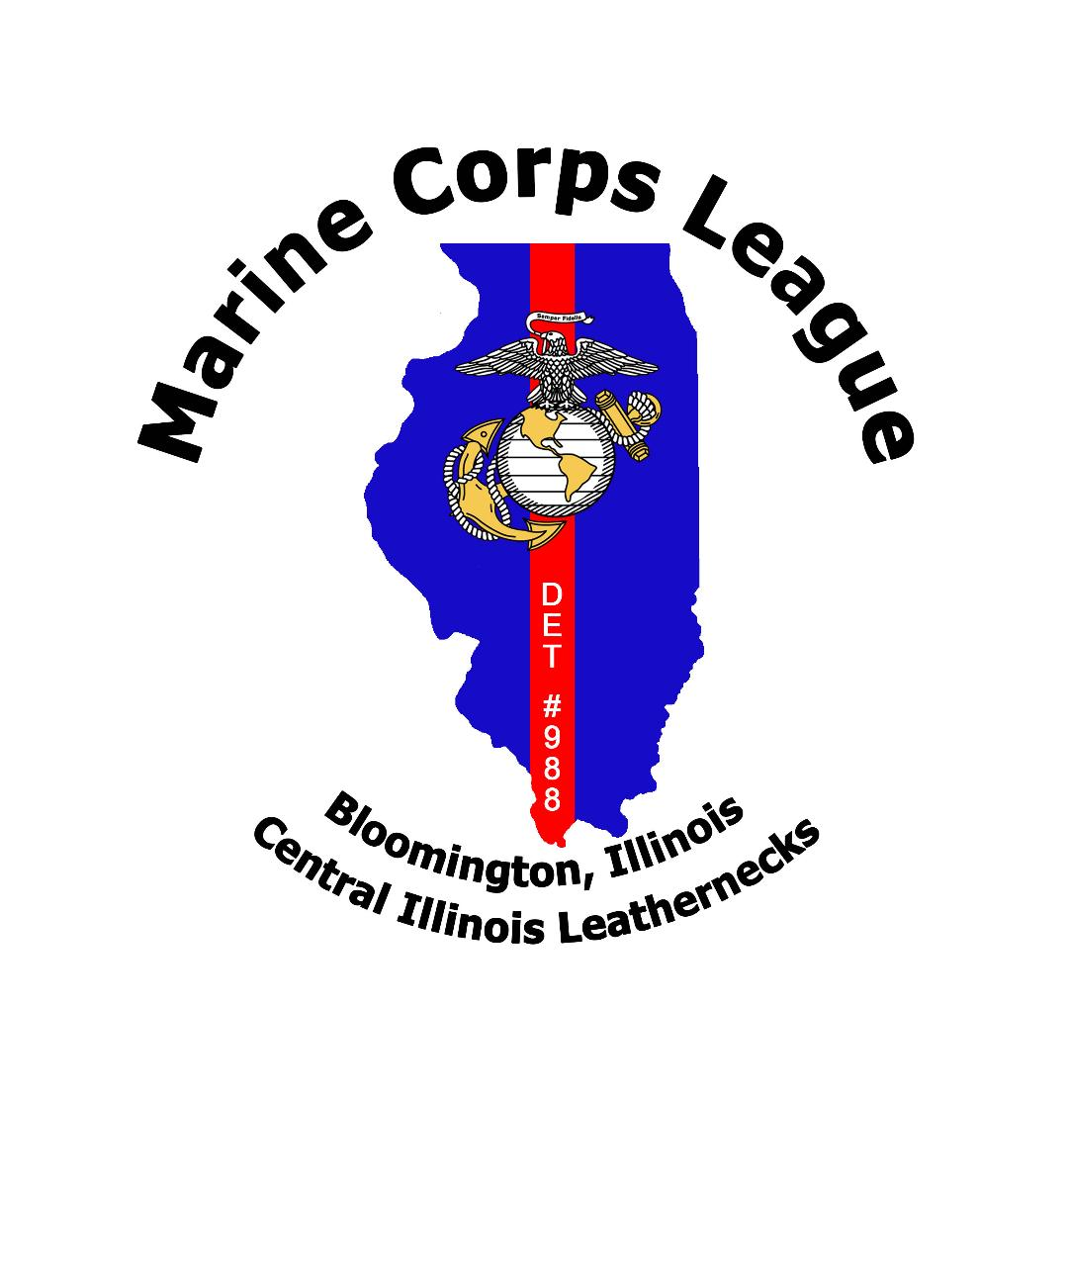
Leatherneck Knowledge
Published by: Marine Corps League
Central Illinois Leatherneck Detachment #988
Volume 20, Edition 06 June 1, 2020

CENTRAL ILLINOIS LEATHERNECK DETACHMENT # 988

Commandant

Kevin D. Keller

Senior Vice
Commandant

Rick Probus

Junior Vice
Commandant

Brandon Cruz

Sergeant at
Arms

Eian Poblador

Editor

Kevin D. Keller

Page Two

Detachment
Officers

Detachment
Members

Page Three

Membership
Statistics

Life Membership

Detachment
Awards

VSO

Recruiting
Info

Page Four

Fundraisers

Upcoming
Events

Information

Mission Statement of the Marine Corps League

The mission of the Marine Corps League is to promote the
Interest and to preserve traditions of the United States Marine
Corps; strengthen the fraternity of Marines and their families;
serve Marines, FMF Corpsmen, and FMF Chaplains who wear or
who have worn the Eagle, Globe and Anchor; and foster the
ideals of Americanism and patriotic volunteerism.

Our Detachment meets the 2nd Tuesday of every month at the John H. Krause
VFW Post #454 at 1006 East Lincoln Street #1, Bloomington, Illinois 61701
at 1900 hours.

Meeting Dates for the 2020

June 9 July 14 August 11
September 11 October 13 November 10 December 8

COMMANDANT’S CORNER
I hope we are all taking the necessary precautions and staying safe during this pandemic.
If you need any assistance, please reach out that is one of the reasons for the Marine Corps League to assist and help our veterans. It is not weak to ask for help. We all need a little assistance every now and then. Reach out and do a buddy check on a veteran, friend or family members. Make buddy checks a weekly routine. The St. Patty’s Day 5K will now be held in September. Please mark your calendars for this event. We will need max participation for this event. As I receive more information, I will pass it along. Our Department of Illinois Conference dates are now September 30th thru October 4th, 2020.
Very soon we will have our Detachment Polo Shirts. Unfortunately delays in the delivery of the shirts due the current pandemic. If you know of a veteran that is in need please let someone know so that we may lend this veteran, the help they need. If you have any ideas that can improve our Detachment or ways, we can help our Community please let someone know. If you see someone with a Marine Corps Bumper sticker or wearing a cover or t-shirt talk to them about joining the Marine Corps League. Semper FI!

Central Illinois Leatherneck Detachment #988
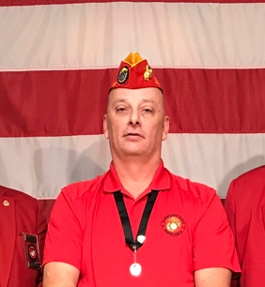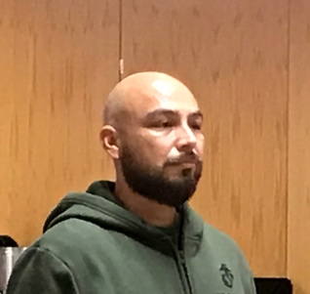
Central Illinois Leatherneck Detachment #988
Detachment Commandant Senior Vice Commandant Junior Vice Commandant
Kevin D. Keller Rick Probus Brandon Cruz
14030 Lara Trace 1005 Gerike Way 335 Basswood Lane
Bloomington, Illinois 61705 Bloomington, Illinois 61704 Normal, Illinois 61701
Email: kkeller64@yahoo.com Email: rickprobus@gmail.com Email:bcruz0811@gmail.co
Cell: 1(618)554-1540 Cell: 1(309)825-1988 Cell: 1(970)396-1520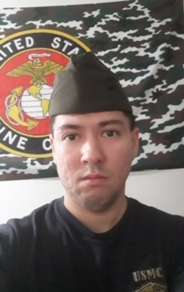 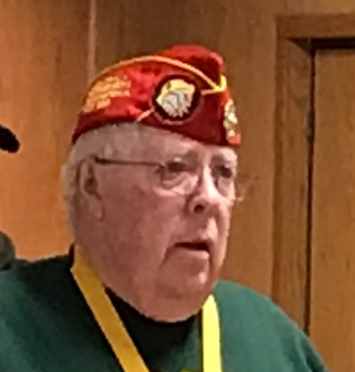 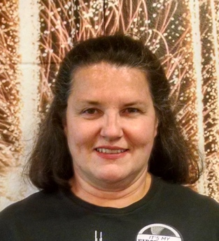
Sergeant of Arms. Paymaster/Adjutant Chaplin
Eian Poblador Dave Edwards Gina Keller 2110 East Empire 904 Star Drive 14030 Lara Trace
Bloomington, Illinois 61704. Heyworth, Illinois 61745 Bloomington, Illinois 61705
Email: ecpoblador@gmail.com Email: die41@aol.com Email: illinigirl65@yahoo.com
Life Members

Rick Clem Roger Dahl Dave Edwards James Howard Kevin Keller
John Maitland Dennis Meeks Russel Radley Allen Starkey Fred Strieff
Art Wynn
Members

Richard Babica Brandon Cruz Nike Pate Andrew Swan Rick Probus
Todd Harmon Eian Poblador Michael Douglas James King Daniel Metz
Richard Parker Mark McNeely Brandon Kleckner Gina Keller Wyatt Miller
Central Illinois Leatherneck Detachment #988
Central Illinois Leatherneck Detachment #988
Membership Statistics Life Membership

Total Members: 26 Annual Renewal Goal: 100 % Ages Costs
Associate Members: 01 Percent of Goal Meet: 126 % 0 – 35 $500.00
Active Duty: 00 36 – 50 $400.00
Life Members: 12 51 – 64 $300.00
65 – Over $200.00
Detachment Awards Veterans Service Officer

Detachment

2018 Membership Streamer Chris Grant GySgt USMC
2019 Membership Streamer National Guard Armory
2019 Dept. of IL. 75th Convention Streamer 1616 South Main Street, Room 117B
2019 National Convention Streamer Bloomington, Illinois 61701
2019 National Meritorious Unit Citation Hours of Operation: 0800 to 1600 hours
2019 National Americanism Award 2nd Place. Phone: 1(309)827-5811

RECRUITING

If you see a Marine, ask a Marine to Join the League.

No, it is not that simple as to just ask to join our organization. If you see a Marine go over and talk to that Marine. Do not ask about joining but ask that Marine about their career so far. Ask where stationed and MOS and thanks for your service. You have to establish a connection between you and the Marine you are talking to. Remember this is to get them to talk about their service not for you to talk about yours. After a few minutes of discussion then bring up the Marine Corps League.
A key is you need to have knowledge of the Marine Corps League and you can get this knowledge by reading the bylaws and going to the National and Department of Illinois web site and reading over all the information. This way when you are asked question about the League you will have the answers. Always carry application with you wherever you go.

Central Illinois Leatherneck Detachment #988
PAPA JOHN’S PIZZA PROMOTION CODE

PAPA
Central Illinois Leatherneck Detachment #988
We now have a promotional code from Papa John’s as a fundraiser for our Detachment. Anyone can use this code as many times they wish and save 30% on their pizza order. Out of the 30% the Detachment will receive 10% per order. Every quarter we will receive a check in the mail. The checks will be mailed to your Detachment Commandant but addressed to Central Illinois Leathernecks and then of course deposited into the Detachment banking account. The promotional Code is: DET988. Give this code to everyone you see and talk to. Everyone loves pizza and saving money along with helping local veterans. So, pass the word to one and all. Our first check was for $203.90.

DEPARTMENT OF ILLINOIS FUND RAISERS

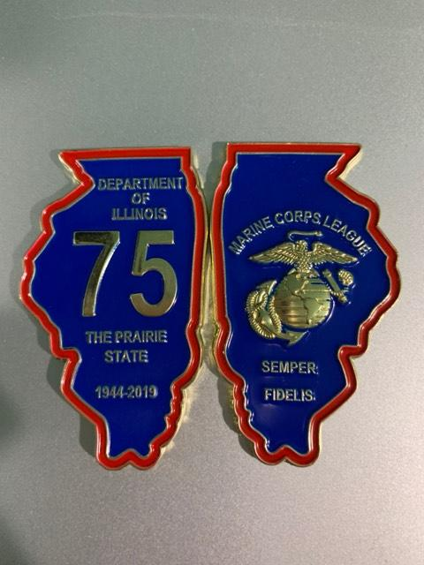

This is the Marine Corps League Department of Illinois 75th Anniversary Challenge Coin. The cost is
$10.00 each. All money goes to the Department of Illinois for funding for programs.

If interested, please contact:

Kevin D. Keller
14030 Lara Trace
Bloomington, Illinois 61705
Email: kkeller64@yahoo.com
Cell: 1(618)554-1540

Department of Illinois – Marine Corps League
Senior Vice Commandant
RAFFLE
1st Prize: Your choice of a SPRINGFIELD ARMORY M1A 7.62 or $1,000.00 CASH
Or a 2-night getaway for 2 at the Herrington Inn and Spa in downtown Geneva, Illinois

2nd Prize: SIG SAUER P320 (9mm) (or similarly priced weapon), or $500.00 CASH
The Drawing will be held at the 2020 Department Convention, Saturday, June 20, 2020.
Ticket cost $10.00 each. Winner need not be present to win.

Central Illinois Leatherneck Detachment #988
Central Illinois Leatherneck Detachment #988
UPCOMING EVENTS

DATE EVENT

Annual St. Patrick’s Day run. the Detachment provides road guards. This is
currently our biggest fund raiser of the year. All are needed for this event.
September will be the month for this event. More info to follow.

September 2020

DATE EVENT

30th – 4th Department of illinois Marine corps league convention
The Department convention take place at the
Magnusson Grand Hotel and conference center
Carlinville, Illinois. Take interstate 55 and get off
at exit 60. Rate is $69.50 plus 10% tax for a total of $76.45.
Complimentary breakfast included. Restaurant on site and will be
Open for breakfast, lunch and dinner. Bar, Indoor pool and Business center
Along with outside area and fitness center. Cutoff date for price is
May 20, 2020. Phone number is: 1(217)324-2100 for reservations.

Central Illinois Leatherneck Detachment #988

AUGUST 2020
Central Illinois Leatherneck Detachment #988

DATE EVENT

8 – 15 MARINE CORPS LEAGUE NATIONAL CONVENTION
​ The 2020 National Convention will be held at the:

HILTON DAYTONA BEACH
Oceanfront Resort, 100 N Atlantic Ave
Daytona Beach, FL 32118.
For reservations call 866-536-8477 with code MCL20.

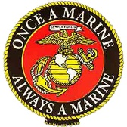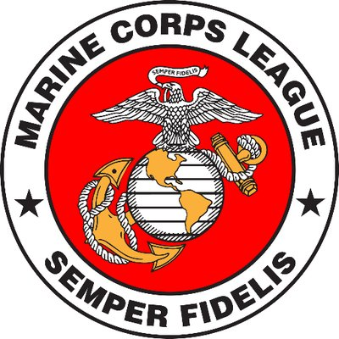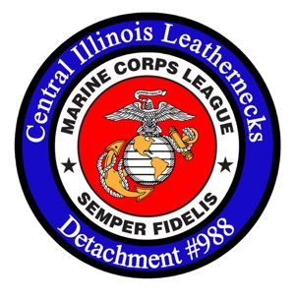
Central Illinois Leatherneck Detachment #988

TRAVEL PLANNER
Central Illinois Leatherneck Detachment #988
Members now have access to over 600,000 lodging options worldwide, and at rates up to 65% off or more. The Marine Corp League Travel Planner sources rates from dozens of supplier channels to bring you the best rate and terms for your hotel for your specific dates. You can also book flights and other travel services right from the site. Make the Marine Corp League Travel Planner your one-stop shop for travel and SAVE Now. Also, you can get unmatched group lodging rates for weddings, reunions, team sports, or any of your special events.

Vets4Warriors
Vets4Warriors is the leading national peer support and resource connection network for veterans, service members, family members and caregivers who need answers and understanding from someone who knows what they are going through.

Marine Corps League members can use Veterans Holidays! Veterans Holidays is a “Space Available” program that offers veterans the opportunity to enjoy vacations at popular destinations around the word – for the incredibly low price of just $349.00 US Dollars per unit, per week. Those eligible a d their family and friends have access to spacious accommodations at more than 4,000 resorts, apartments, condominiums and homes in more than 100 countries. Membership with Veterans Holiday is FRRE to all veterans of the U.S. military.
Central Illinois Leatherneck Detachment #988

VETERANS CRISIS LINE
Central Illinois Leatherneck Detachment #988
The Veterans Crisis Line is a free, confidential resource that’s available to anyone, even if you’re not registered with VA or enrolled in VA health care. The caring, qualified responders at the Veterans Crisis Line are specially trained and experienced in helping Veterans of all ages and circumstances.
- Send a text message to 838255 to connect with a VA responder.
- Start a confidential online chat session at VeteransCrisisLine.net/Chat.
- Take a self-check quiz at VeteransCrisisLine.net/Quiz to learn whether stress and depression might be affecting you.
- Find a VA facility near you.
- Visit MilitaryCrisisLine.net if you are an active duty Service member, Guardsman, or Reservist.
- Connect through chat, text, or TTY if you are deaf or hard of hearing.
www.veteranscrisisline.net
Call: 800-273-8255 and Press 1

GOVX
(From their website) Patriots like you deserve the best deals and savings. That’s why we built GovX exclusively for the men and women who’ve served our country.
Every day we work to create the ultimate members-only experience for current and former uniformed professionals, with exclusive deals on on-duty gear, apparel, technology, event tickets, travel and a lot more.
At GovX, we go beyond outstanding deals. Every month, our GovX community comes together to raise funds for a deserving non-profit in the military/first-responder space. We call it GovX Gives Back.
Central Illinois Leatherneck Detachment #988
Central Illinois Leatherneck Detachment #988

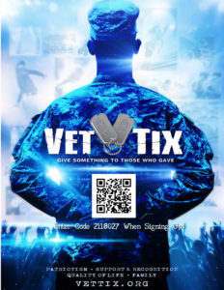

VETTIX.ORG
Give Something to Those Who Gave.
(From their website) Vet Tix * provides tickets to events which reduce stress, strengthen family bonds, build life-long memories and encourage service members and veterans to stay engaged with local communities and American life. We support our troops by honoring their service and providing positive family and life experiences, during and after their years of service to our country.
Vet Tix provides tickets to all branches of currently serving Military and Veterans, including immediate family of troops KIA.
Vet Tix secures tickets to sporting events, concerts, performing arts, educational and family activities across the nation. VetTixers sign up online. We verify their service. VetTixers request tickets to events that interest them, then pay a small delivery fee to receive their free tickets.

Central Illinois Leatherneck Detachment #988
Central Illinois Leatherneck Detachment #988
HIRING OUR HEROS
The U.S. Chamber of Commerce Foundation’s Hiring Our Heroes initiative launched in March 2011 as a nationwide effort to connect veterans, transitioning service members, and military spouses with meaningful employment opportunities.
Working with the U.S. Chamber of Commerce’s vast network of state and local chambers and strategic partners from the public, private, and non-profit sectors, our goal is to create a movement across America in hundreds of communities where veterans and military families return every day.
Our digital resources include distinct resume builders for veterans and transitioning service members as well as military spouses; a jobs portal that allows veterans and service members to search for employment opportunities in America’s fastest growing job markets and industries; an interactive employer best practices site; and a virtual mentorship program that connects veteran and spouse protégés with experienced mentors.
These online tools have also been integrated into the employment workshops that take place at hundreds of our fairs. Our goal is to ensure veterans, transitioning service members, and military spouses are able to utilize our resources to connect with employers no matter where they are in the world.

MARINE FOR LIFE NETWORK
Marine For Life Network (M4L) connects transitioning Marines and their family members to education resources, employment opportunities, and other Veterans services that aid in their career and life goals outside of military service. The Marine For Life Network offers Marines and family members connections to military-friendly employment, education, and other Veteran and community resources. To connect with our LinkedIn network please visit us on https://www.linkedin.com/company/marine-for-life-network.
www.usmc-mccs.org/services/career/marine-for-life-network/
Central Illinois Leatherneck Detachment #988

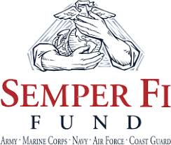
Central Illinois Leatherneck Detachment #988

Semper FI fund
Supporting Our Heroes recover, transition, & thrive. Semper Fi Fund focuses on innovative and effective programs that make a difference. They provide financial assistance and lifetime support to post-9/11 combat wounded, critically ill and catastrophically injured service members and their families. You are not alone. From injury through recovery, comprehensive programs improve the lives of wounded veterans and address the unique needs of their immediate families.
- Service Member and Family Support Program – Bedside Financial, Housing Assistance, Transportation Assistance, Kids Camp, Canine Program, Horsemanship Program, Adaptive Equipment, Caregiver Support & Retreats
- Transition Program – Education & Career Assistance, Veteran 2 Veteran Support, Apprenticeship Program, Veterans & Unit Reunions, Odyssey Retreat
- Integrative Wellness Program – Neuro Fitness, Specialized Equipment, Counseling, Doc’s Corner, Post Traumatic Growth Video Resources, and Sports Program
- LCpl Parsons Welcome Home Fund for Vietnam Veterans – The program will expand the mission to care for veterans from all US military service branches who are catastrophically injured from combat operations in Vietnam.
www.semperfifund.org
Call: 760-725-3680

Central Illinois Leatherneck Detachment #988
Central Illinois Leatherneck Detachment #988

FOCUS MARINES FOUNDATION
The mission of Focus Marines Foundation (FMF) is to develop and administer programs for wounded warriors which will assist them in their transition from military to civilian lives. FMF developed a weeklong program called FOCUS, located west of St. Louis, Missouri. The program is conducted four times each year with a maximum of 30 per class. Participants arrive on Saturday and depart the following Saturday.
If you or someone you care about is struggling with the transition from military life to civilian life, you are not alone and there is help! Many men and women who have left the military are experiencing the same problems, like:
- ANXIETY: Quick to anger. The smallest things can trigger anger
- DEPRESSION: Lacks motivation, focus and purpose. Not working or attending school
- ADDICTION: Addicted to drugs, alcohol, porn or video gaming
- INSOMNIA: Poor or erratic sleep. Little or no sleep at night and little sleep during the day
- ISOLATION: Avoids public places, friends and family
- RELATIONSHIPS: Problems with family, friends and coworker relationships
- NEGATIVITY: Most things have a negative meaning, the glass is always half empty
- SELF-DOUBT: Lacks self-confidence and has lost pride and self-respect
www.focusmarines.org
Call: 314-243-4140
email: help@focusmarines.org

Central Illinois Leatherneck Detachment #988

MARINE CORPS LEAGUE FOUNDATION. 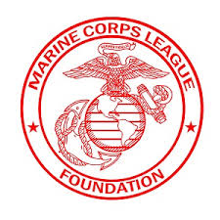
Central Illinois Leatherneck Detachment #988
The foundation has a blocked scholarship fund which assists funding the Marine Corps League’s Scholarship Program. These scholarships are granted to children and grandchildren of members of the Marine Corps League and its Ladies Auxiliary. Applications are encouraged by League members from every state and the local sponsoring Detachment is responsible for determining that the applicant(s) it is sponsoring have demonstrated through activities or interviews that values such as respect, attitude, patriotism and self-discipline are held.
The Foundation supports the educational activities of the Young Marines of the Marine Corps League and the Youth Physical Fitness Program of the Marine Corps League. Both of these programs have been widely recognized as being very effective in the area of drug prevention and character development. The Young Marine of the Year is awarded recognition in the form of funds to further their education. The Youth Physical Fitness National Team Competition is held annually, and top scoring male and female teams and individuals are recognized with cash awards.
The foundation provides Humanitarian Aid through grants to individual Marines and families of Marines who are in a difficult position due to circumstances beyond their control. The needs are verified by local Marine Corps League officials, who often rally local Marine Corps League members to provide additional assistance as needed.
Phone: 301.455.3362
email: president@mclfoundation.org

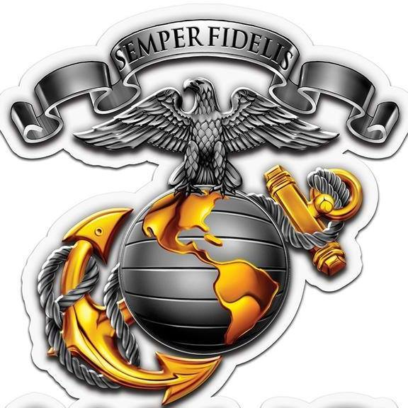
Central Illinois Leatherneck Detachment #988
Central Illinois Leatherneck Detachment #988

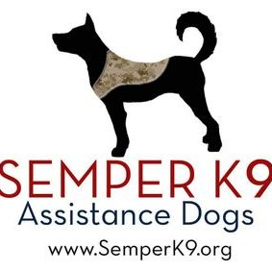

semper k9
Marine Combat veteran founded and operated, Semper K9’s mission is to enhance the quality of life for wounded, critically ill and injured members of the U.S. Armed Forces and their families by providing them assistance dogs. Using rescued and donated dogs we provide service dogs for psychiatric alert and mobility challenges free of charge to wounded service members to enhance their quality of life.
www.semperk9.org
Call: 571-494-5144

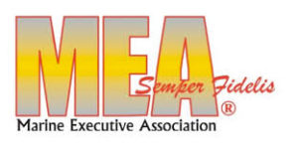
The Marine Executive Association is a national, volunteer, non-profit organization of former and current active duty Marines. MEA provides resume review, job hunting tips
and tools, job posting by employers, resume posting by Marines, and resume and interview coaching by volunteer Marines.
www.marineea.org
email: ExecDir@MarineEA.org
Central Illinois Leatherneck Detachment #988
Central Illinois Leatherneck Detachment #988

TRAGEDY ASSISTANCE PROGRAM FOR SURVIVORS (TAPS)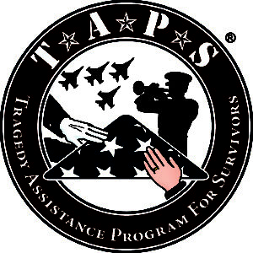
The Tragedy Assistance Program for Survivors (TAPS) is the leading national organization providing compassionate care and survivor support services for the families of America’s fallen military heroes. Since 1994, TAPS has offered support to more than 80,000 survivors of fallen military in the form of peer-based emotional support, grief and trauma resources, grief seminars and retreats for adults, Good Grief Camps for children, case work assistance, connections to community-based care, online and in-person support groups and a 24/7 resource and information helpline for all who have been affected by a death in the Armed Forces. Services are provided free of charge.
www.taps.org
TAPS Helpline: 800-959-8227 (TAPS)

SUBSIDIARY/SUBORDINATE ORGANIZATIONS

MCL AUXILLARY YOUNG MARINES
MILITARY ORDER OF DEVIL DOGS DEPARTMENT OF DEFENSE
MCL FOUNDATION U.S. MARINE CORPS
MARINE OF THE YEAR SOCIETY VETERANS AFFAIRS
U.S. MARINE YOUTH FOUNDATION
Central Illinois Leatherneck Detachment #988

From the National Marine Corps League Website
Central Illinois Leatherneck Detachment #988

Coronavirus (covid-19) info
Please know that our headquarters continues to serve as best we can remotely.
Moving forward, the Ship's Store ordering is temporarily closed until we can normalize operations.
We do expect the Mail, UPS, and FedEx receiving to be affected by the overall change in operations and are working to provide continuity or to temporarily halt the flow of paperwork. Remember that Report of Officer Installations can be emailed.
While the Marine Corps League is not an expert regarding the Coronavirus, we want to provide some resources you can refer to:
President's Coronavirus Guidelines for America
White House Updates
​World Health Organization
​Center for Disease Control
​Department of Veterans Affairs
Visit Our Library for Additional Information
Central Illinois Leatherneck Detachment #988
Central Illinois Leatherneck Detachment #988

Jarhead Java
Jarhead Java has teamed up with the Marine Corps League! Jarhead Java has a new shopping page and is offering FREE SHIPPING! Please go to jarheadjava.com and select the flat rate box containing the items you desire, and then use the coupon code MCL at checkout for FREE SHIPPING! We will then make a cash donation for each order placed using that code to the Marine Corps League - this as well as our regular donation of 50% of profits to the Semper Fi Fund/America's Fund to support our wounded heroes from ALL branches of our military. Jarhead Java is 100% Colombian Arabica - "BOLD ROAST" - coffee. Great coffee for a great cause!
Central Illinois Leatherneck Detachment #988
Central Illinois Leatherneck Detachment #988
MARINE CORPS LEAGUE
WHAT WE DO
The Marine Corps League is proud to support our Marines in many areas. We have 10 Divisions covering 48 Departments, and over 1,140 Detachments in communities across the Country.
We support the Toys for Tots efforts working with the Marine Corps Reserve and Toys for Tots Foundation to raise millions of dollars for the youth of America, collect and distribute millions of toys all across the United States.
The Marine Corps League provides funeral honors support to over 10,000 funerals per year. This support allows the Marine Corps (Active and Reserve) to focus more of their resources on mission preparation.
The Marine Corps League supports the Marine Corps Scholarship Foundation, Semper Fi Fund, Navy Marine Corps Relief Society, Mack's Marines, and the Young Marines.
We have several scholarship/award programs including the Merchant Marine Academy Marine-Option Honor Graduate, Marine Corps University Lt-Gen Lejeune (luh-jern) Leadership Award, Delta Dental Scholarship, and college scholarships through the Marine Corps League Foundation.
One of our most critical missions is assisting transitioning Marines and their families in support of the Marine Corps' Marine for Life program.
With our partners at the Marine Corps Association and Foundation, we produce the Marine Military Expositions including Modern Day Marine Expo, Marine West Expo, and Marine South Expo.
The Marine Corps League produces a quarterly publication called the Semper Fi Magazine.
Central Illinois Leatherneck Detachment #988
We have many programs supporting our Marines, their families, and our community:
Central Illinois Leatherneck Detachment #988
Veteran Service Officers (VSO)
Scouting/Eagle Scout Program
Marine Roses Program
POW/MIA Remembrance
Rifle and Pistol Competition Matches
Volunteer Assistance Veterans Service (VAVS)
Color Guards

THE END
Central Illinois Leatherneck Detachment #988

