VOICE Your Story.

The Healing Power of Poetry & Writing For Teen Girls
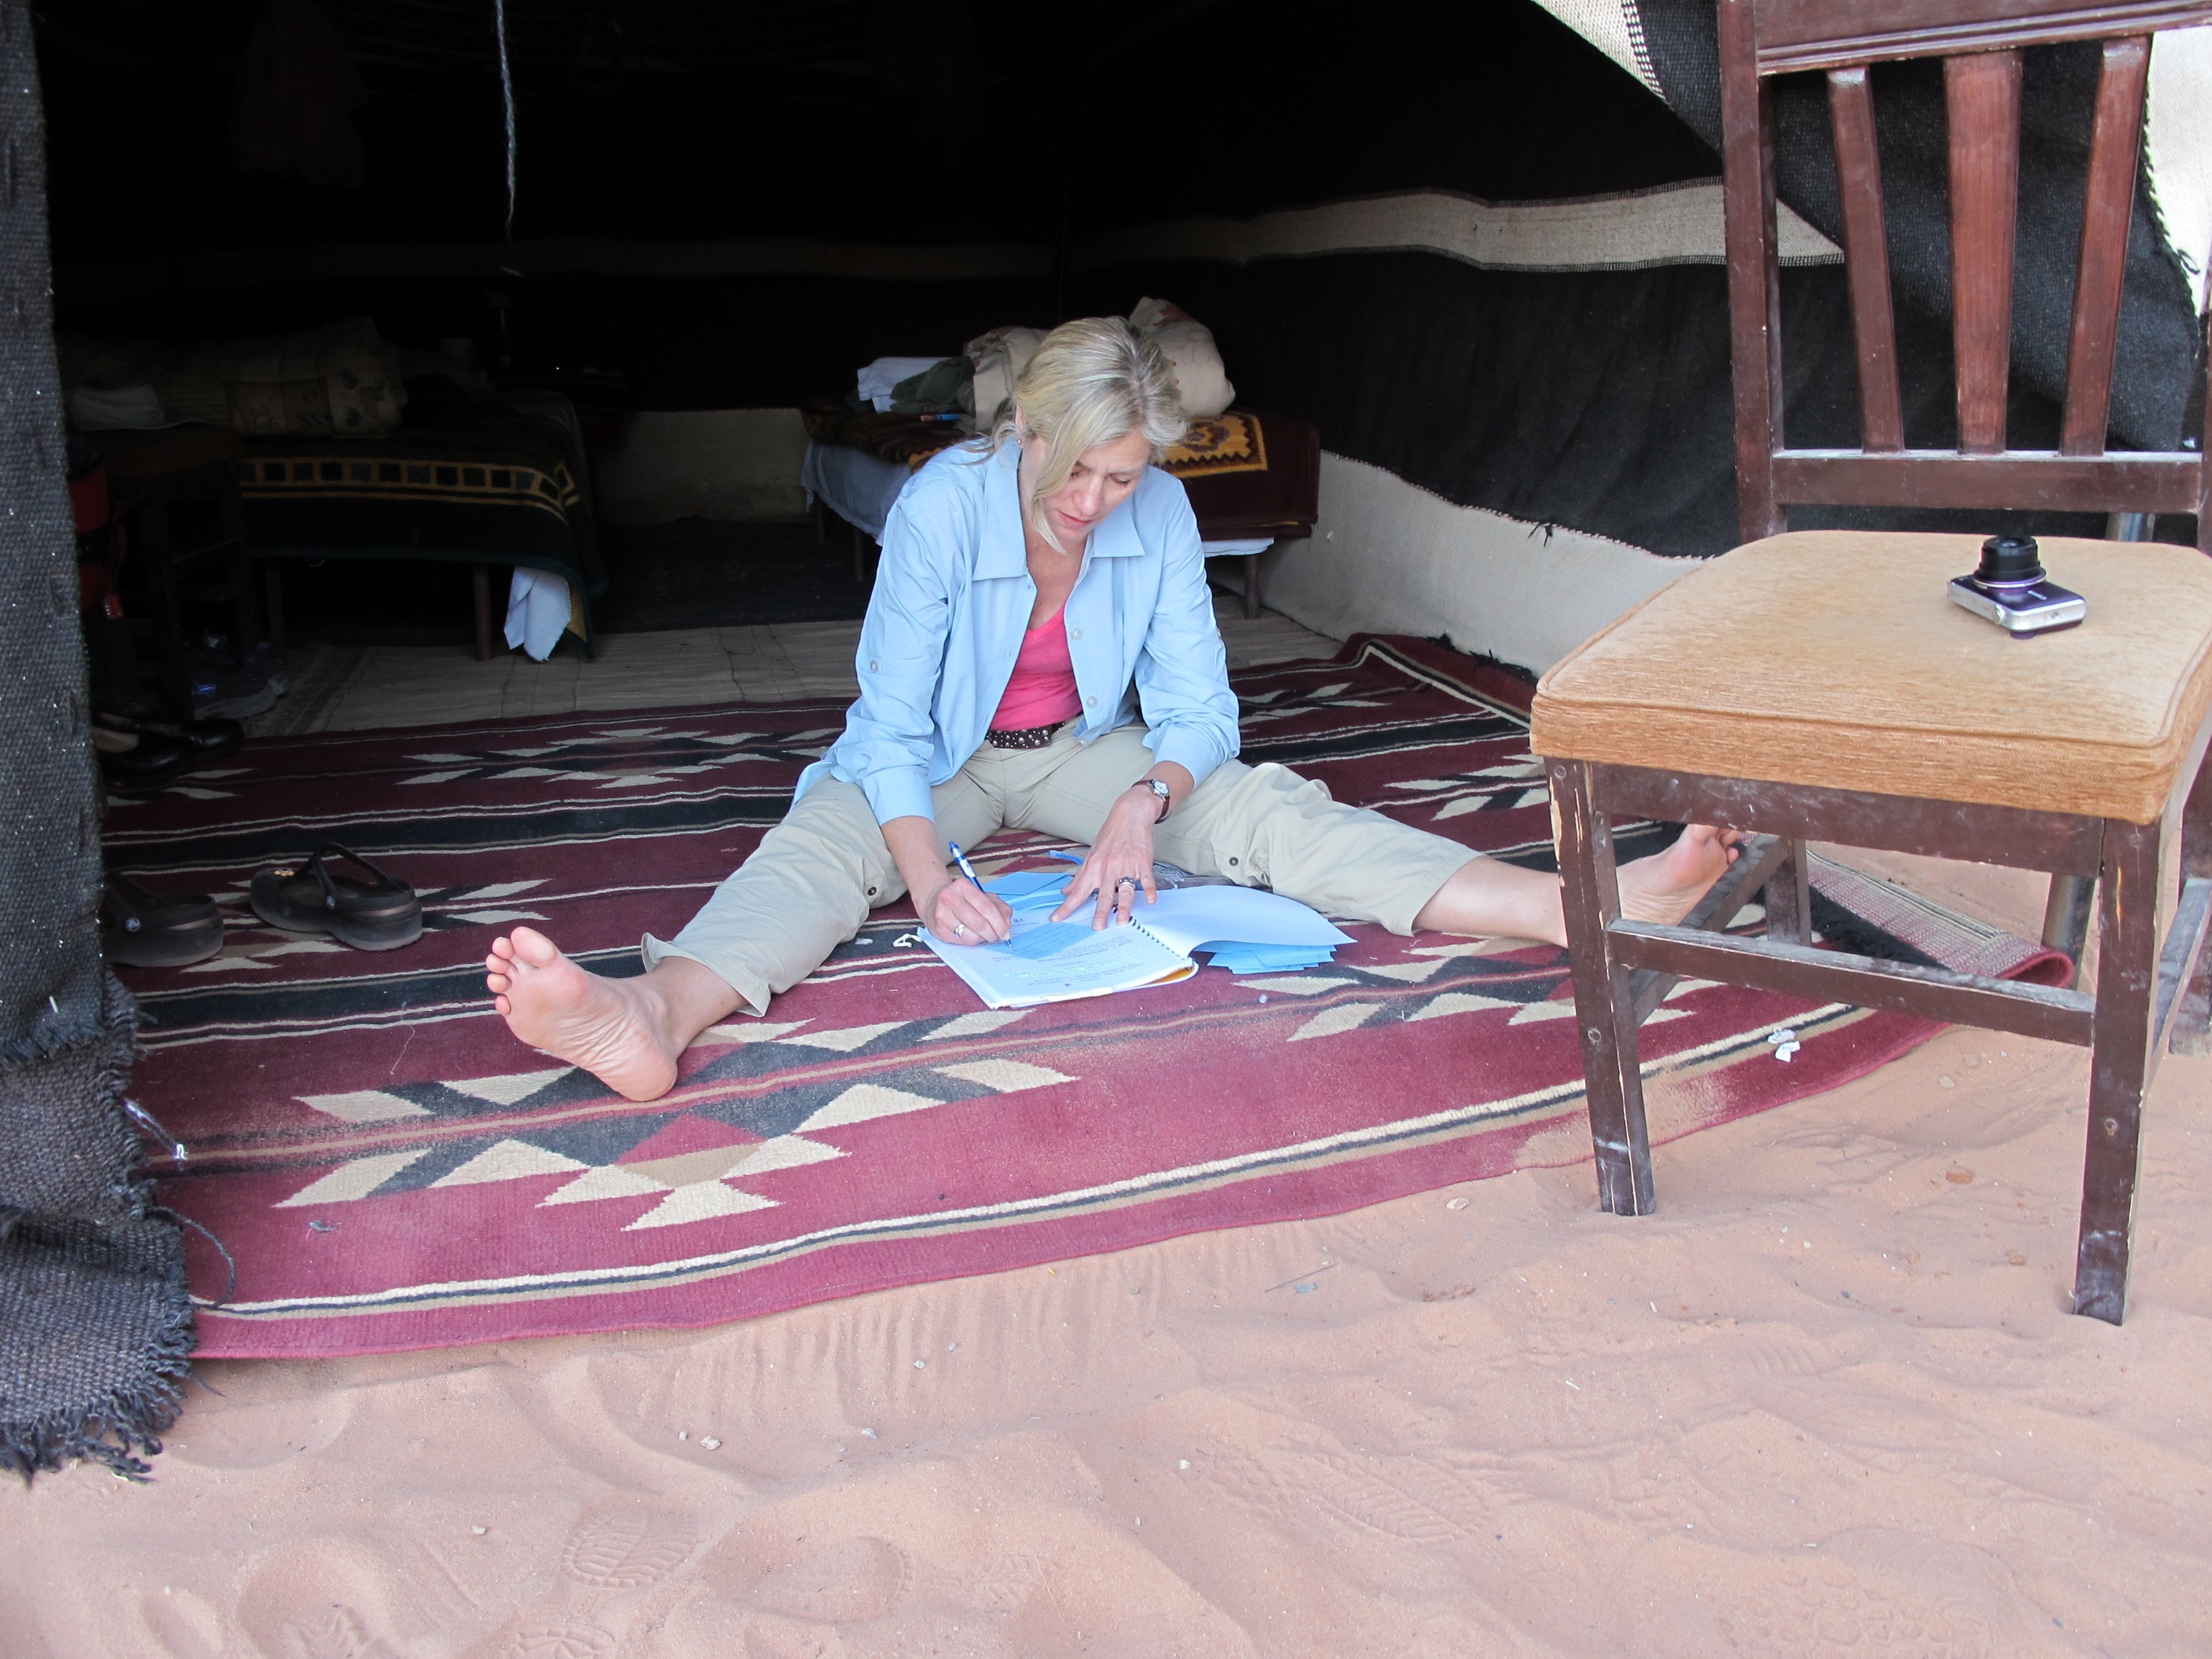  You can write any where even in a tent in the desert.  I am a licensed MFT and registered Drama Therapist who works with individuals and groups in various settings. My strong background in the arts integrates play with clinical techniques such as Hakomi, Grief work and 12 step recovery. For the past 4 years, I’ve work with Marin Shakespeare Co. directing men in therapeutic theatre at San Quentin. I love working with teens and elderly as well. I believe in the importance of warm support and encouragement to explore your dreams in a more creative way.  -Marianne Shine |  | Who This Is For  Standing at the threshold of adulthood, adolescence can be a confusing time. This healing workshop is for young emerging women. Held in a safe and nurturing environment, they will be guided to find their creative voice. We will explore the power of writing and expression. We will learn how writing is both self-regulating and self-motivating. If there is a desire, we will close our time together with a ceremonial reading .  What To Expect  - An opportunity to find your unique voice  - Create a story woven from your inner wisdom  - Gain confidence in your creativity  - Work in community with others  DATES : April 2, 16, 23, 30 MAY 7 & 14  Cost: Sliding scale $275- 325 (No session 4/9)  415-849-1761
6 Mondays 3:15-4:45pm April and May Echo Rock (above Starbucks), 45 Camino Alto Suite 204
Marianne Shine Therapy
45 Camino Alto Ste 204, Mill Valley, CA 94941
415-849-1761 | dramatxshine@gmail.com | marianneshinetherapy.com

