Welcome to our pumpkin patch!
We are excited you're here! Our ranch is home to horses all year long. During the fall, we bring in pumpkins from local growers so families can celebrate the Fall season while enjoying the beauty of our ranch. As you explore today, see what you can learn about both pumpkins and horses!

Did You Know?
- Pumpkins grow on long, green vines.
- Most pumpkins are planted in late spring and harvested in the fall.
- Pumpkins come in many colors, including orange, white, green, and even blue!
- Every pumpkin starts as a yellow flower.
- Pumpkins are actually a type of fruit because they grow from a flower and contain seeds.

Find & Count
Can you find:
- ☐ 2 pumpkins
- ☐ A scarecrow

True or False?
Circle the correct answer.
- Pumpkins grow underground. True / False
- Every pumpkin begins as a flower. True / False

Pumpkin Life Cycle
- Number these in order of a pumpkin’s life cycle:
Seed Orange Pumpkin Flower
Harvest Green Pumpkin

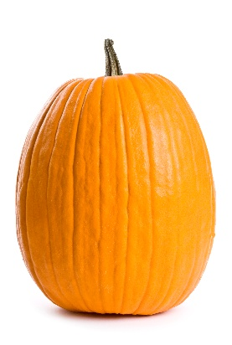
Label the Pumpkin
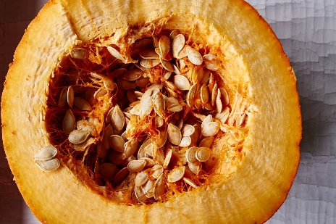
Draw lines to label a pumpkin:
- Stem
- Skin (Rind)
- Seeds
- Flesh

Observation Challenge
Find a pumpkin in the patch and look closely!
- What color is it? ____________________________________________________
- Is it smooth or bumpy? ______________________________________________
- Is it big or small? ___________________________________________________
- Estimate how many seeds might be inside! _______________________________
- Is it heavy or light? _________________________________________________
- Count the lines (ridges) on your pumpkin. ________________________________
- Does it have a long stem or short stem? _________________________________
Coloring Prompt
Draw your favorite pumpkin!

Circle the correct answer.
- Pumpkins grow on:
  - Trees
  - Vines
  - Bushes
- A pumpkin starts as a:
  - Seed
  - Flower
  - Leaf
- What do pumpkins need to grow (mark the box(es) for the correct answer)?
☐ Water
☐ Sunlight
☐ Soil
☐ Air
- What part of the pumpkin can you plant to grow another pumpkin?
  - Stem
  - Seeds
  - Leaves

Writing Prompt
Today I learned: ___________________________________________________________________________________________________________________________________________________________________________________________________________________________________________________________________________________________________________________________________________________________________________________________________________________________________________________________________________________.

