Daily Devotional Romans 2:17-29
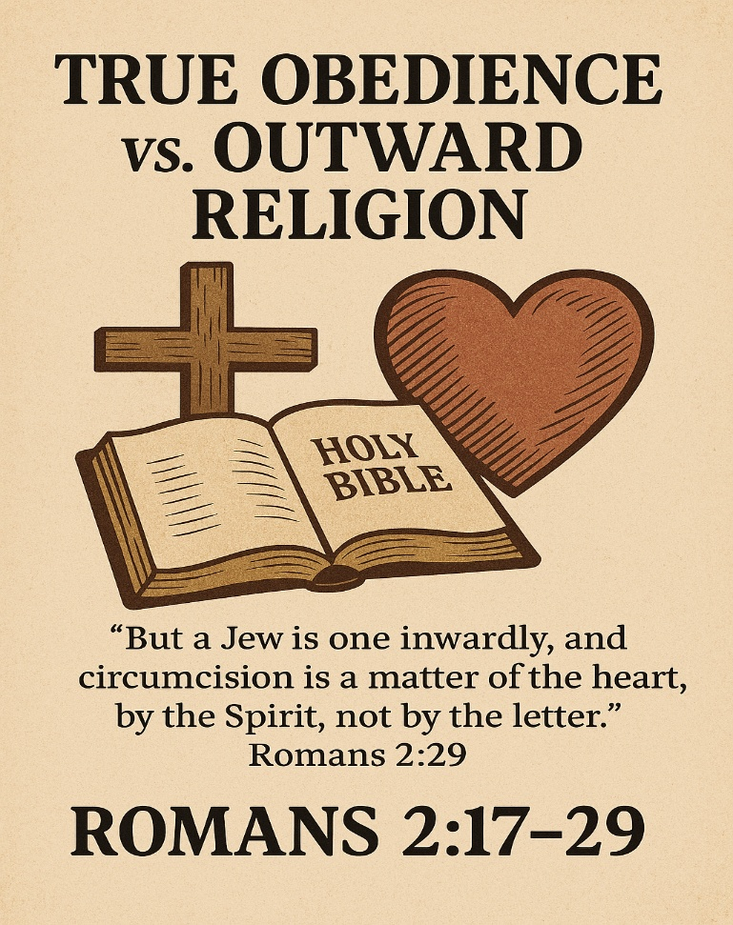

World Outreach West
  - http://www.wowchurchaz.com

7-Day Devotional Booklet: True Religion of the Heart

Day 1 – Outward Religion vs. Inward Faith
Scripture Art: Romans 2:17
“Indeed you are called a Jew, and rest on the law, and make your boast in God.”
Reflection: Titles and traditions don’t save us. Paul warns against boasting in religion without true devotion. Christianity is not about labels but about living faith.
Reflection Prompt: In what ways might I be relying on outward identity rather than inward devotion?
Prayer: Lord, keep me from empty religion. Let my faith be more than words—alive in love.
Application Checklist:
☐ Examine where you rely on labels
☐ Replace them with living faith
Journaling Section:
Today I realized…
I want to grow by…
____________________________________________________________________________________________________________________________________________________________________________________________________________________________________________________________

Day 2 – Knowledge Without Obedience
Scripture Art: Romans 2:18
“…and know His will, and approve the things that are excellent, being instructed out of the law.”
Reflection: Knowing God’s Word is not enough. True faith requires obedience. Knowledge without surrender leads to pride.
Reflection Prompt: Where do I know God’s truth but struggle to obey it?
Prayer: Father, help me not only to know Your Word but to live it daily.
Application Checklist:
☐ Put one verse into practice today
☐ Live it, not just read it
Journaling Section:
A verse I will live out today…
How I will apply it…
______________________________________________________________________________________________________________________________________________________________________________________________________________________________________________________________________________________________________
__________________________________________

Day 3 – Blind Guides
Scripture Art: Romans 2:19
“…and are confident that you yourself are a guide to the blind, a light to those who are in darkness.”
Reflection: Confidence without humility leads to hypocrisy. Paul warns against being a “blind guide.” True leadership flows from dependence on Christ.
Reflection Prompt: Am I leading others with humility or relying on my own strength?
Prayer: Jesus, make me a light that points others to You, not to myself.
Application Checklist:
☐ Encourage someone today with God’s truth
☐ Point them to Christ
Journaling Section:
Someone I can encourage today…
How I will point them to Christ…
__________________________________________________________________________________________________________________________________________________________________________________________________________________________________________________________________________________________________________________________________________________________________________________________

Day 4 – Hypocrisy Exposed
Scripture Art: Romans 2:21
“You who preach that a man should not steal, do you steal?”
Reflection: Hypocrisy damages God’s witness. Teaching others while living in sin dishonors His name. Integrity matters.
Reflection Prompt: Where do my actions fail to match my words?
Prayer: Lord, cleanse me of hypocrisy. Let my life match my words.
Application Checklist:
☐ Identify one area where actions need to align with faith
☐ Commit it to God
Journaling Section:
An area of inconsistency in my life…
Steps I will take to change…
____________________________________________________________________________________________________________________________________________________________________________________________________________________________________________________________________________________________________________________________________________________________________________________________________________________________________

Day 5 – Empty Rituals
Scripture Art: Romans 2:25
“For circumcision is indeed profitable if you keep the law; but if you are a breaker of the law, your circumcision has become uncircumcision.”
Reflection: Rituals are meaningless without obedience. Baptism, communion, or church attendance cannot replace a transformed heart.
Reflection Prompt: Do my rituals flow from love for God or habit?
Prayer: Spirit of God, circumcise my heart. Make my worship genuine and pure.
Application Checklist:
☐ Reflect on one ritual you practice
☐ Ensure it flows from love for God
Journaling Section:
A ritual I practice…
How I will make it meaningful…
__________________________________________________________________________________________________________________________________________________________________________________________________________________________________________________________________________________________________________________________________________________________________________________________

Day 6 – True Religion Defined
Scripture Art: Romans 2:28–29
“For he is not a Jew who is one outwardly… but he is a Jew who is one inwardly; and circumcision is that of the heart, in the Spirit.”
Reflection: True religion is inward transformation by the Spirit. It is love for God and obedience to His Word.
Reflection Prompt: How is the Spirit transforming my heart today?
Prayer: Lord, let my heart be alive with Your Spirit. Transform me from the inside out.
Application Checklist:
☐ Spend time in prayer asking God to renew your heart
☐ Focus on inward transformation
Journaling Section:
Evidence of God’s Spirit in me…
Areas I want Him to renew…
__________________________________________________________________________________________________________________________________________________________________________________________________________________________________________________________________________________________________________________________________________________________________________________________

Day 7 – Living Testimonies
Scripture Art: Romans 2:24
“For ‘The name of God is blasphemed among the Gentiles because of you.’”
Reflection: Our lives either glorify God or cause His name to be dishonored. True faith shines as a testimony of His grace.
Reflection Prompt: Does my life bring honor to God’s name?
Prayer: Father, may my life bring honor to Your name. Let others see Christ in me.
Application Checklist:
☐ Live today as a witness through kindness, humility, and love
☐ Let others see God’s glory
Journaling Section:
How I will honor God today…
A testimony I want to share…
__________________________________________________________________________________________________________________________________________________________________________________________________________________________________________________________________________________________________________________________________________________________________________________________

Weekly Wrap-Up
Reflection Prompt: What has God taught me this week?
Journaling Section:
Lessons I learned…
How I will live them out…
__________________________________________________________________________________________________________________________________________________________________________________________________________________________________________________________________________________________________________________________________________________________________________________________________________________________________________________________________________________________________________________________________________________________________

Closing Thought
True religion is not about outward rituals but inward transformation. It is both heart and obedience—love for God and love for people, guided by His Word.

