**59 Rothesay Road, Luton, LU1 1RB**

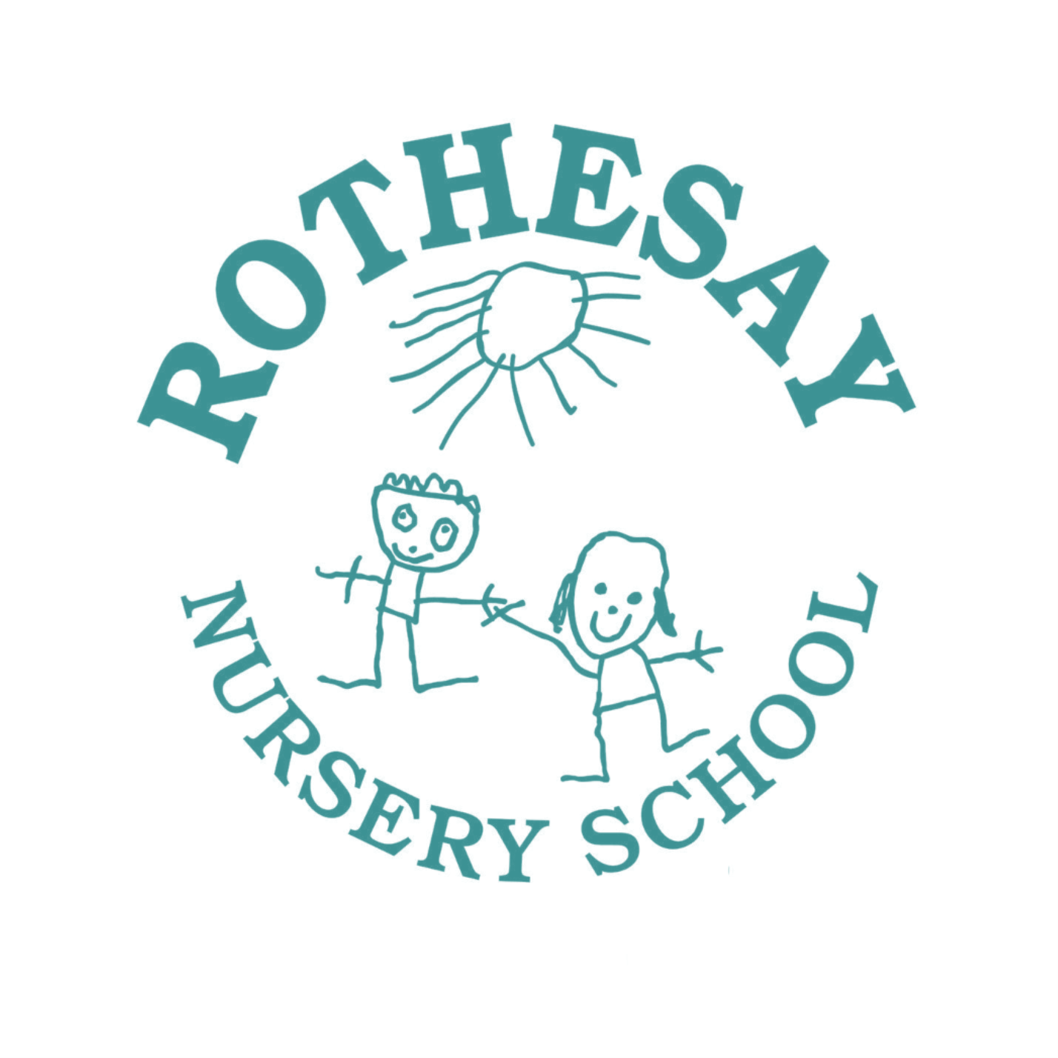



***Telephone: -* 01582 726966**

**www.rothesaynursery.co.uk**

***Headteacher: -* Mrs N Cary**

# ROTHESAY NURSERY SCHOOL

**ADMISSIONS POLICY**

Rothesay is a Local Authority maintained nursery school for children aged 2-5 years. The nursery primarily serves the local multi-ethnic community and our children come from a wide variety of backgrounds. We have an open catchment area.

Children are offered a place the term after their 3rd birthday and usually stay for 3 - 6 terms, before they transfer to an infant or primary school. We also admit 2 year olds as part of the 2 year old funding scheme. We can accommodate 80 children in the morning and afternoon sessions. We have 3 classes.

**Session Times**

**Morning Session:** 8.30am - 11.30am 5 days per week

**Afternoon Session:** 12.45pm - 3.45pm 5 days per week

**or if eligible** 30 hours education and childcare place

**Staffing**

The Headteacher is an Early Years Specialist. Each class is led by an experienced Nursery Teacher/ Early Years Specialist and other qualified staff, who work together as a team.

**Allocation of Places**

Places are offered in writing at least 3 weeks before the end of each term, when arrangements will be made for a home visit and a school visit prior to starting. However, as this is a very popular school we always have more names registered than places available, therefore not everyone may be offered a place.

Acceptance is at the discretion of the Governing Body.

**Registration**

Parents wishing to register for a place in the nursery should complete a registration form which is available from the school office or on our website.

Parents are welcome to look around the school to help them make an informed choice. They will need to book an appointment at the school office. The school prospectus is available on request. All parents are given a prospectus on the home visit.