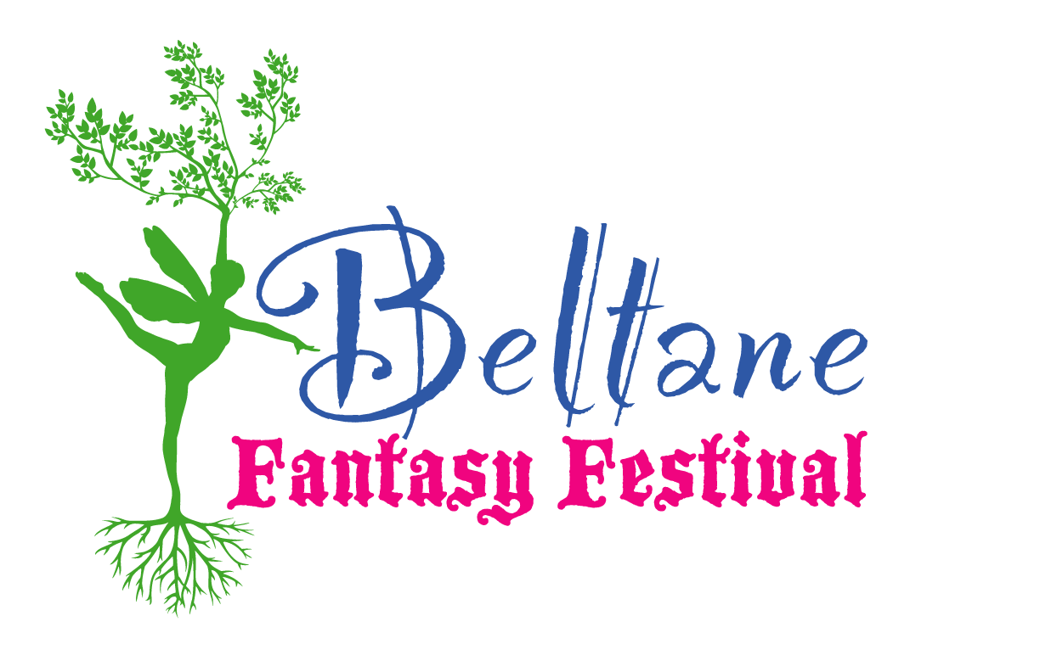

Idaho Renaissance Faire Inc

Entertainer Application

(All Fields are Required for your Act to be Considered)

Event you are Applying for:

Name of Primary Contact:

Name of Act:

Phone number:

Address:

Email:

Are you a returning entertainer?

How can we best reach you?

Short Description of Act:

Do you require space at the event?

If yes, how much space would best suit your needs?

Are you a stage performer or a street performer?

Asking Price:

Website URL:

\*If you are new to working with us, please include a video or link to one so that we may determine if your act is appropriate for our event.

Contracts will be negotiated once the application has been accepted.