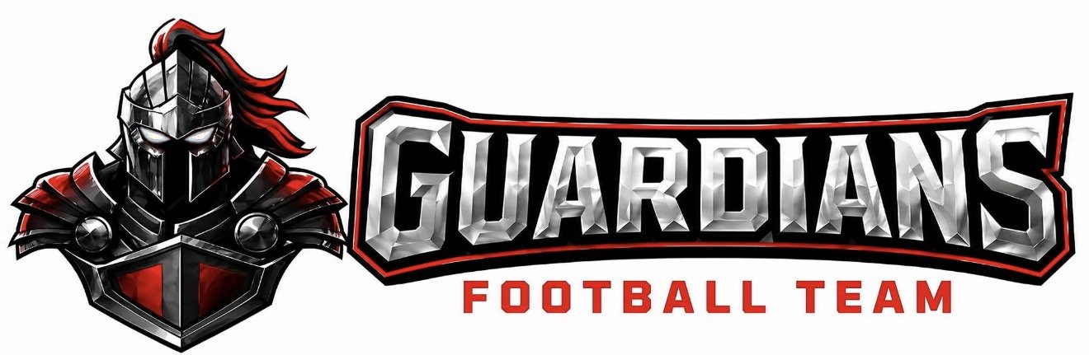
INCLEMENT WEATHER POLICY
OA Guardians Football | Southwest Missouri
Effective: 2026 Season

POLICY STATEMENT
The safety and well-being of every OA Guardians player, coach, staff member, and spectator is our highest priority. No game, practice, or team activity is worth risking the health or safety of our athletes and community. This policy establishes clear guidelines for how the OA Guardians Football program will respond to inclement weather conditions common to the Southwest Missouri region.

SECTION 1: LIGHTNING & THUNDERSTORMS
Southwest Missouri is one of the most lightning-active regions in the country. All lightning must be taken seriously.

Guidelines:
- The 30-30 Rule: The 30-30 Rule is enforced at all times — if the time between a lightning flash and thunder is 30 seconds or less, all outdoor activities must stop immediately.
- All players, coaches, and spectators must seek shelter in a sturdy building or hard-topped vehicle. Dugouts, open canopies, and trees are NOT safe shelters.
- Activities will not resume until 30 minutes have passed after the last observed lightning or thunder.
- A designated weather monitor (head coach or athletic director) is responsible for actively tracking weather conditions before and during all activities using a weather app such as WeatherBug or the National Weather Service.
- If lightning is detected within 10 miles of the activity site, all outdoor activities will be suspended immediately.

SECTION 2: SEVERE THUNDERSTORMS & HIGH WINDS
Guidelines:
- When the National Weather Service issues a Severe Thunderstorm Watch, coaching staff will begin monitoring conditions closely and prepare to suspend activity.
- When a Severe Thunderstorm Warning is issued, all outdoor activities will be suspended immediately and everyone must take shelter indoors.
- Winds exceeding 40 mph will result in suspension of all practice and game activities due to risk of flying debris, falling equipment, and unstable structures.
- All tents, canopies, and portable equipment must be secured or taken down when high winds are expected.

SECTION 3: TORNADOES
Southwest Missouri sits within Tornado Alley. Tornado threats must be treated with the utmost urgency.

Guidelines:
- When a Tornado Watch is issued, all outdoor activities will be closely monitored and may be suspended at the discretion of the head coach or athletic director.
- When a Tornado Warning is issued for the area, all outdoor activities will stop immediately. Everyone must move indoors to an interior room on the lowest floor, away from windows — such as a locker room hallway, gym interior, or interior school corridor.
- In the absence of a permanent structure, players and staff should move away from vehicles and lie flat in a low-lying ditch or depression, covering their heads.
- No one should remain in the bleachers, on the field, or inside a vehicle during a tornado warning.
- Activities will not resume until the warning has expired and conditions are confirmed safe by the head coach or designated weather monitor.

SECTION 4: EXTREME HEAT & HEAT INDEX
Southwest Missouri summers produce dangerous heat and humidity combinations that can be life-threatening during outdoor activities.

Heat Index | Required Action
Below 95°F | Normal activity with mandatory hydration breaks
95°F – 99°F | Increase water breaks, reduce intensity, monitor athletes closely
100°F – 104°F | Modify practice — limit full pads, reduce duration, increase rest periods
105°F and above | Suspend ALL outdoor activity or move indoors immediately

Additional Heat Guidelines:
- Water must be available and accessible to all players at all times.
- Players are encouraged to hydrate before arriving to practice, not just during.
- Coaches will monitor players for signs of heat exhaustion (heavy sweating, weakness, nausea, dizziness) and heat stroke (confusion, no sweating, hot skin, loss of consciousness).
- Heat stroke is a medical emergency — call 911 immediately.
- Players will NEVER be denied water or rest as a form of discipline.

SECTION 5: COLD TEMPERATURES & WIND CHILL
Southwest Missouri winters can produce dangerously cold conditions, particularly during late-season practices and playoff games.

Wind Chill | Required Action
20°F – 32°F | Normal activity; players must wear appropriate cold-weather gear
10°F – 19°F | Mandatory layering required; increase warm-up duration; monitor for frostbite
0°F – 9°F | Reduce outdoor exposure; limit practice duration; consider indoor alternative
Below 0°F | All outdoor activities suspended — no exceptions

Additional Cold Weather Guidelines:
- Coaches will monitor players for signs of frostbite (numbness, white or grayish skin on fingers, toes, nose, and ears) and hypothermia (intense shivering, slurred speech, fatigue). Both are medical emergencies — call 911 immediately.
- Players must arrive to cold-weather activities with proper base layers, gloves, and headwear.

SECTION 6: HEAVY RAIN & FLOODING
Guidelines:
- Light to moderate rain alone will not automatically suspend activities, provided there is no lightning and field conditions are safe.
- Activities will be suspended when heavy rain significantly reduces visibility, creates unsafe field conditions (standing water, slippery surfaces), or is accompanied by lightning or severe weather.
- Flash Flood Watches and Warnings will result in immediate suspension of all activities. Players and families should avoid low-lying roads, underpasses, and flooded areas when traveling.
- The head coach reserves the right to cancel or postpone any activity when rainfall makes conditions unsafe, even in the absence of an official warning.

SECTION 7: WINTER WEATHER — ICE, SLEET & SNOW
Guidelines:
- When Winter Storm Watches, Warnings, or Ice Storm Warnings are issued for Southwest Missouri, all outdoor activities will be cancelled or postponed.
- Practices and events will be cancelled any time ice accumulation is present on playing surfaces, parking lots, or walkways.
- Snow alone will not automatically cancel activities, but decisions will be made based on accumulation level, road conditions, and player safety when traveling to the facility.
- All cancellations due to winter weather will be communicated to players and families as early as possible.

SECTION 8: AIR QUALITY
Poor air quality — including conditions caused by wildfire smoke — can pose serious health risks, especially for athletes performing high-intensity outdoor activities.

AQI Level | Required Action
0 – 150 (Good/Moderate) | Normal activity; monitor sensitive athletes
151 – 200 (Unhealthy) | Modify or suspend outdoor activity; restrict athletes with respiratory conditions
201+ (Very Unhealthy) | All outdoor activities cancelled — no exceptions

- Coaches should check the AQI through AirNow.gov or a local weather app before all outdoor activities.
- Players with asthma or respiratory conditions should be especially monitored during elevated AQI days.

SECTION 9: COMMUNICATION & CANCELLATION PROCEDURES
Notification:
- All weather-related cancellations, delays, or location changes will be communicated via team group chat, email, and social media as early as possible.
- The head coach or designated staff member is responsible for making the final call on all weather-related decisions.
- Parents and guardians are encouraged to use their own judgment regarding travel to events during severe weather, even if an activity has not been officially cancelled.

Our Standard:
When in doubt, we err on the side of player safety. No game or practice is more important than the health and well-being of our athletes.

SECTION 10: EMERGENCY ACTION PLAN
In the event of a weather-related emergency, the following steps must be followed immediately:

- Call 911 immediately for any life-threatening situation.
- Notify the head coach and program director.
- Render first aid until emergency personnel arrive.
- Document the incident for program records.
- Notify parents and guardians as quickly as possible.

This policy is reviewed and updated annually by OA Guardians Football program leadership.
All coaches, staff, players, and families are expected to be familiar with and adhere to this policy.
OA Guardians Football — Protecting Our Players On and Off the Field.

