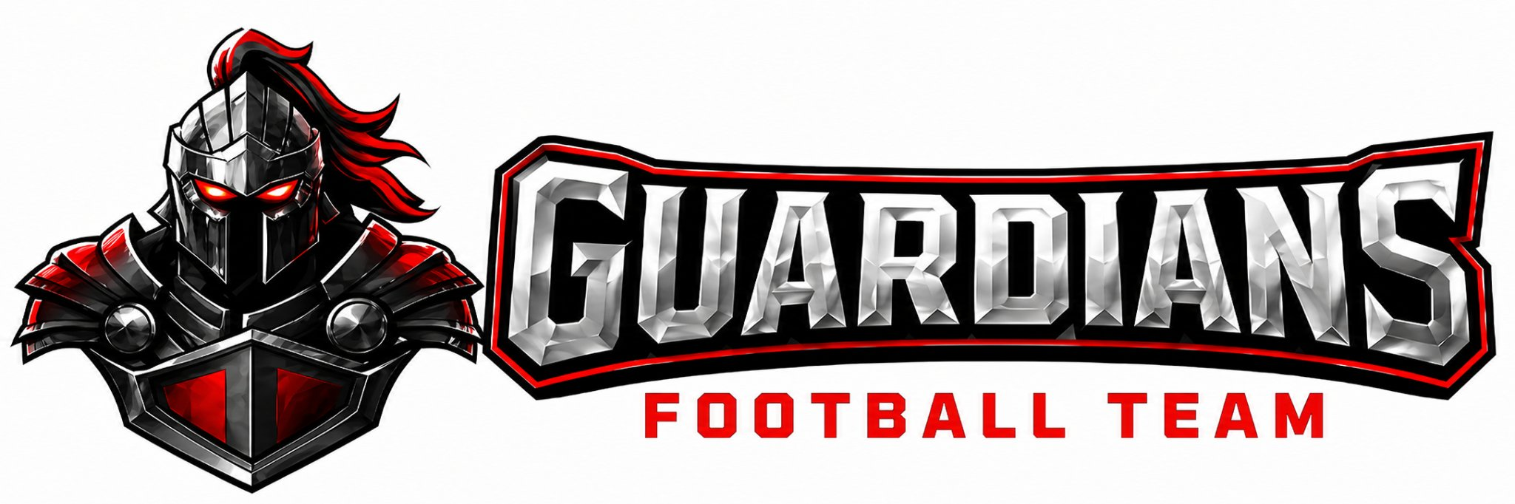

OA Guardians Football
Coaching Candidate Application & Philosophy Assessment

Please be sure to complete each section below.

SECTION 1 — Coaching Background & Availability (Circle all that apply):
1. Coaching Experience Youth, Middle School, High School, College, No formal experience
Years coaching: _______

2. Positions Coached: Offensive Line, QB, RB, WR/TE, DL, LB, DB, Special Teams, Strength & Conditioning
Primary area of expertise: _______

3. Leadership Roles: Head Coach, Coordinator, Position Coach, Volunteer Assistant, Player Leadership Only
Explain briefly:

4. Why do you coach football, and what responsibility does a coach have beyond teaching the sport?

Availability (Circle): Mon Tue Wed Thu Fri Sat

Season conflicts:

Other commitments:

SECTION 2 — Coaching Philosophy & Player Development
5. Coaching style (choose two): structured & disciplined, relationship-first, energy-driven, fundamentals focused, player-led accountability, intense competitive environment
Explain:

6. When a player repeatedly makes mistakes, your first response?
Explain why:

7. Rank priorities: Winning, Skill development, Confidence, Character, Discipline
Explain your #1 choice:

8. How do you develop less talented or late-maturing players?

SECTION 3 — Faith, Leadership & Culture
9. Faith Integration: lead devotionals, support participation, model values only, new but willing
Explain:

10. A player shows poor attitude. Write exactly what you would say to the player:

11. Parent confrontation about playing time — response and why:

12. What does servant leadership mean in a football program?

SECTION 4 — Coaching Decisions Under Pressure
13. A talented starter skips workouts but performs well on game day. What do you do and why?

14. A weaker player works hard but hurts competitiveness. How do you handle playing time?

15. Another coach disagrees with you in front of players. What is your response?

16. Your position group repeatedly fails assignments in a game. What changes next week?

17. Players criticize a teammate behind his back. What action do you take?

18. You believe the Head Coach made a wrong decision. What do you do afterward?

SECTION 5 — Football Knowledge & Areas of Focus
Offense philosophy & teaching execution:

Defense approach & teaching discipline:

Special Teams experience & competitive advantage:

Choose one primary strength: Install teacher, Technique teacher, Scheme designer, Motivator
Explain why:

SECTION 6 — Practice & Preparation
Practice structure and why:

Weekly preparation routine:

Ensuring development of non-starters:

Self-Assessment
Rate yourself 1–5:
Teaching fundamentals ___
Communication ___
Patience ___
Organization ___
Leadership ___
Football IQ ___
Describe a coaching mistake you made and what you learned:

Program Commitment Acknowledgement
I understand and agree:
Players' wellbeing comes before winning
I will never demean or embarrass players
I will support Head Coach decisions publicly
I will communicate professionally with parents
I will attend required practices and meetings
I will model Christlike character at all times
I am willing to be coached and corrected as a staff member
I understand coaching time commitment is significant
I will complete all required certifications before the season
I will follow the OA Guardians communication protocol at all times

Signature: ____________________________________ Date: _________

