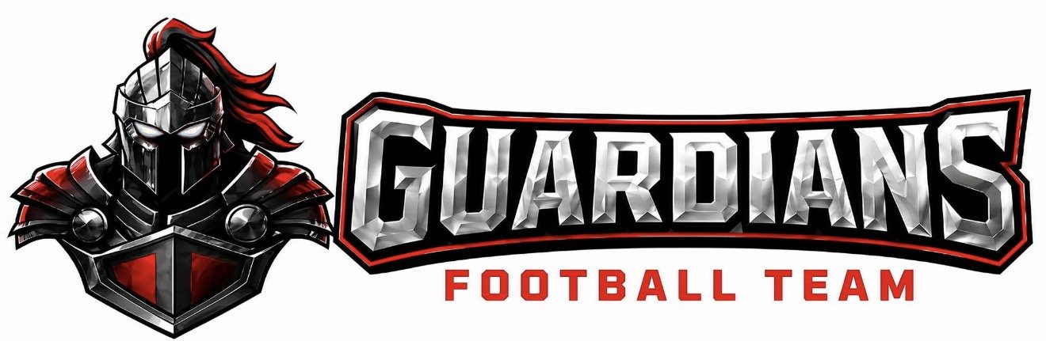
COACHING STAFF CERTIFICATIONS &
PLAYER SAFETY POLICY
OA Guardians Football | Southwest Missouri
Effective: 2026 Season

POLICY STATEMENT
The OA Guardians Football program is committed to the highest standard of player safety, coach preparedness, and child protection. Every coach, assistant coach, and team staff member is required to complete and maintain the certifications outlined in this policy before participating in any practice, game, or team activity. These requirements are non-negotiable and exist to protect our players, our coaches, and our program.

CERTIFICATION REQUIREMENTS OVERVIEW
All coaching staff must maintain current certification in every category listed below. Expired certifications must be renewed before the coach may return to the sideline.

Certification | Provider | Renewal
CPR/AED | American Red Cross or American Heart Association | Every 2 years
First Aid | American Red Cross or American Heart Association | Every 2 years
Heads Up Football | USA Football / NFL | Annual
Concussion Recognition | CDC Heads Up Program | Annual
Mandatory Reporter Training | Missouri DCFS or Approved Provider | Annual

SECTION 1: CPR & AED CERTIFICATION
Sudden cardiac arrest is one of the leading causes of death in young athletes. Every member of the OA Guardians coaching staff must be trained and prepared to respond immediately if a player experiences a cardiac emergency on the field.

Requirements:
- All head coaches, assistant coaches, and team staff must hold a valid CPR and AED certification from the American Red Cross or the American Heart Association.
- Certification must be renewed every two (2) years. Expired certifications are not accepted.
- At least two (2) certified staff members must be present at every practice and game.
- Coaches must know the location of the nearest AED at every facility used by the program.
- An AED must be accessible and on-site at all home games and practices when possible.

In the Event of a Cardiac Emergency:
- Call 911 immediately.
- Begin CPR if the athlete is unresponsive and not breathing normally.
- Deploy the AED as soon as it is available and follow the device prompts.
- Do not stop CPR until emergency medical services arrive and take over.
- Notify the program director and the athlete's parents or guardians immediately.

SECTION 2: FIRST AID CERTIFICATION
Football carries an inherent risk of injury. Coaches must be equipped to assess and respond to injuries on the field before medical professionals arrive.

Requirements:
- All coaching staff must hold a valid First Aid certification from the American Red Cross or the American Heart Association.
- Certification must be renewed every two (2) years.
- A stocked first aid kit must be present at every practice and game. The kit must be inspected and restocked at the beginning of each season.

First Aid Kit Must Include at Minimum:
- Sterile gauze pads, bandages, and medical tape
- Disposable gloves (multiple pairs)
- Cold/ice packs
- Scissors and tweezers
- Emergency contact information for all athletes
- Inhaler access information for players with asthma
- Written emergency action plan

General First Aid Protocol:
- Coaches may provide basic first aid but must not diagnose injuries.
- Any injury involving the head, neck, spine, or loss of consciousness must be treated as a medical emergency — call 911 and do not move the athlete.
- No player may return to activity following a significant injury without clearance from a medical professional.

SECTION 3: HEADS UP FOOTBALL CERTIFICATION
The OA Guardians Football program is committed to teaching the game the right way — with proper technique that reduces the risk of concussion and serious injury. All coaching staff are required to be certified through the USA Football Heads Up Football program.

Requirements:
- All coaches must complete USA Football's Heads Up Football coaching certification before the first practice of the season.
- Certification must be renewed annually.
- Heads Up Football techniques — including heads-up tackling, blocking, and ball carrier fundamentals — must be taught and enforced at every practice.

Core Heads Up Football Principles Taught by All Coaches:
- Heads Up Tackling: Eyes up, see what you hit. Drive through the contact. Never lead with the crown of the helmet.
- Heads Up Blocking: Proper shoulder and hand placement. No helmet-to-helmet contact.
- Ball Security: Proper carry technique to reduce contact to the head during collisions.
- Concussion Awareness: Coaches, players, and parents are educated on concussion signs, symptoms, and the return-to-play protocol.

Concussion Protocol:
- Any player suspected of having a concussion must be removed from activity immediately.
- "When in doubt, sit them out." A player does not need to be unconscious to have a concussion.
- A player may not return to practice or games until cleared in writing by a licensed healthcare professional.
- The program follows Missouri state law regarding concussion management in youth sports.

A coach who knowingly allows a player with a suspected concussion to continue playing will face immediate removal from the coaching staff.

SECTION 4: CHILD ENDANGERMENT POLICY
The OA Guardians Football program has a zero-tolerance policy for any form of child endangerment. Every member of our coaching staff and program leadership is responsible for maintaining an environment that is physically and emotionally safe for every player.

Prohibited Conduct — Coaches and Staff May Never:
- Use physical punishment of any kind as a form of discipline.
- Verbally abuse, demean, humiliate, or bully any player.
- Use excessive physical conditioning as punishment (e.g., running players until they vomit or collapse).
- Isolate a player from the team or from communication with parents or guardians.
- Transport a player alone in a vehicle without a second adult present.
- Communicate with players through private messages on social media or personal cell phones without a parent or guardian copied.
- Administer any medication, supplement, or substance to a player without written consent from a parent or guardian.
- Allow players to practice or compete in conditions that present a known, unreasonable risk of harm.

Safe Environment Standards:
- The two-deep rule must be followed at all times — no coach should ever be alone with a single player without another adult present.
- All coaches are subject to a criminal background check before joining the program. Background checks are renewed annually.
- Any coach found to have engaged in conduct that endangers a child will be removed from the program immediately and reported to the appropriate authorities.

Violations of this policy will result in immediate termination from the OA Guardians coaching staff and referral to law enforcement.

SECTION 5: MANDATORY REPORTER POLICY
Under Missouri law (RSMo § 210.115), all coaches and staff who work with children are designated mandatory reporters. This means every member of the OA Guardians coaching staff is legally required to report any known or reasonably suspected child abuse or neglect — without exception.

What Is a Mandatory Reporter?
A mandatory reporter is any person who, in the course of their professional duties, has reasonable cause to suspect that a child has been subjected to abuse or neglect. In Missouri, this includes youth sports coaches, volunteers, and program staff.

What Must Be Reported:
- Physical abuse — any non-accidental physical injury to a child.
- Sexual abuse — any sexual contact, exploitation, or exposure involving a minor.
- Emotional abuse — persistent patterns of belittling, threatening, or rejecting a child.
- Neglect — failure to provide adequate food, shelter, clothing, supervision, or medical care.
- Any situation where a child appears to be in immediate danger.

How to Report:
- Missouri Hotline: Reports must be made to the Missouri Child Abuse and Neglect Hotline:
1-800-392-3738 (available 24 hours a day, 7 days a week)
- Reports may also be made online at: reportchildabuse.missouri.gov
- If a child is in immediate danger, call 911 first, then notify the hotline.
- After making a verbal report, a written report may be required within 48 hours.

Important Legal Protections & Obligations:
- You do not need proof of abuse to make a report — reasonable suspicion is enough.
- Mandatory reporters who fail to report known or suspected abuse may face criminal charges under Missouri law.
- Reporters who make a good-faith report are protected from civil and criminal liability, even if the report is later found to be unsubstantiated.
- Confidentiality: The identity of the reporter is kept confidential by the state.
- Reports should never be delayed while waiting for program leadership approval — the legal obligation belongs to the individual who suspects abuse.

Program Responsibility:
- All coaches must complete Missouri-approved Mandatory Reporter training before the start of the season. Training must be renewed annually.
- The head coach or program director must be notified after a report is made, but notification of leadership does not replace the legal obligation to report directly to the hotline.
- The OA Guardians Football program will fully cooperate with any investigation by child protective services or law enforcement.
- Retaliation against any person who makes a good-faith report of suspected abuse is strictly prohibited and will result in immediate removal from the program.

Every coach has both a legal and moral obligation to speak up for children who cannot speak for themselves. If you see something — report it.

COACH ACKNOWLEDGEMENT & COMPLIANCE
All OA Guardians coaching staff members are required to sign and return this acknowledgement before participating in the program. Proof of current certifications must be submitted to the program director before the first practice of the season.

Coach Name (Print):
Signature:
Date:
Role / Title:

This policy is reviewed and updated annually by OA Guardians Football program leadership.
All coaching staff are required to comply fully with every section of this policy.
OA Guardians Football — Developing Champions On and Off the Field.

