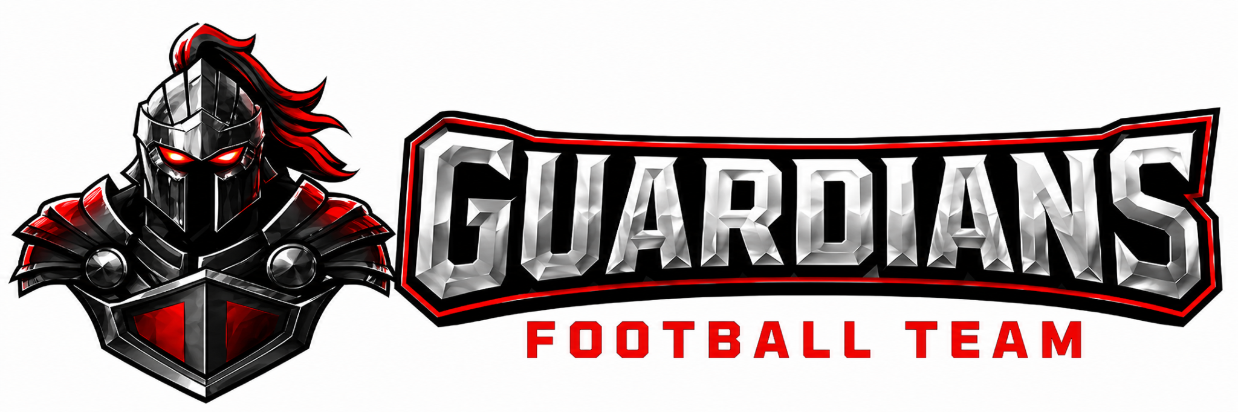

OA GUARDIANS
FOOTBALL COACHING GUIDE

VISION STATEMENT
“Building Men of Character. Competing with Excellence. Honoring Christ in All Things.”

WELCOME
Dear Coach,
Welcome to the OA Guardians Football Program. You are joining a ministry, not just a team. Your influence will shape young men spiritually, academically, athletically, and personally. This guide outlines the standards, expectations, and culture that define our program.
We are grateful you are here. Let’s build something excellent — for Christ, for the OA Guardians community, and for our players.
In His service,
Coach Mboob

1. PROGRAM OVERVIEW
1.1 Vision
To develop Christ-centered student-athletes who pursue spiritual maturity, academic excellence, athletic discipline, and outstanding character.
1.2 Mission
We exist to:
- Train student-athletes to honor Christ through discipline, teamwork, and integrity
- Prepare athletes through intentional coaching and sound fundamental execution
- Build character rooted in biblical truth
- Establish a tradition of excellence that represents Christ to our communities

2. CORE VALUES

Every coach must model and reinforce the following values:
- Commitment
- Integrity
- Pride
- Teamwork
- Resilience
- Humility
- Servant Leadership

These values guide every decision, interaction, and expectation within the program.

3. COACHING PHILOSOPHY
Our football identity is built on:
- Disciplined, physical defense
- A relentless, attacking offense
- Special teams that consistently create competitive advantages

Our coaching approach emphasizes:
- Fundamentals and proper technique
- Intentional teaching and preparation
- Positive, corrective discipline
- Christlike leadership
- Player safety
- Accountability and continuous growth

4. COACH EXPECTATIONS

4.1 What OA Guardians Coaching Looks Like
Coach on the move, correct briefly, praise publicly and correct privately, teach effort first, never lecture during drills

4.2 Staff Unity Rule
Coaches never contradict another coach in front of players. All disagreements resolved privately before next practice.
4.3 Roles
- Head Coach: Culture and final decisions
- Coordinators: Scheme and game planning
- Position Coaches: Technique instruction and grading
4.4 Player Development
- Youth Level (Foundation Phase) Focus: Safety, fundamentals, love of the game Players learn stance, alignment, tackling posture, ball security, and effort habits. Success Measure: Can safely execute fundamental techniques at controlled speed.

- Junior Varsity (Execution Phase) Focus: Assignment discipline and football IQ Players execute scheme responsibilities and understand situational football. Success Measure: Correct assignment >80% of reps in practice and games.

- Varsity (Mastery Phase) Focus: Situational mastery and competitive performance Players execute under pressure, communicate adjustments, and play fast. Success Measure: Consistent performance regardless of opponent or environment.
4.5 Professional Conduct
Coaches must:
- Uphold the highest moral and ethical standards
- Never place winning above player wellbeing
- Dress professionally and represent the OA Guardians with pride
- Refrain from profanity, sarcasm, or belittling language
- Handle disagreements privately and never in front of players

4.6 Preparation & Organization
Coaches must:
- Arrive on time and fully prepared
- Provide written practice plans (position and scout team coaches)
- Ensure assistant coaches are prepared and aligned
- Know rules, concepts, and techniques and teach them accurately
- Maintain a safe environment, including proper equipment, drill design, hydration, and concussion awareness

4.7 Academic & Personal Development
Coaches must:
- Promote and support academic achievement
- Reinforce that school responsibilities come before athletics
- Discourage and actively prevent substance use
- Encourage leadership, character development, and spiritual growth

The Head Coach has final authority on all football-related decisions, including discipline, playing time, and staff responsibilities, in alignment with OA Guardians’ policies.

5. COMMUNICATION PROTOCOL

Required Chain of Communication
- Player → Position Coach
- Player → Head Coach
- Parent → Position Coach
- Parent → Head Coach
- Football Director or Athletic Director (only if unresolved)

Coaches are expected to respond to communications within 24 hours and maintain professionalism at all times.

6. PLAYER DEVELOPMENT STANDARDS

Coaches must:
- Teach fundamentals appropriate to each grade and developmental level
- Match players by size, skill, and aggressiveness when necessary
- Encourage late-maturing athletes
- Provide consistent, constructive feedback
- Celebrate effort, improvement, and growth
- Ensure every player has a positive and developmentally appropriate experience

7. DISCIPLINE & DUE PROCESS
Non-Negotiable
A player may never be dismissed from the team without due process and Head Coach review.
Corrective Action Steps
- Pull the player aside and clearly explain the behavior and expectations
- Remove the player from the drill, practice, or game until ready to rejoin
- Use appropriate physical reset activities when applicable
- If behavior continues, remove the player again and notify the head coach
- Document repeated issues and share documentation with the Head Coach
- Review with the Head Coach and discuss next steps to include parents and AD

Discipline Will Never Include
- Degrading or embarrassing a player
- Excessive or punitive physical activity
- Physical grabbing, including facemask pulling

8. GOOD SPORTSMANSHIP
Coaches must consistently model:
- Respect
- Humility
- Integrity
- Encouragement

Examples of Good Sportsmanship
- Helping opponents up
- Showing concern for injured players
- Accepting referee decisions
- Encouraging less experienced teammates
- Congratulating opponents

Examples of Poor Sportsmanship
- Trash talking
- Intentional injury
- Cheating
- Blaming others
- Running up the score
Violations of sportsmanship standards may result in disciplinary action, up to and including dismissal.

9. COACH–REFEREE COMMUNICATION

Coaches must:
- Speak calmly and respectfully
- Ask for clarification, not arguments
- Understand that judgment calls are not debatable
- Never insult or intimidate officials
- Treat officials as partners in creating a safe and fair environment

10. SAFETY & RISK MANAGEMENT
Coaches must:
- Ensure proper fitting and use of all equipment
- Teach and reinforce safe tackling and blocking techniques
- Monitor hydration, weather, and heat conditions
- Immediately remove any player with a suspected concussion
- Require physician clearance before return to play

11. COACHING CODE OF CONDUCT
Coaches commit to:
- Leading with fairness, honesty, and humility
- Prioritizing emotional, spiritual, and physical wellbeing
- Promoting inclusion and treating every player with dignity
- Addressing bullying or harassment immediately
- Maintaining appropriate boundaries with players
- Avoiding inappropriate social media content
- Refraining from private direct messaging with players
- Using only approved communication platforms
- Never providing rides without a third person present
- Ensuring a drug-, tobacco-, and alcohol-free environment
- Communicating openly and respectfully with families
- Creating a safe, supportive, and enjoyable environment
- Completing all required certifications
- Using provided coaching resources (iPads, playbooks, technology)
- Modeling Christlike leadership at all times

12. PRESEASON PREPARATION CHECKLIST
Before the first practice:
- Read the Coaching Manual in full
- Complete all required certifications
- Review practice schedules and playbooks
- Meet with the Head Coach and staff
- Understand emergency and safety procedures
- Confirm equipment and supply needs

13. IN-SEASON EXPECTATIONS

13.1 OA Guardians Coaching Model
- Demonstrate
- Walk-through
- Half-speed
- Full speed
- Competitive
- Reinforce immediately.
All coaches teach using the same progression for consistency across levels
13.2 Culture & Spiritual Leadership
- Lead or support team devotionals
- Pray with players
- Model Christ-centered leadership
- Reinforce humility, service, and gratitude
- Celebrate character as much as performance

13.3 Week One Priorities
- Learn all player names
- Establish clear expectations
- Teach base fundamentals
- Build strong relationships
- Reinforce safety protocols

13.4 Film & Game Planning
- Review previous game film (position coaches)
- Identify corrections for each position group
- Prepare weekly installs for offense, defense, and special teams
- Meet with coaching staff to align on the game plan

13.5 Practice Planning
- Create detailed written practice plans
- Script team periods (inside run, team offense/defense, special teams)
- Prepare individual and group drills
- Confirm equipment and technology needs
- Communicate weekly schedules to players and parents

13.6 Practice Tempo Standards
- Rep spacing under 20 seconds
- One coaching point per rep
- No long-standing lines
- Fast transitions
- High engagement
13.7 During Practice
- Coach with energy, clarity, and purpose
- Reinforce fundamentals daily
- Correct with grace and praise with intention
- Maintain tempo and discipline
- Ensure safety in all drills
- Track repetitions to support development and rotations

13.8 Practice Design
- Dynamic Warmup
- Individual Fundamentals
- Group Instruction
- Team Execution Periods
- Situational Football
- Conditioning / Competition

13.9 After Practice
- Communicate next-day reminders
- Check in with injured athletes
- Pray together
- Ensure fields and equipment are cleaned and secured

14. GAME DAY EXPECTATIONS
14.1 Sideline Standards
- Maintain professionalism at all times
- Use positive, respectful language
- Encourage players consistently
- Correct calmly and clearly
- Respect officials and opponents
- Support fellow coaches
- Keep the sideline organized, safe, and focused

14.2 Post-Game
Immediately following the game:
- Shake hands respectfully
- Address the team briefly
- Celebrate effort and sportsmanship
- Pray together

15. END-OF-SEASON CHECKLIST
- Collect and inventory equipment
- Conduct player exit interviews
- Review season data (attendance, injuries, performance)
- Celebrate team accomplishments
- Plan for off-season development

16. ACKNOWLEDGMENT FORM
I acknowledge that I have read, understand, and agree to uphold the standards, expectations, and responsibilities outlined in the OA Guardians Football Program Coaching Manual.
Coach Name: ___________________________
Signature: ______________________________
Date: __________________________________

