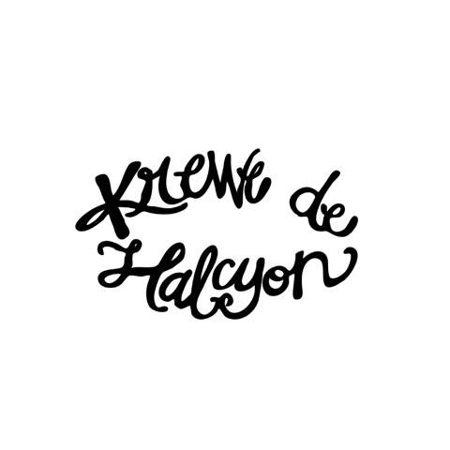

16483 Summerlin Drive, Prairieville, Louisiana 70769 ~ krewedehalcyon@gmail.com

PARADE COSTUME ORDER FORM
(2020 MARDI GRAS PARADE)

MEMBER NAME(S):
(FIRST) (LAST)

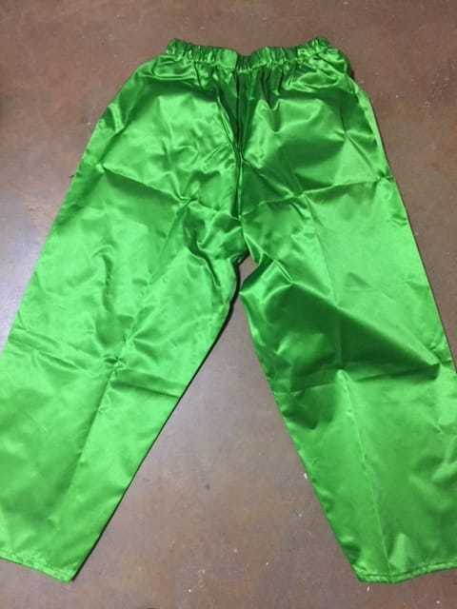
Quantity
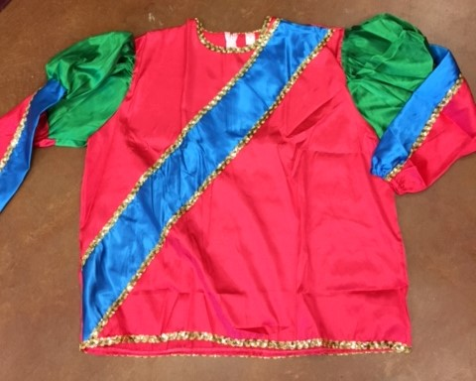

Adult Small

Adult Medium
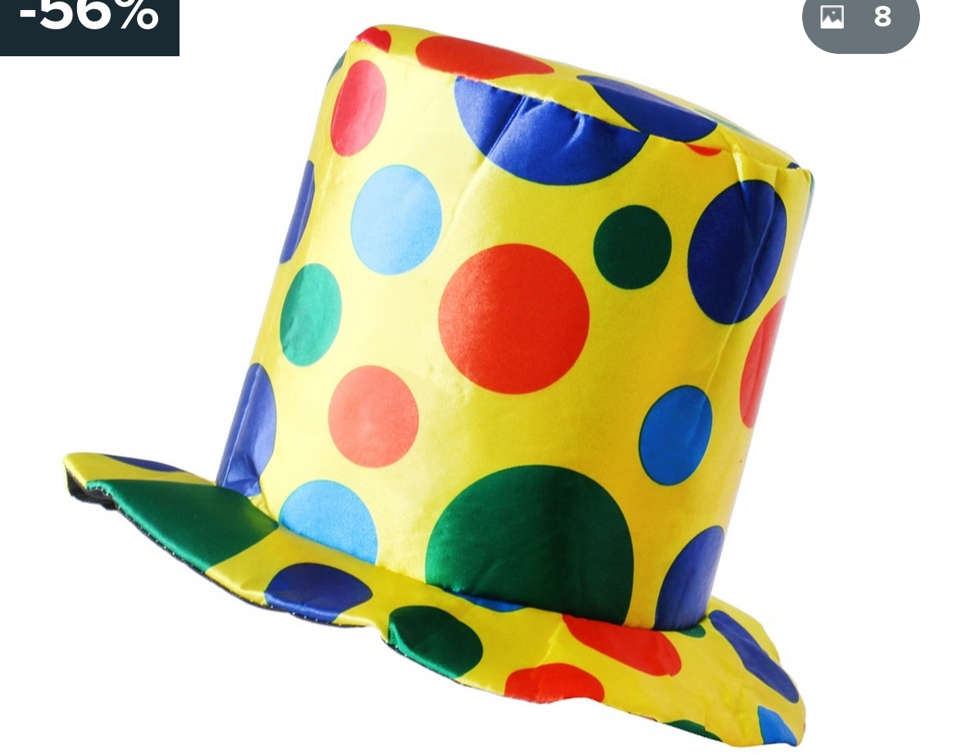
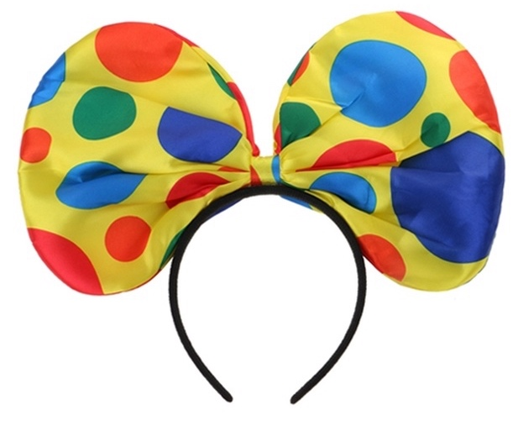
Adult Large

Adult X-Large

Adult 2X-Large

Adult 3X-Large
Includes top, matching green pants & hat/headpiece

Total Number: x $60.00 = $

Please make your check payable to Krewe de Halcyon and deliver it to the following address or pay online on our Krewe Store at www.krewedehalcyon.com:
Vickie Hall
16483 Summerlin Drive
Prairieville, LA 70769

Contact Vickie Hall at (225) 400-4383 or krewedehalcyon@gmail.com with any questions about the order.

PARADE DAY IS 2/15/2020!

ORDERS ARE DUE NO LATER THAN OCTOBER 31ST.

