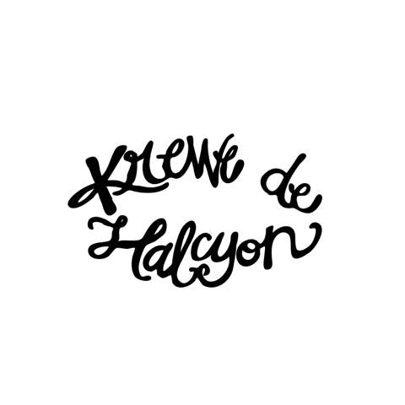

16483 Summerlin Drive, Prairieville, Louisiana 70769 ~ krewedehalcyon@gmail.com

**T-SHIRT ORDER FORM**

**(2020 MARDI GRAS BALL)**

**Description: Red shirt with white Krewe logo on the front and Ball logo (circus theme) on the back**

MEMBER NAME:

(FIRST) (LAST)

Quantity

Adult Small

Adult Medium

Adult Large

Adult X-Large

Adult 2X-Large

Adult 3X-Large

Total Number: x $20.00 = $

TOTAL = $

Please make your check payable to **Krewe de Halcyon** and deliver it to the following address or pay online on our Krewe Store at [www.krewedehalcyon.com](http://www.krewedehalcyon.com):

Nichole Sitz

16286 Natalie Lane

Prairieville, LA 70769

Contact Nichole Sitz at (225) 253-8284 or [krewedehalcyon@gmail.com](mailto:krewedehalcyon@gmail.com) with any questions about the order.

**ORDERS ARE DUE NO LATER THAN JANUARY 7, 2020.**