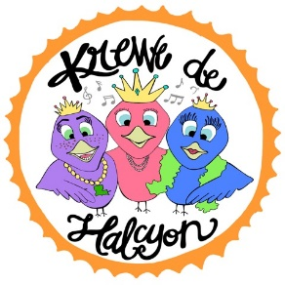

As part of our mission, we will continue to positively impact our community. Here are the ways Krewe de Halcyon has touch the lives of others since May 2015:

* Helped flood victims - Volunteered at Lamar Dixon’s shelter; worked at individuals’ homes; collected and donated clothes, household products and personal hygiene items
* Dutchtown High School's Dress for HOCO Success Project - Kids were able to choose from several hundred dresses and suits.  There was no limit to their shopping spree!
* Donated over 60 pair of eyeglasses to the Lions Club International “Recycle for Sight” Program
* Participate in Wreaths Across America each year
* Adopted families in need during the holidays
* Participate and raise money for the Muscular Dystrophy Association Family Day, American Heart Association Walk, and Ascension Veterans Associations’ Musical Tribute Fundraisers
* Homeless Outreach Projects - Prepare and donate personal hygiene bags for the homeless with notes of encouragement (a total of 200 bags and counting)
* Annual St. Jude Walk/Run
* Annual Gonzales Veterans’ Parade
* Sponsored the Dutchtown HS Debate Team’s HOCO float in a local parade.
* Sponsor the Ascension Veterans Association – attend monthly meetings, help with projects and fundraisers
* Collected and donated coats and socks for kids during the winter
* Volunteer at Farm Day – a special day where children and their families are able to eat, play games, do crafts, ride horses and pet animals for free!
* Collected eye glasses and hats for the Honduras Mission Trip, as well as donated 2 Mardi Gras Ball tickets to St. John’s raffle to help raise money for projects with the Olancho Aid Foundation
* Sponsored raffle for the Christy Dugas Medical Fund
* Operation Christmas Child Project
* Partnership Investment Sponsor of the Jambalaya Festival
* Helping Heal Little Hearts Sponsor of the Louisiana Pediatric Cardiology Foundation
* Sponsor of The Arc of East Ascension’s Dancing for a Cause fundraiser
* Participant in the Ryan’s Sickle Cell Anemia Walk/Run fundraiser
* Participant in the March of Dimes Walk/Run fundraiser

What’s next? Let us know...*live.love.give.*