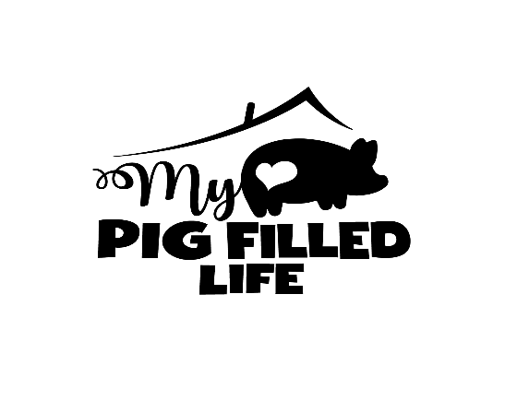
SPONSOR COMMITMENT
Name __________________________________________
Address_________________________________________
Email___________________________________________
Shirt Size________________________________________

I agree to sponsor _______________________for 12 months for $20 per month. I understand that my sponsorship donation is used in a general fund to cover My Pig Filled Life rescue expenses including but not limited to feed, vet care, housing and bedding.

___________________________________ ___________________
Signature Date

