09/9/2026
Pastor Mark Choate
Bible Study Notes

strangers and pilgrims
entering the Promised Land
- Talk about Why mercy showed up
- Do you know your word?
Psalm 51:5 – “Surely I was sinful at birth, sinful from the time my mother conceived me,”
emphasizing that sin is part of human nature from conception
shalt not wear
Deuteronomy 22:11 KJV
11 Thou shalt not wear a garment of divers sorts, as of woollen and linen together.
outlines laws for the Israelites
This command appears in Deuteronomy 22:11, part of a section in the Book of Deuteronomy that outlines laws for the Israelites as they prepare to enter the Promised Land. The verse is paired with a related instruction in Deuteronomy 22:12, which commands making tassels (tzitzit) on the corners of garments
Meaning and Purpose
Scholars and commentators explain that the prohibition against mixing wool and linen was not merely about fashion but about identity, purity, and separation from surrounding pagan cultures

Wool symbolized the animal kingdom and God’s creation.
Linen came from flax, representing agricultural life and human labor. Mixing these fabrics could have been seen as blending the sacred (God’s creation) with the secular (pagan practices), which was spiritually risky in the ancient Near East

By keeping clothing distinct
By keeping clothing distinct, the Israelites were to set themselves apart as God’s chosen people, maintaining a visible sign of their allegiance to Him in a world filled with idolatry and moral compromise
Practical Application
While the cultural context is ancient, many believers see this as a principle about holiness in daily life — maintaining boundaries between what is spiritually pure and what is not. It can be interpreted as a call to dress in a way that reflects one’s values, identity, and commitment to God, rather than conforming to worldly influences
chosen generation
1 Peter 2 9-12
9 But ye are a chosen generation, a royal priesthood, an holy nation, a peculiar people; that ye should shew forth the praises of him who hath called you out of darkness into his marvellous light;
10 Which in time past were not a people, but are now the people of God: which had not obtained mercy, but now have obtained mercy.
11 Dearly beloved, I beseech you as strangers and pilgrims, abstain from fleshly lusts, which war against the soul;
12 Having your conversation honest among the Gentiles: that, whereas they speak against you as evildoers, they may by your good works, which they shall behold, glorify God in the day of visitation.
When thou buildest a new house
Deuteronomy 22:8
“When thou buildest a new house, then thou shalt make a parapet for thy roof, that thou bring not blood upon thine house if any man fall from thence.
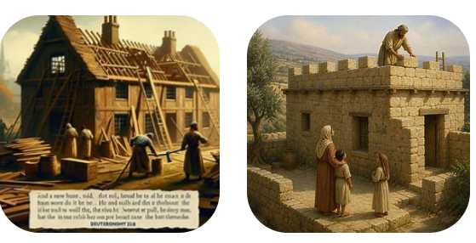
Rules for the Poeple
Deuteronomy 22 9-13
9 Thou shalt not sow thy vineyard with divers seeds: lest the fruit of thy seed which thou hast sown, and the fruit of thy vineyard, be defiled.

10 Thou shalt not plow with an ox and an ass together.

11 Thou shalt not wear a garment of divers sorts, as of woollen and linen together.

12 Thou shalt make thee fringes upon the four quarters of thy vesture, wherewith thou coverest thyself.

13 If any man take a wife, and go in unto her, and hate her,

speech against her

Deuteronomy 22 14-17

14 And give occasions of speech against her, and bring up an evil name upon her, and say, I took this woman, and when I came to her, I found her not a maid:

15 Then shall the father of the damsel, and her mother, take and bring forth the tokens of the damsel's virginity unto the elders of the city in the gate:

16 And the damsel's father shall say unto the elders, I gave my daughter unto this man to wife, and he hateth her;

17 And, lo, he hath given occasions of speech against her, saying, I found not thy daughter a maid; and yet these are the tokens of my daughter's virginity. And they shall spread the cloth before the elders of the city.

Knowledge without understanding means possessing information or facts without grasping their deeper meaning context, or application.

1 TIMOTHY 2:12 ESV
I DO NOT PERMIT A WOMAN TO TEACH OR TO EXERCISE AUTHORITY OVER A MAN; RATHER, SHE IS TO REMAIN QUIET.

PROVERBS 14:1 ESV
THE WISEST OF WOMEN BUILDS HER HOUSE, BUT FOLLY WITH HER OWN HANDS TEARS IT DOWN.

elders of that city

Deuteronomy 22 18-22

18 And the elders of that city shall take that man and chastise him;

19 And they shall amerce him in an hundred shekels of silver, and give them unto the father of the damsel, because he hath brought up an evil name upon a virgin of Israel: and she shall be his wife; he may not put her away all his days.

20 But if this thing be true, and the tokens of virginity be not found for the damsel:

21 Then they shall bring out the damsel to the door of her father's house, and the men of her city shall stone her with stones that she die: because she hath wrought folly in Israel, to play the whore in her father's house: so shalt thou put evil away from among you.

22 If a man be found lying with a woman married to an husband, then they shall both of them die, both the man that lay with the woman, and the woman: so shalt thou put away evil from Israel.

