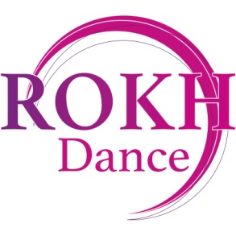
Safe Touch Policy
Physical Contact
Teaching dance is a physical activity and appropriate physical contact between students and teachers in class is essential to training.
Teachers will use their hands, and occasionally a foot or knee, to illustrate a concept to a student or to adjust parts of a student’s body (especially with the younger students). Dance posture often requires adjusting the rib-cage and the buttock area simultaneously and it is sometimes necessary to touch the inner thigh, especially with younger students.
In choreographic teaching, teachers demonstrate positions and movements to the students by moving parts of the students’ bodies and by moving dancers in relation to each other: this often involves a good deal of contact with students.
ROKH Dance recognises that such physical contact is a potentially complex area and the School also fully recognises its responsibilities for safeguarding students and teachers and for protecting their welfare. The following principles and procedures are in place to fulfil the School’s obligations: a) Contact by the teacher is made with particular awareness of the needs of each individual, to assist the young dancer in correcting placement b) All teachers will treat any physical contact with due sensitivity and care c) Teachers will always seek permission before making contact with a pupil to make adjustment.

Reviewed: 10/1/2023

