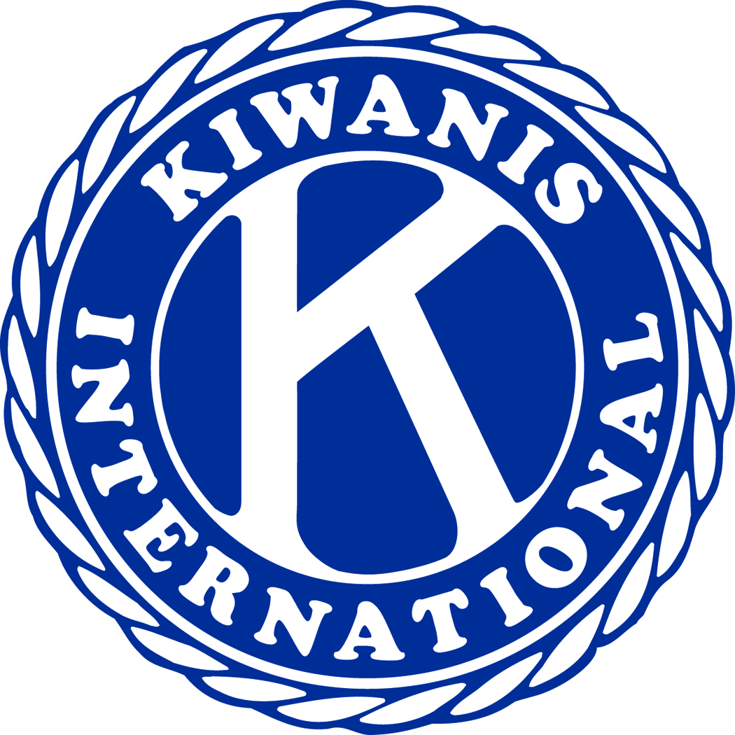

Kiwanis Club of Wenatchee
(Downtown)

Meetings are held each Tuesday at Noon at the Pybus Public Market

March 01, 2022

Ernie Hobbs, Editor

What happened at last Tuesday’s Downtown Kiwanis meeting

Flag Salute Leader: Ernie Hobbs

Patriotic Song Leader: Al (The Song) Smith

Invocation: President Kyle

Member’s Present: 12

Guest: Dave Erickson, (Speaker)

The BIG EVENT: Apple Blossom Kiwanis Pancake Breakfast will be May 7th

Helping Eastmont CLub
Help Eastmont Kiwanis with this fund-raising project. In turn they may help us earn money. We’ll need help at our Pancake Breakfast.

Eastmont Kiwanis Club is having a “See’s Candy” sale as a fund-raising project. Help them raise money and help yourself enjoy some delicious “See’s Candy”. Here is the link you can cut and paste into your browser to place your order.

If you hold down the control key on your keyboard then just click on the below link you’ll go straight to the “See’s ”web-site.

https://www.yumraising.com/secure/eastmontk_eastmont_kiwanis_easter_sale7/candy?h=Yve_Dav7880

We all know how difficult it is to raise money for Kiwanis since Covid. You can’t get a better candy product than “See’s” so paste the above link into your browser or hold down your control key as you click on the above link so you can taste the magic of “See’s Candy” while you help Eastmont Kiwanis Club raise money for their Kiwanis projects.

Last Tuesday’s Program
Program Chairman: Tom Irvin

Tom introduced Dave Erickson, the City of Wenatchee’s Director of Parks, Recreation and Cultural Services. Dave provided each of us a power point document titled City Parks Project Update. He then told us about the current status of Kiwanis Methow Park. There has been substantial vandalism and destruction of parts of the park. As an example, Dave told us about someone plugging up the wading pool drain with rocks, which created an expensive repair job. Lots of damage to practically every part of the park. The Trust for Public Lands had the design work done and directed a refurbishing and upgrading of the park to the tune of somewhere in the neighborhood of $3 million. The construction took more than a year to complete. The City Police has their work cut out for them trying to stop the vandalism and malicious destruction of the park improvements. If you’d like to know the current condition of this park, I recommend you go to the park and see for yourself. Judging from the photos Dave had in his presentation the park is a mess.

Thank you, Dave for a fine presentation and Thank you Tom for arranging for Dave to come speak to our club.

------------------------------------------------------------------------------
THE WENATCHEE WILD ICE HOCKEY PANCAKE BREAKFAST

A fine team of Downtown Kiwanians pulled together a fantastic pancake breakfast for the WILD Hockey Team players, management, coaches and the dedicated season ticketholders. The crew had many MVP’s, including Tom Irvin, Paul Gray, Tony Wright, Bill Dearing, Studdy, Doug Head, Mel Birmingham, Kyle & Riley Bruggman, Theresa Samuelsen, Ernie Hobbs, John & Gloria Reichmann as well as anyone that I missed their name. Everything was excellent to include the food, Wild fans, Wild players coaches and management. Even the weather was terrific. What a privilege to work side by side with all these fine people. Kiwanis is a blessing to us all.

Tom Irvin’s Tuesday March 8th Program will be the Royalty of the 2022 Washington State Apple Blossom Festival.

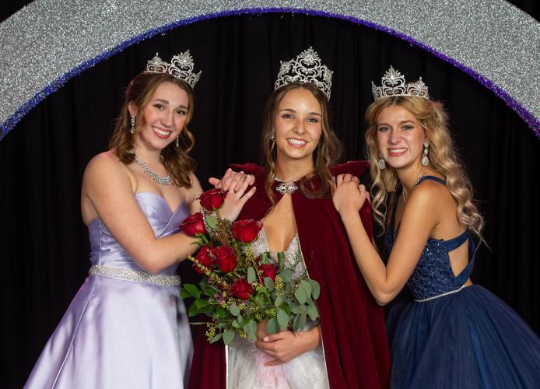Princess: Presley Nelson Queen: Rianne Salcido Princess : Ainsley Shearer

CLUB OFFICERS 2020 - 2021

President: Kyle Bruggman President Elect: Tom Paul
Vice President: Open Secretary: Melody Neidhart
Treasurer: Bill Dearing Past President: Jerome Tuss
BOARD OF DIRECTORS

1 Year Board Members 2 Year Board Members
Doug Head Ernie Hobbs
Vacant Position Tony Wright
Becky Aldrich Tom Irvin

