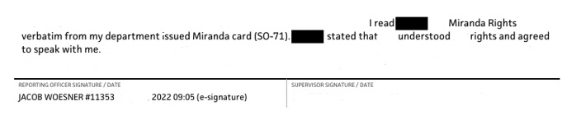
Victim #3

Victim #1, Me

Victim #3

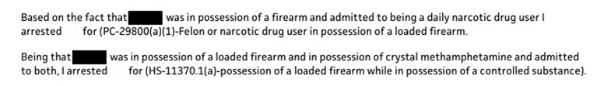
By falsifying that Victim #3 stated they used “methamphetamine daily”, Woesner was able to add the PC-29800(a)(1) charge, instead of just the HS-11370.1(a) charge

By falsifying that Victim #3 stated they sold drugs, Woesner was able to charge Victim #3 with HS-11378 possession of a controlled substance for sales.
Victim #2
By falsifying this statement/confession against victim #2 Woesner was able to “pin” a gun that was found in a vehicle that was not the victims vehicle onto the victim so that the victim would then be charged with Felon in Possession of a Firearm, on what was an illegal search.
“saw me locate the rifle and said “Oh shit I forgot about that”

Victim #1, Me
By falsifying this statement/confession Woesner was able to cover up a false arrest and ensure my conviction just like the other victims.
“Here’s what happened I hit him”.

Woesner followed the SAME, IDENTICAL pattern with Victim #3 just as he did with me, Victim #1.
That he read us, the victims, our Miranda rights, that we understood and agreed to talk then proceeded to make incriminating and damaging statements. All of which were false.
I REITERATE EVERY SINGLE CASE THAT THIS OFFICER HAS BEEN INVOLVED IN NEEDS TO BE REOPENED, WITH A FOCUS ON “CONFESSIONS”.
MORE SPECIFICALLY:
I read (insert poor victims name) Miranda rights verbatim from department issued Miranda card (SO-71). (Poor victims name) stated that they understood and agreed to talk. (Insert incriminating false statements/confession).
Because Woesner has an MO.
Finding Victim #3…it was also bittersweet…..Victim #3 has been significantly impacted by Woesner just as myself, and Victim #2 have been. Victim #3 has experienced a lot of very similar trauma responses due to the violation, that I have experienced as a victim by the same person. You realize me and these other victims were all experiencing a shared trauma at the same time, yet all alone in it, because we didn’t know about each other. I have ZERO doubt there are more, more victims that were corralled through the court system because public defenders told them they would never win when there was a confession, which Woesner was aware of, many likely had public defenders who didn’t believe them.
I cannot begin to explain the trauma, there is a victim that a police officer has falsified they sold drugs at their work. This is something this persons employer could see. Ironically this place of employment for Victim #3, that Woesner falsified statements about, I was denied employment due to Woesner, and the criminal charges. For victims, it not only creates criminal charges which impacts your ability to gain employment, it harms your reputation, your mental health, it attacks your trust at the very core, it impacts friendships which involves ending them, adds rifts into family relationships, so much more.
Victim #2 spent 2 ½ years wrongfully incarcerated. I am teary eyed as I type this. This victim was robbed of time with their family and loved ones.
The scope of Woesner’s impact on his victims lives is yet to be revealed. I have found 2 others so far who have been deeply impacted. DEEPLY IMPACTED.
I wasn’t supposed to still be here 6 years later, after all I was just another falsified confession Woesner had ensured a conviction on, the ultimate abuse of power. But my life has been deeply, deeply, impacted as well. Finding Victim #3 is just making me push harder. I still do not trust that the Fresno County Sheriff is trying to find victims.

