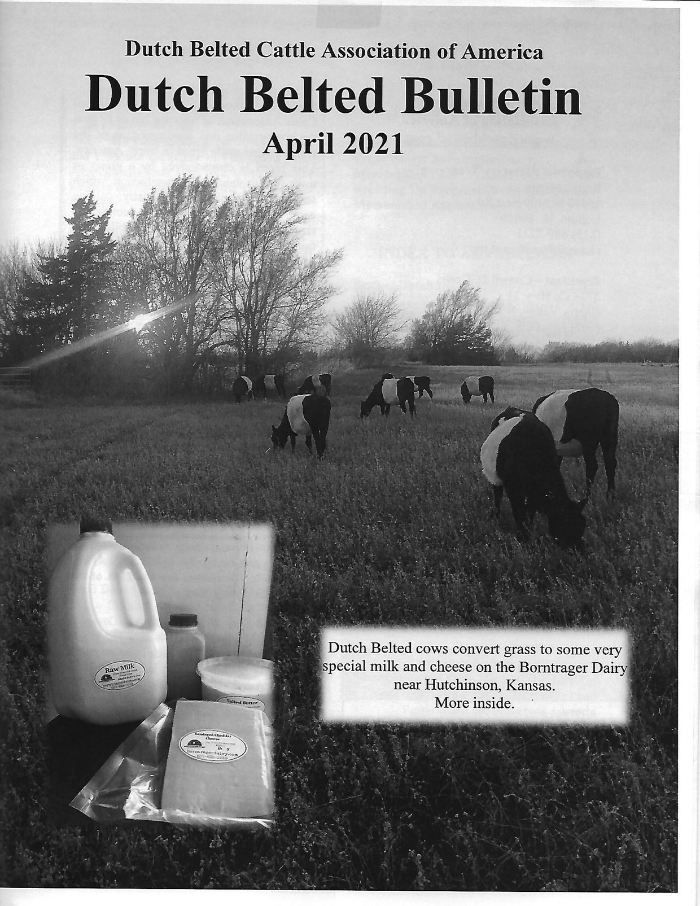

INSIDE THE APRIL 2021 DUTCH BELTED BULLETIN....
- Mission Statement and Contacts
- Cover Story: Bontrager Dairy
- Membership Lists
- Breeding Up Program/Breed Standards
- Classified Ads
- Membership Application
- Farm/Journal Advertising

