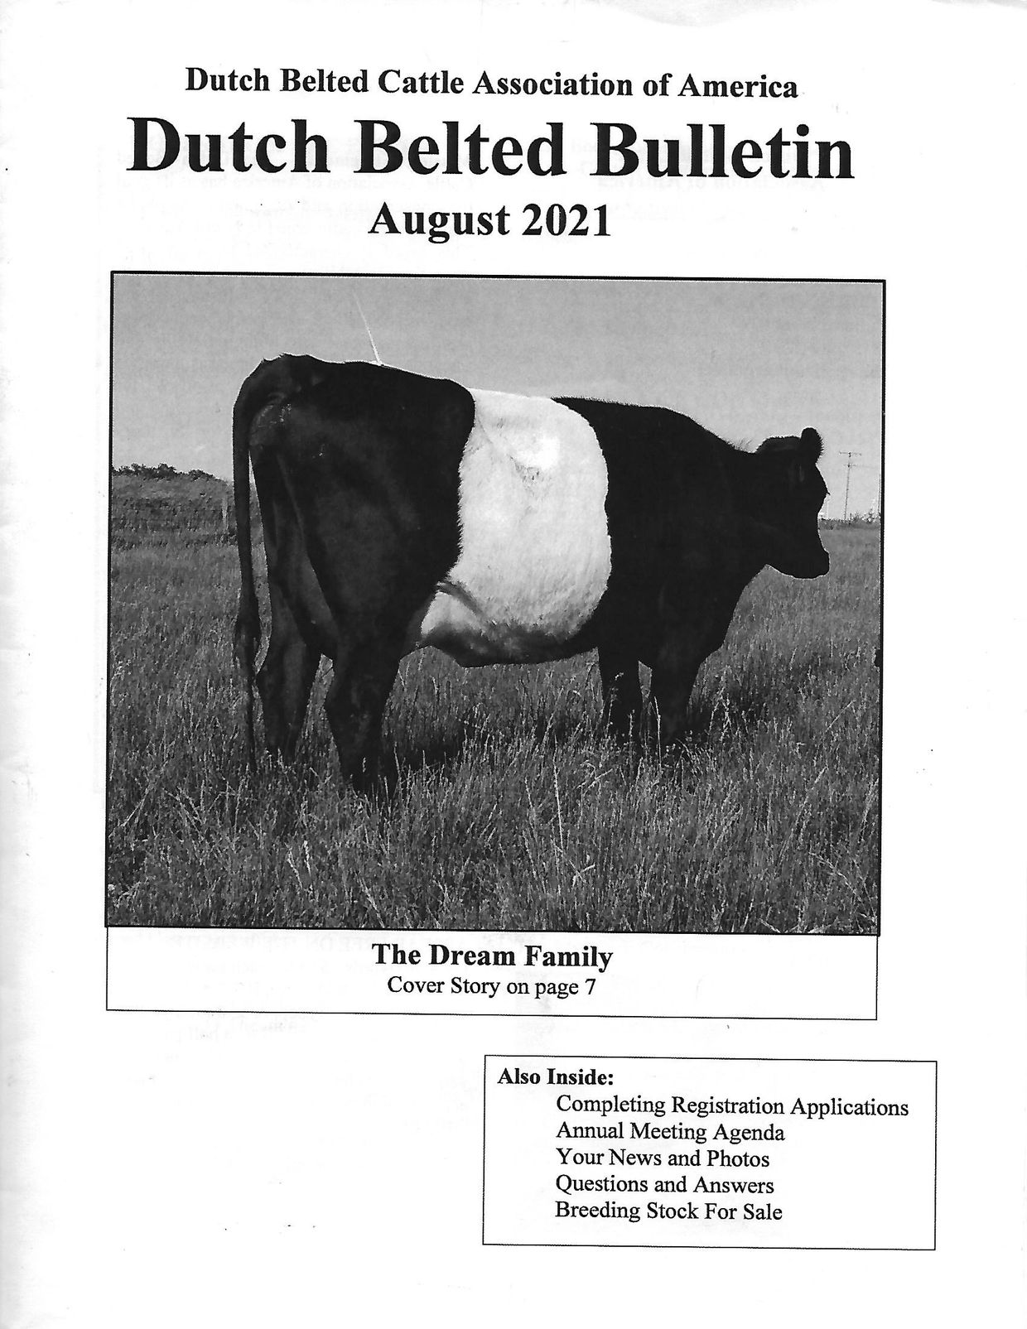
INSIDE THE AUGUST 2021 DUTCH BELTED BULLETIN....
- Mission Statement and Contacts
- Completing Registration Applications
- Annual Meeting Agenda
- Cover Story: The Dream Family
- Your News and Photos
- Questions and Answers: A2 Status
- Breeding Up Program/Breed Standards
- Classified Ads
- Membership Application
- Farm/Journal Advertising

