DBCAA Bulletin

The Dutch Belted Bulletin is published four times a year: January, April, August, and November.
It contains breeder profiles, classified ads, meeting reports, and much more news about Dutch Belted cattle.
To subscribe, click here and download membership application.

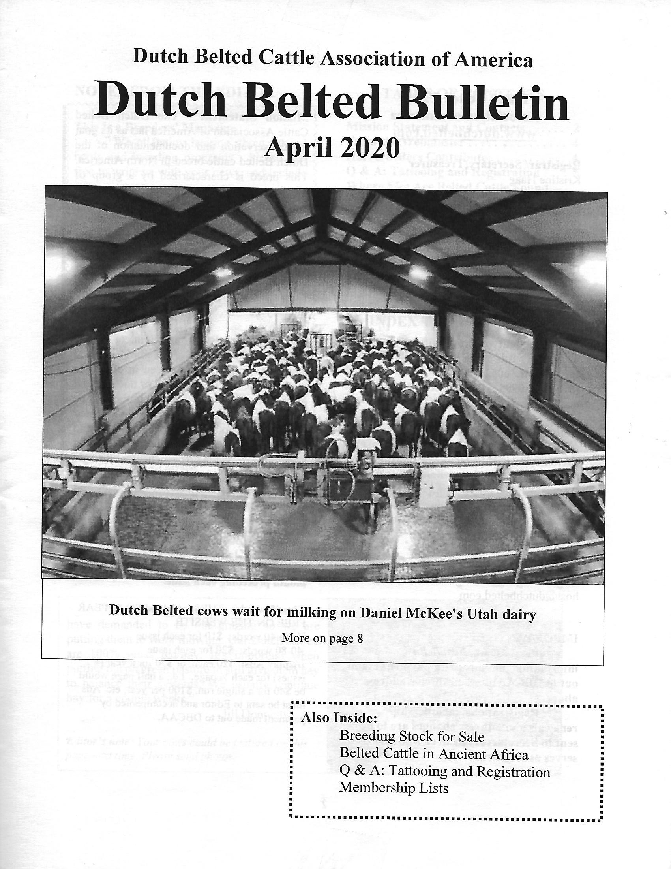

INSIDE THE APRIL 2020 DUTCH BELTED BULLETIN....
- Mission Statement and Contacts
- From the Webmaster-please help keep the breeder listing up to date and always seeking new pictures
- Harris Sisters Contribute
- Q and A: Tattooing and Registration
- Where else are Belted Cattle Found: Africa
- Cover Story-McKee dairy
- Membership Lists
- Classifieds
- Breeding Up Program/Breed Standards
- Membership Application
- Farm/Journal Advertising

Previous Editions

January 2020 (doc)Download

Copyright © 2020 Dutch Belted Association - All Rights Reserved.

