The Dutch Belted Bulletin is published four times a year: January, April, August, and November.
It contains breeder profiles, classified ads, meeting reports, and much more news about Dutch Belted cattle.
To subscribe, click here and download membership application.
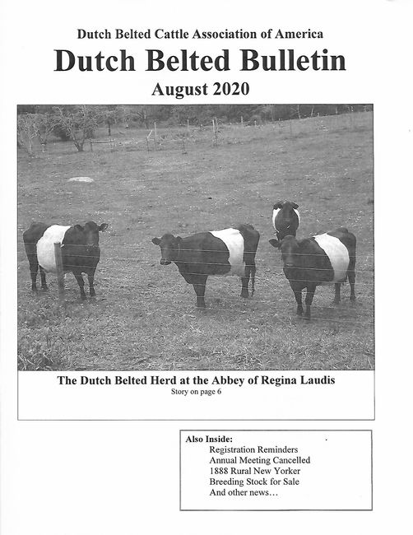

INSIDE THE 2020 AUGUST DUTCH BELTED BULLETIN....
- Mission Statement and Contacts
- Editorial: Connections from Past to Future
- Annual Meeting Cancelled
- Officer Name Change-Martha Hoffman Kerestes
- Cover Story-Dutch Belted Cattle at the Abbey of Regina Laudis
- Dutch Belted Cattle Article from the Summer of 1888
- Classifieds
- Breeding Up Program/Breed Standards
- Membership Application
- Farm/Journal Advertising

