Registration fees male or female:
Lifetime Member Non-Member
Under 6 mo. $5.00 $10.00
6-12 mo. $7.00 $15.00
Over 12 mo. $15.00 $30.00
Transfers $4.00 $8.00
Duplicate Certs. $4.00
After 1/1/15, include $30 for bull DNA testing.

Name of Animal:

Sex: M F Date of Birth: Color:

This animal is a product of: Natural Service Embryo Transfer
(Check one) (Attach ET certificate)
Artificial Insemination

Tattoo Right: ______________ Tattoo Left: ______________ Ear Tag #: _________________ Brand/Microchip: _______________________________

Sire Name/Reg. #: ________________________________________ Dam Name/Reg. #: ___________________________________________________

If bull is not owned by the owner of the cow, please complete the following:

I certify that my bull Reg. # bred the dam named in this application

on (date) . Insemination was: Natural Artificial Signed:

Address: State: Zip:
Breeding Certification: (Attach breeding receipt if that system is used.) Breeder agrees to maintain accurate breeding records, to open all records for inspection on demand, and to submit to blood typing as deemed necessary by DBCAA. I hereby certify that the above pedigree is correct and that this animal is eligible for registration under the rule of DBCAA.

Breeder: Address:

State: Zip: Phone: Email:

First Owner: Address:

State: Zip: Phone: Email:
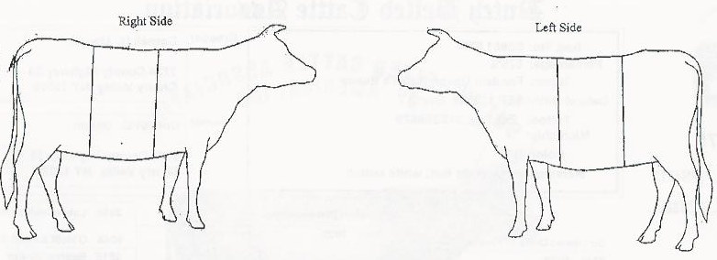
Diagram of Animal Showing Belt & Other Markings
(“Standard Belt” Outlined in black)

Transfer Form
Upon sale of animal, it is the responsibility of the seller to sign, date and return this certificate to the Dutch Belted Cattle Association of America with the transfer fee of $4.00 for member/$8.00 for non-member. A new certificate will be sent to the current owner.
(Print name and address clearly.)
For the value received, I (we) hereby sell, assign and transfer:

Name of Animal: Reg. #:

To new owner: Address: State: Zip:
Please make checks payable to DBCAA.
Send to: DBCAA
c/o Kristine Haag
15470 N 3400 East Rd
Cullom, IL 60929
(815) 689-2231
rhaag@frontiernet.net

Phone: Email: and consent to the transfer on the books of the DBCAA.

Signature:

Date: _______________________________________________________________

