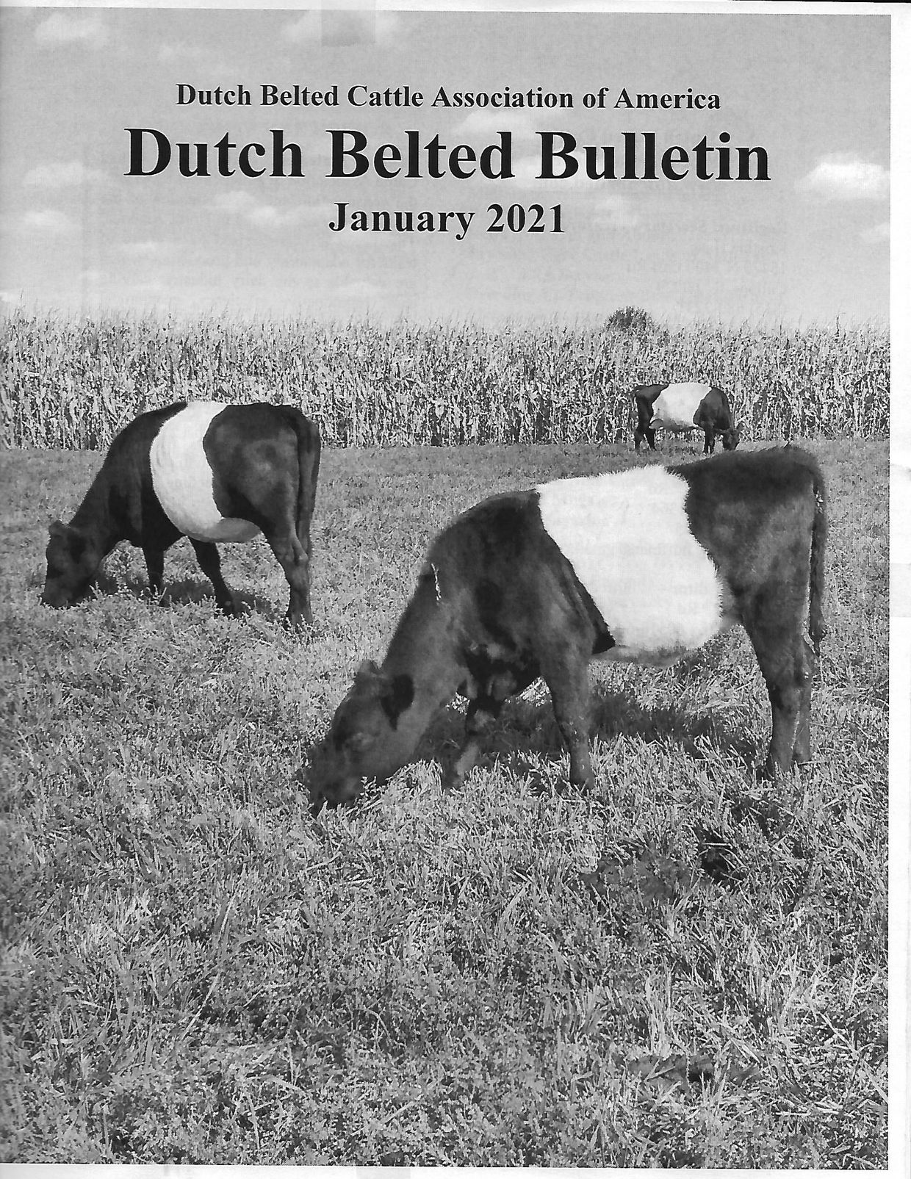
INSIDE THEJANUARY 2021 DUTCH BELTED BULLETIN....
- Mission Statement and Contacts
- Bull Registration Reminders
- News from Out and About
- Breeding Rare Cattle Leads to National FFA Service-Miriam Hoffman
- Breeding Up Program/Breed Standards
- Classified Ads
- Membership Application
- Farm/Journal Advertising

