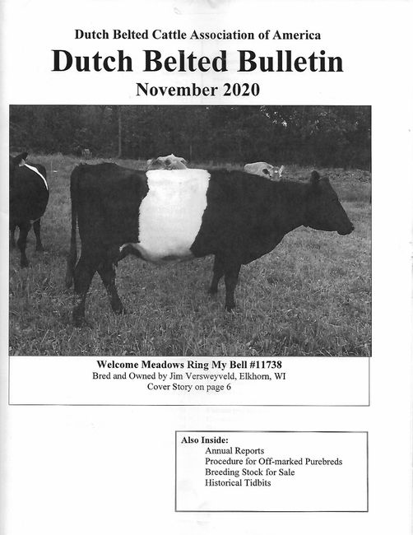

INSIDE THE NOVEMBER 2020 DUTCH BELTED BULLETIN....
- Mission Statement and Contacts
- Annual Reports
- Procedure for Off-marked Purebreds
- Cover Story-Welcome Meadow's Bell Family
- Historical Titbits
- Breeding Up Program/Breed Standards
- Membership Application
- Farm/Journal Advertising

