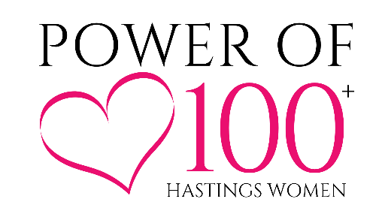

Hello! We are a local community giving circle and we would like to consider your non-profit for

an upcoming meeting presentation.

Attached is the **Submission Form** to be completed.

Please attach the following documents: (incomplete applications will not be considered)

● Recent Annual Report

● Current year AND previous year budget

● Current year Income/Expense

● IRS 501(c)(3) status verification or IRS 501(c)(19) status verification

**Please note:** We understand that some programs and collaborative community initiatives have a fiscal agent/sponsor. We are willing to entertain those programs and initiatives, provided that the above items are submitted. (Budgets and income/expense reports can be program-specific, annual reports and IRS non-profit status must be for the fiscal sponsor if the program or initiative does not have its own.) Power of 100 Hastings Women reserves the right to request additional information to prove fiscal agent responsibility and good standing if desired.

Typically, all information must be received 45 days prior to the selected Impact Meeting. Impact Meetings for 2024 will be held on the following dates:

* **April Event Date:** Thursday, April 25, 2024 – **Charity submissions due on or before March 11,2024.**
* **October Event Date**: Thursday, October 24, 2024 – **Charity submissions due on or before September 9, 2024.**

Please direct questions to:

Melissa Freiermuth

admin@powerof100hastings.com

715-222-4611

***Please feel free to check us out at www.Powerof100Hastings.com!***

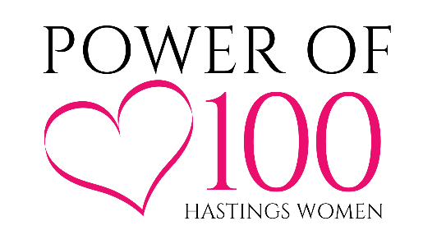

**Charitable Organization Submission Form**

Nonprofit Name:

Power of 100 Member Who Encouraged You to Apply:   
*(Power of 100 Hastings Women wants our members to make connections with charitable organizations. If you have not chatted with a member, no worries, just tell us how you heard about this submission opportunity.)*

Website:

Nonprofit Address:

Contact Name:

Contact Email: Contact Phone:

Organization Mission Statement:

Year nonprofit attained 501(c)(3) or 501(c)(19) status:

Number of Volunteers:

Approximately how many people receive your services on an annual basis?

Geographic area served by nonprofit:

What need does your organization strive to fill?

How is the Hastings area impacted by your organization?

How would the Impact Award be used locally?

What percent of your budget is spent on overhead/salaries/administrative fees?

* If selected, do you agree to present at our next meeting to describe the impact of the donation?

* Do you agree that your organization will NOT sell, give or use Power of 100 Hastings Women contact information for solicitations by themselves or other organizations?
* Do you agree to provide charitable tax receipts to all members?

If selected, to whom should checks be payable?

*Feel free to include any other supporting information that you may find helpful to the review committee.*

**Please attach the following documents: (incomplete applications will not be considered)**

* Recent Annual Report
* Current year AND previous year budget
* Current year Income/Expenses
* IRS 501(c)(3) status verification or IRS 501(c)(19) status verification

*Typically, all information must be received 45 days prior to the selected Impact Meeting. Impact Meetings are planned for April and October this year.*

**How Are the 3 Presenting Charities Chosen?** The Core 10 Team (original 10 founding members) for Power of 100 Hastings Women reviews all applications for their completion and validity. An objective, yet confidential, scoring rubric is used in the vetting process. Applications are not discussed in a group setting, rather all applications are vetted by the Core 10 Team members individually. Each is reviewed, then scored, and an aggregate score is tallied from each Core 10 Team member. The math prevails. The top 3 cumulative scores are the charities chosen to present at the event. Please be aware that the application will not be provided to the general membership. The presenting charities are charged with making their message clear in their presentations.

**Please note:** We understand that some programs and collaborative community initiatives have a fiscal agent/sponsor. We are willing to entertain those programs and initiatives, provided that the above items are submitted. (Budgets and income/expense reports can be program-specific, annual reports and IRS non-profit status must be for the fiscal sponsor if the program or initiative does not have its own.) Power of 100 Hastings Women reserves the right to request additional information to prove fiscal agent responsibility and good standing if desired.

**Please submit your completed forms and supporting documents via email to:** [**admin@powerof100hastings.com**](mailto:admin@powerof100hastings.com)

**If you have questions, please reach out to** [**admin@powerof100hastings.com**](mailto:admin@powerof100hastings.com)**.**