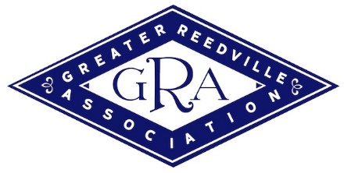
2022 Classic Reedville Boat Show
Sponsorship Opportunities

_______________________________________________________________________________________
Every year the Greater Reedville Association (dba Reedville Fishermen’s Museum) hosts the Classic Boat Show that attracts hundreds to Reedville for a full day of exhibits and activities along Main Street and Cockrell Creek. This year the Classic Boat Show will be held from 10-4p on Saturday, September 10, 2022. The Boat Show kicks off with an opening reception on Friday, September 9 at the Reedville Railway (Woody Boater Word Headquarters) at 5p. Events on that Saturday include over 40 classic boats on display, cruises on the Elva C and Skipjack Claud W. Somers, oyster po’boys and beer garden, and a reading and book signing by Larry Chowning, local author and award-winning reporter.

Being a sponsor of the Classic Boat Show will not only help promote your business to event participants/attendees but will support this annual community event which has become a tradition in Reedville.

Please consider being a SPONSOR! We rely on your generous financial support to make this possible! THANK YOU!

Sponsorship Levels & Benefits
Bronze Sponsorship: $100 | - Two Tickets to the Classic Boat Show  - Free Admission to Reedville Fishermen’s Museum on 9  - Company logo on the RFM website and event banner  - T-shirt or hat
Silver Level: $250+ | - Four Tickets to the Classic Boat Show  - Free Admission to Reedville Fishermen’s Museum  - Pre and Post-Event Marketing Recognition  - Company logo on RFM website and event banner  - One free boat registration  - T-shirt or hat
Gold Level Sponsorship: $500+ | - Four Tickets to the Classic Boat Show  - Free Admission to Reedville Fishermen’s Museum  - Pre and Post-Event Marketing Recognition  - Company logo on RFM website and event banner  - Free vendor table in the Vendor area  - One free boat registration  - T-shirt or hat
Premier Level Sponsorship - $1,000 & Above | - All of these above, plus  - Company logo as event sponsor in radio & newspaper ads  - VIP Parking at Reedville Fishermen’s Museum

To be a sponsor of the 2022 Classic Boat Show, please send a check to:
Greater Reedville Association
PO Box 306
Reedville, VA 22539

Contact Liz Buxton or Danielle Harris-Burnett with questions and/or to pay with a credit card at 804-453-6529.
Logos need to be submitted to office@RFmuseum.org by August 26, 2022 to be included in promotional materials.

THANK YOU FOR YOUR SUPPORT!

* All proceeds benefit the event, which is operated by the Greater Reedville Association, Inc., a charitable, non-profit organization, classified under the provisions of IRS Code 501(C)(3)

