The Museum’s mission is to acquire, document, interpret and display materials that are historically important to the lower Chesapeake Bay – with special emphasis on activities relating to Reedville fisheries and the lives of the region’s watermen – and to establish educational programs to interpret this maritime heritage. |  | Reedville Fishermens Museum  Family Boat Building Weekend  PO Box 306  Reedville, VA 22539 |  |  | Reedville Fishermen’s Museum  Family Boat Building Workshop  June 25 – 27, 2021  Hosted by:  The Museum’s Boat Shop Crew  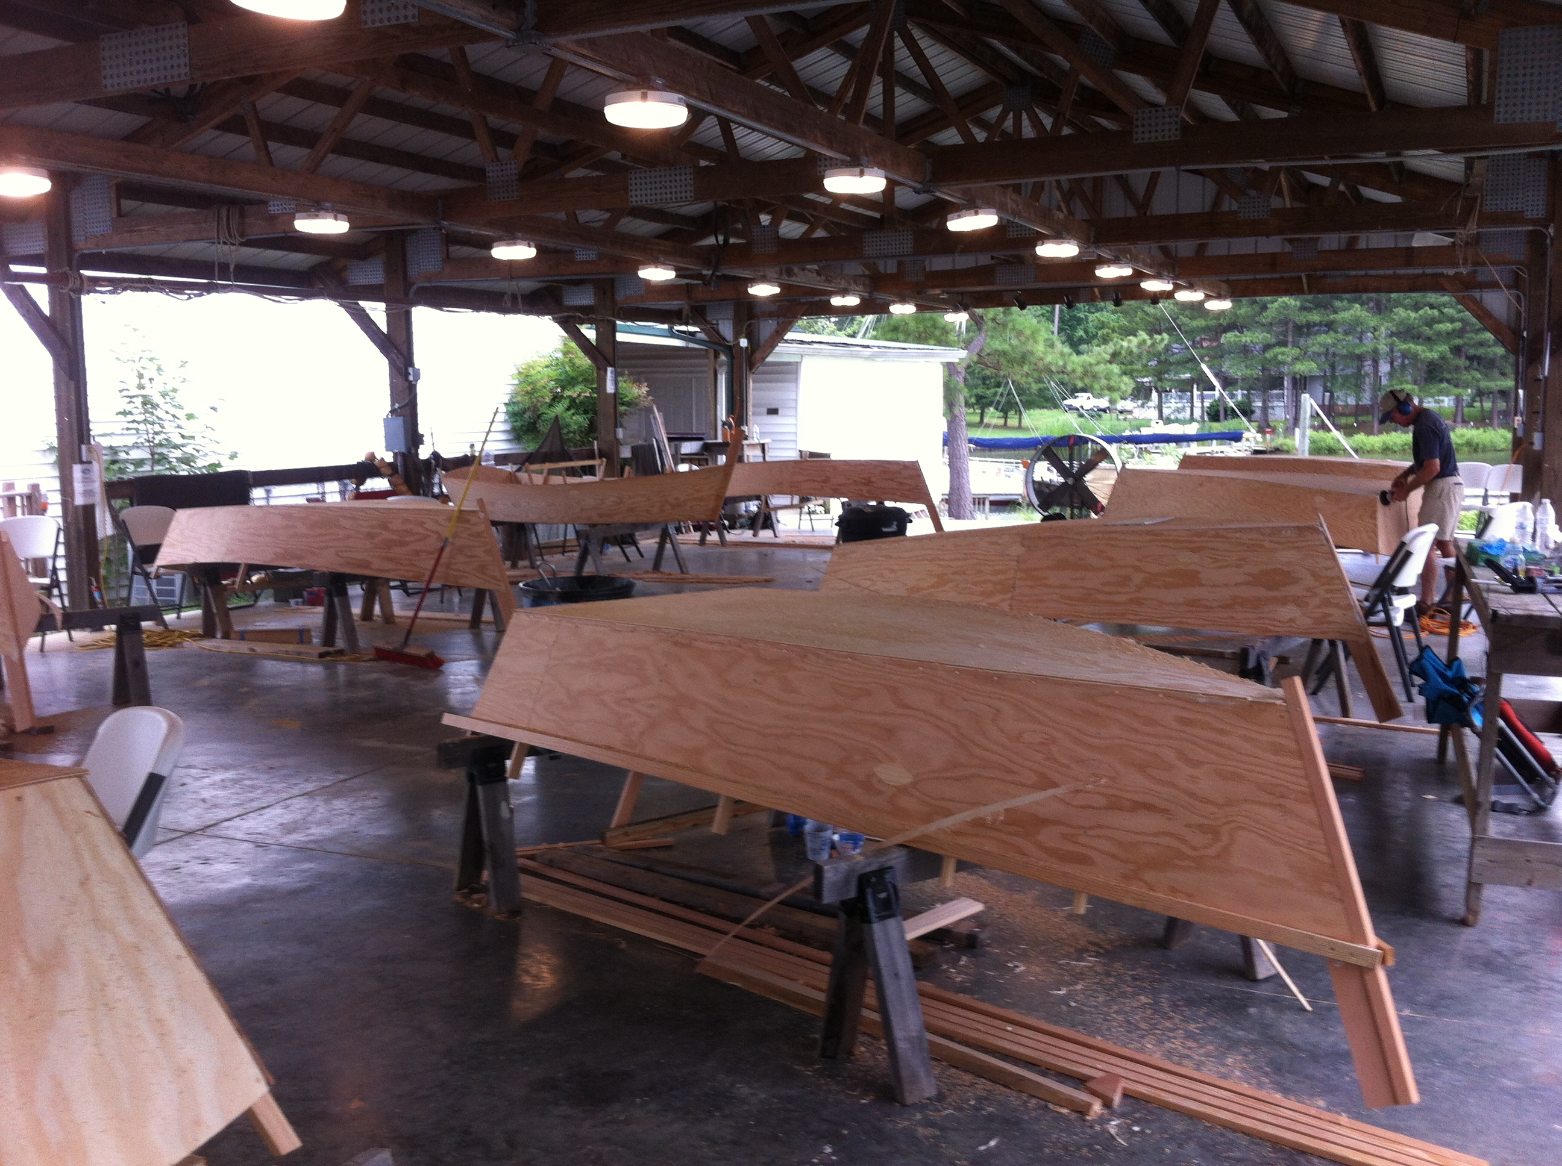

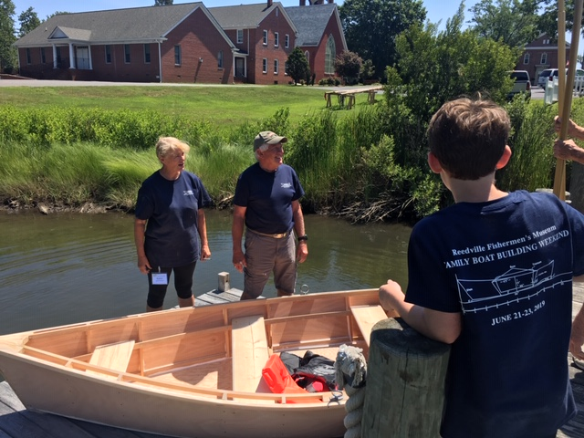  Join us at the Museum to build a flat-bottom skiff! You’ll take it home with you at the end of the weekend!  Space is limited to 8 families or teams  To register your family for the 2021 workshop, or for more information, please call the office at 804-453-6529 or go on-line to www.rfmuseum.org | Family Boat Building Weekend Includes:  Boat kit, 2 T-shirts, lunch on Friday & Saturday, water & sodas all weekend, and admission to the Museum for all team members.  Registration: $950.00  Oars are $100.00  Extra T-shirts are $20.00  The Mabel Skiff  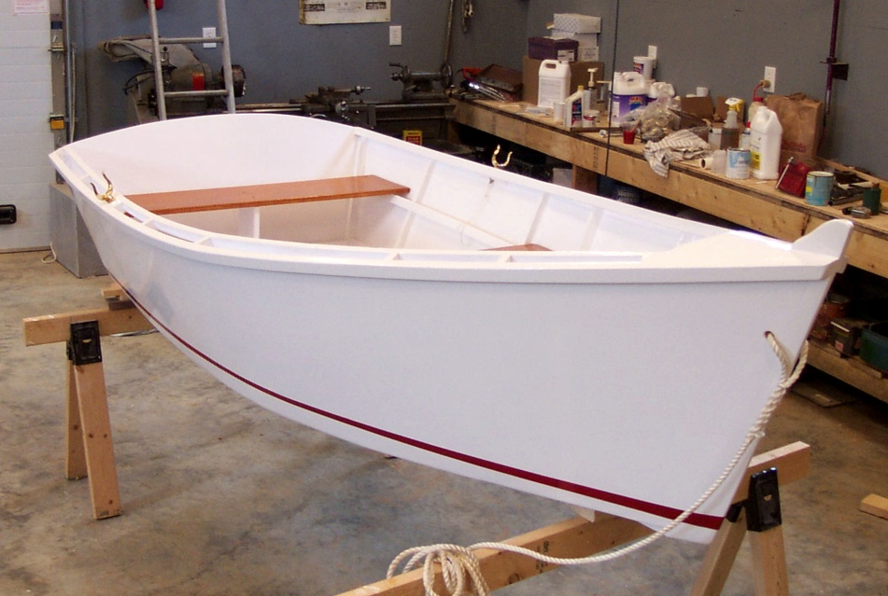  This skiff was named after Mabel, the grand- daughter of the boat shop’s founder. | Comments from 2019 Participants:  - “Family Boat Building was a memory that our family will treasure. We got a chance to appreciate the craft of boat building.”  - “The instruction manual was easy to understand.”  - “The whole weekend was amazing; we could not have asked for anything better.”  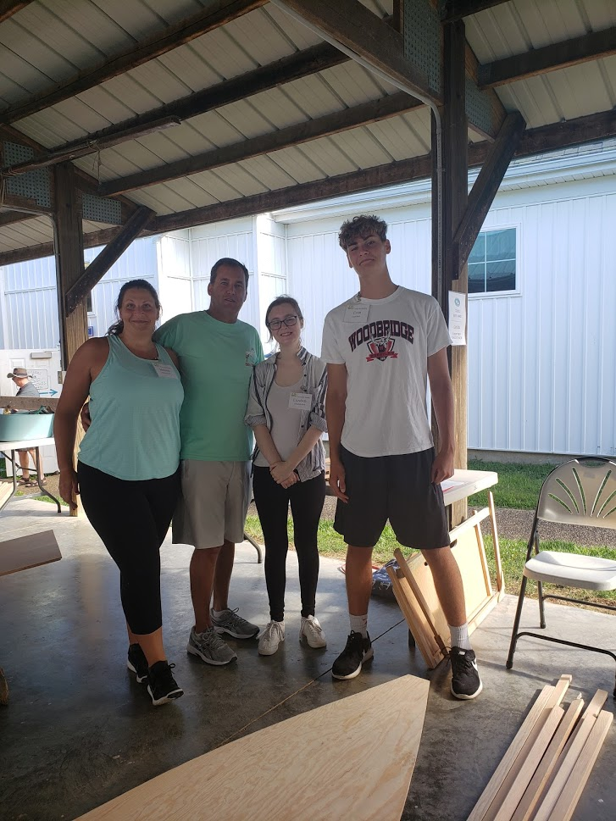  The Roth Family in 2019  Reedville Fishermens Museum  Family Boat Building Weekend  PO Box 306  Reedville, VA 22539  804-453-6529  office@rfmuseum.org

