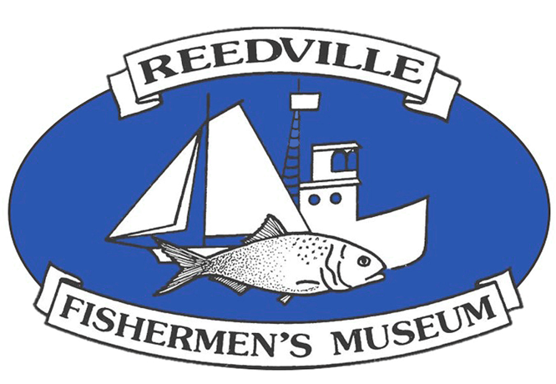

Reedville Fishermen’s Museum

Family Boat Building Workshop
June 25 - 27, 2021

Personal Information:
Name: | Age:
Address:
City: State: Zip:
Telephone:
E-mail:
Team member’s names, ages and [shirt sizes if applicable]

Fees:
Family Boat Building Weekend Includes:  Boat Kit, 2 T-shirts, lunch Friday & Saturday, water & sodas all weekend, and admission to museum for team members. |  | $950.00
Oars: (optional) | $100.00 pair | $
Additional T-Shirts: | $ 20.00 ea. | $
Total Cost |  | $
Balance due: |  | $

Mail to:
Reedville Fishermen’s Museum
Family Boat Building
P.O. Box 306
Reedville, VA 22539
Contact Information: (804) 453-6529
E-mail: office@rfmuseum.org
Web: www.rfmuseum.org

Note: COVID TEST FOR ALL ADULTS 72 HOURS BEFORE THIS EVENT

Make checks payable to Reedville Fishermen’s Museum

