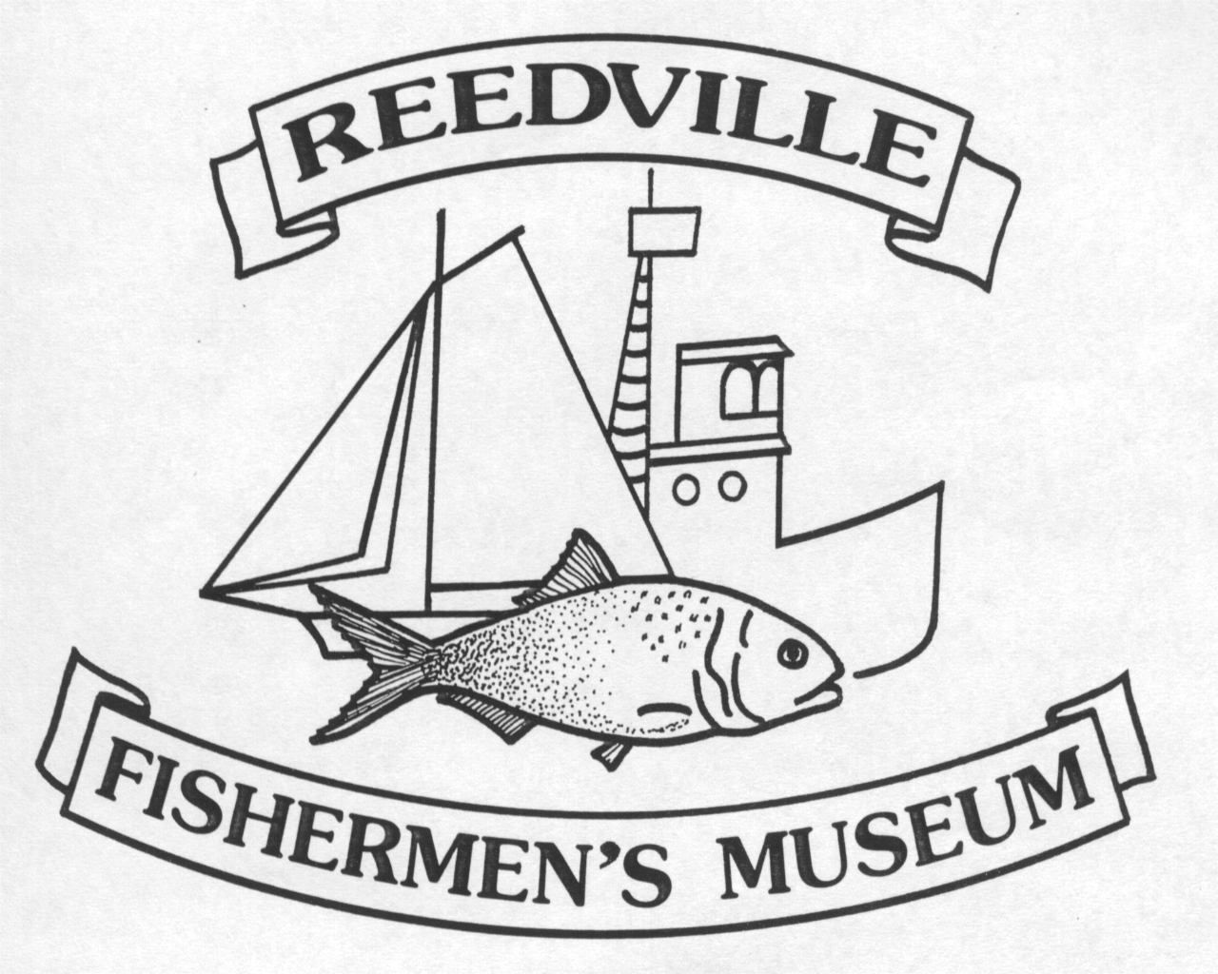
Reedville Fishermen’s Museum
Volunteer Application

Contact Information Date: ___________
Name
Street Address
City, State, Zip Code
Home Phone
Work Phone
E-Mail Address

Availability
During which hours are you available for volunteer assignments?
___Weekday mornings | ___Weekend mornings
___Weekday afternoons | ___Weekend afternoons
___Weekday evenings | ___Weekend evenings
___Special Events Only | ___Need flexible schedule

How You Can Help
Tell us in which areas you are interested in volunteering:

COMMITTEES
___Boat Donation Committee SPECIAL EVENTS:
___Boat Shop ___ Annual Benefit Auction - April
___Buildings & Grounds ___ Antique & Classic Boat Show – Sept.
___Claud Somers Crew ___ Christmas on Cockrell’s Creek – Dec.
___Curatorial Committee ___ Family Boatbuilding - June
___Docent in Museum ___ Independence Day Celebration - July
___Education Committee ___ Oyster Roast – November
___Elva C Committee ___ Mistletoe & Mimosas - December ___ Exhibits Committee
___ Gift Shop Committee
___ Lecture Series (Feb-May) SPECIAL NEEDS:
___ Model Shop Committee
___ Starry Banner (newsletter) ___ I can bake or make an appetizer for
___ Walker House Committee a special event or reception
___ Winter Markets (Nov., Dec., Feb)
___ I can assist with office work (computers, bookkeeping, phones, etc.

Please share any special considerations that may influence your volunteer activities _______________________________________________________________________________________________________________________________________________________________________________________________________________________________________

Are you a Reedville Fishermen’s Museum member? ____ Yes ____ No

Special Skills or Qualifications
Please share any of your skills, interests, employment, or other volunteer experiences that you feel would contribute as a volunteer at RFM (research projects, handicrafts, college degree, clerical/computer skills, etc.

Previous Volunteer Experience
Summarize your previous volunteer experience.

Person to Notify in Case of Emergency
Name
Street Address
City ST ZIP Code
Home Phone
Work Phone
E-Mail Address

Agreement and Signature
By submitting this application, I affirm that the facts set forth in it are true and complete. I understand that if I am accepted as a volunteer, any false statements, omissions, or other misrepresentations made by me on this application may result in my immediate dismissal.
Name (printed)
Signature
Date

Our Policy
It is the policy of the Reedville Fishermen's Museum to provide equal opportunities without regard to race, color, religion, national origin, gender, sexual preference, age, or disability.

Thank you for completing this application form and for your interest in volunteering with us.

