SIMPLE OPERATING INSTRUCTIONS
Filling a Liquid Nitrogen (LN₂) Dewar
Using a Low-Pressure Liquid Withdrawal Device

1. PURPOSE & SCOPE
These instructions cover safe filling of a portable open-mouth or low-pressure LN₂ dewar from a low-pressure liquid nitrogen supply cylinder (typically 22–35 psig) using a transfer hose / low-pressure liquid withdrawal device. For trained personnel only. Always follow the manufacturer’s manual for your specific equipment.

2. CRITICAL SAFETY WARNINGS
⚠ CRYOGENIC HAZARD
Liquid nitrogen is −196 °C (−320 °F). Contact causes severe frostbite/cold burns in seconds. Always wear full PPE. Never touch uninsulated lines, valves, or dewar neck with bare skin.
⚠ ASPHYXIATION HAZARD
LN₂ expands ~700:1 and displaces oxygen. Work only in well-ventilated areas. Never fill or store in confined spaces, elevators, or poorly ventilated rooms. Oxygen monitors strongly recommended.
⚠ PRESSURE HAZARD
Never completely seal a dewar. Always leave a vent path open. Do not exceed rated working pressure (typically 22 psig primary relief). Source pressure must not exceed 45 psig.
⚠ SPLASH / SPRAY HAZARD
Liquid violently boils on warm surfaces. Use a phase separator on the hose end for open dewars. Stand clear of the vent and fill stream. Keep face and body away from the open neck.

3. PERSONAL PROTECTIVE EQUIPMENT (PPE)
- Cryogenic gloves (loose-fitting, insulated, wrist coverage – able to shake off quickly)
- Full face shield + safety goggles underneath
- Long-sleeve lab coat or cryo apron (buttoned / closed)
- Long pants without cuffs (must cover tops of shoes)
- Closed-toe, non-absorbent safety shoes / boots

4. FILLING PROCEDURE — STEP BY STEP
Step 1 — Position equipment
Place the receiving dewar on a stable, level surface near the supply cylinder. Lock cart wheels if used. Position yourself so you can reach the supply valve and watch the dewar neck at the same time.
Step 2 — Don full PPE
Put on cryogenic gloves, face shield + goggles, lab coat/apron. Verify clothing covers all exposed skin. Do this before touching any cold equipment.
Step 3 — Connect the transfer hose
Attach one end of the cryogenic transfer hose securely to the liquid withdrawal valve labeled LIQUID (low-pressure liquid withdrawal device) on the supply cylinder. Hand-tighten then snug with wrench if required (do not over-torque).
Step 4 — Open Vent Valve
Open VENT or VAPOR valve on the liquid withdrawl device attached to the dewar being filled.
Step 5 — Open supply liquid valve slowly
Slowly open the liquid withdrawal valve on the supply cylinder. Liquid will initially flash to gas, producing loud boiling, sputtering, fog, and whistling. This is normal while hose and dewar cool (30–90 seconds). Keep valve only partially open until steady liquid flow is established.
Step 6 — Fill to desired level
Continue filling until desired volume is reached. Preferred method: weigh the dewar (tare empty weight + desired fill mass). Alternative: fill until liquid begins to spit from the VENT/VAPOR valve (stop before full overflow). Never overfill – leave headspace for expansion.
Step 7 — Close supply valve first
When fill is complete, fully close the liquid withdrawal valve on the supply cylinder. Wait a few seconds for residual liquid in the hose to stop flowing. Then close VENT/VAPOR valve and then close LIQUID valve on dewar.
Step 8 — Disconnect and stow
Disconnect the transfer hose from the supply cylinder (after pressure has bled down). Cap the hose ends if required. Return the supply cylinder valve to the fully closed position and secure the area.

7. POST-FILL ACTIONS
- Inspect the filled dewar for leaks, unusual frosting, or pressure relief activity.
- Label the dewar with date/time filled and contents if not already labeled.
- Transport the dewar upright on a proper cryogenic cart. Never roll, drag, or tip it.
- Store in a well-ventilated designated area. Do not leave unattended in corridors or occupied rooms.
- Log the fill if required by facility procedures.
- Allow the transfer hose to warm and dry completely before storing.

8. EMERGENCY RESPONSE (QUICK REFERENCE)
Cold Burn / Frostbite | Flush affected area with tepid (not hot) water for 15+ minutes. Do not rub. Seek medical attention. Remove clothing only after thawing if stuck.
Eye Contact | Immediately flush with water for 15 minutes, holding eyelids open. Get medical help at once.
Asphyxiation / O₂ Alarm | Evacuate the area immediately. Do not re-enter until oxygen levels are confirmed safe. Call emergency services if anyone is down.
Major Spill | Alert others, evacuate, activate emergency shut-off if available, and call facility emergency number. Large spills create oxygen-deficient atmospheres.
Visual Reference
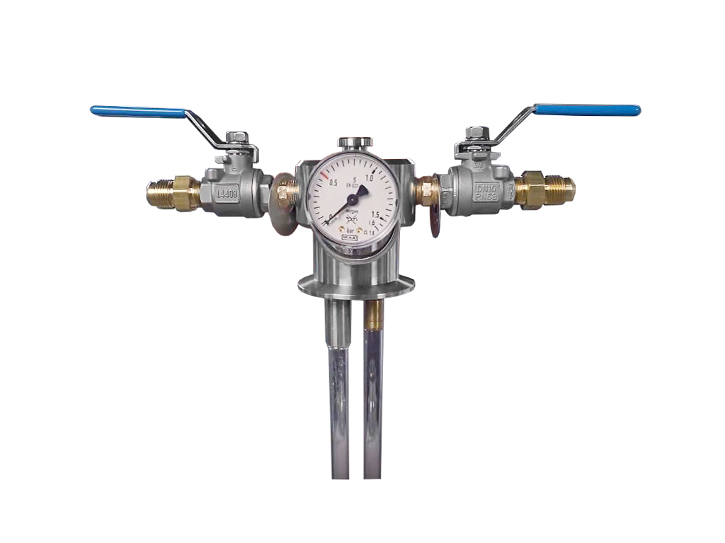
Vapor
From Supply Tank
Liquid Valve Vent/Vapor Valve

