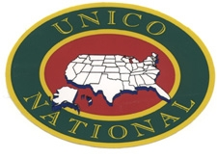 WETHERSFIELD-ROCKY HILL
CHAPTER of UNICO National

BRIAN PICCOLO AWARD
MAIL TO:
TONY MARTINO
UNICO SCHOLARSHIP COMMITTEE DUE DATE: MARCH 17, 2025
374 HIGHLAND STREET
WETHERSFIELD, CT 06109

Student’s Name: E-mail

Student’s Address: Phone No.:

Explain where Student inherited Italian Heritage (Mother or Father’s Family or both)

To be completed by Coach / Athletic Director:
Sports Student has participated in:
1)

2)

3)

Student’s Athletic Leadership Qualities (Team Captain etc.):

Special Recognition from Conference:

Special Recognition from State:

To be completed by Athlete:
Students: On a separate sheet of paper
- Tell us, in essay format, how you demonstrate the characteristics exemplified by Brian Piccolo.
- Please advise us in essay format why you are the best candidate for this award.

Signature: Date:

INCOMPLETE APPLICATIONS WILL RESULT IN ELIMINATION FOR CONSIDERATION.

